**VIETNAM NATIONAL UNIVERSITY HO CHI MINH CITY**

**UNIVERSITY OF INFORMATION TECHNOLOGY**

**FACULTY OF INFORMATION SYSTEM**



**FINAL PROJECT REPORT**

**INFORMATION SYSTEM ANALYST AND DESIGN**

**TOPIC**

**BUILDING A COFFEE SHOP MANAGEMENT APPLICATION**

Theory lecturer: PhD. Cao Thị Nhạn

Practical lecturer: Master Tạ Việt Phương

Class: IS201.M22.HTCL

Members of group: Lê Thị Ngọc Hảo – 20521292

Nguyễn Duy – 20521234

Trương Mỹ Song Dân – 20520424

Hồ Thị Hằng – 20521285

ACKNOWLEDGEMENT

First of all, we would like to express our sincere thanks to all the lecturers of University of Information Technology – Vietnam National University HCMC and lecturers of Faculty of Information Systems for helping us have the basic knowledge as a basis for implementation of this project. We pay our deep sense of gratitude to PhD. Cao Thi Nhan (theory lecturer of Information System Analysis and Design subject) and Master. Ta Viet Phuong (practical lecturer of Information System Analysis and Design subject) for providing invaluable guidance, comments and suggestions throughout the course to help us complete our subject report. During one semester of implementation, we applied the accumulated background knowledge and combined it with learning and researching new knowledge. However, we definitely can not avoid shortcomings. Therefore, we are looking forward to receiving suggestions from the lecturers in order to improve the knowledge that we learned and be a preparation for us to carry out other topics in the future.

Thank you.

Group of authors

**LECTURERS COMMENTS**

.......................................................................................................................................................................................................................................................................................................................................................................................................................…....................................................................................................................................................................................................................................................................................................................................................................................................................….....................................................................................................................................................................................................................................................................................................................................................................................................................................................................................................................................................................................................................................................................................................................................................................................................................................................................................................................................................................................................................................................................................................................................................................................................................................................................................................................................................................................................................................................................................................................................................................................................................................................................................................................................................................................................................................................................................................................................................................................................................................................................................................................................................................................................................................................................................................................................................................................................................................................................................................................................................................................................................................................................................................................................................................................................................................................................................................................................................................................................................................................................................................................................................................................................................................................................................................................................................................................................................................................................................................................................................................................................................................................................................................................................................................................................................................................................................................................................................................................................................................................................................................................................................................................................................................................................................................................................................................................................................................................................................................................................................................................................................................................................................................................................................................

**Tables of content**

**CHAPTER 1: INTRODUCTION** 6

1.1 Problem 7

1.2 Solution 7

1.3 Aims 8

1.4 Functions 8

1.5 Scope of projects 9

1.6 Tools 9

**CHAPTER 2: REQUIREMENT SPECIFICATION** 9

2.1 Situation survey 9

2.1.1 Interview 9

2.1.2 Survey of existing system. 14

2.1.3 Business process 14

**CHAPTER 3: ANALYSIS AND DESIGN** 19

3.1 Use-case Diagram 19

3.2 List of actors 22

3.3 List of use cases 23

3.4 Describe use cases and activity diagrams 24

3.4.1 Use Case Login. 24

3.4.2 Use Case Manage Invoice 25

3.4.3 Manage Revenue 28

3.4.4 Manage Employee 29

3.4.5 Manage Drinking 34

3.4.6 Manage Customer 36

3.4.7 Manage Goods 38

3.4.8 Manage Import 41

3.4.9 Order Process 42

3.5. Sequence Diagram and Class Diagram 43

3.5.1 Login 43

3.5.2 Manage Revenue 45

3.5.3 Manage Employee 47

3.5.4 Manage goods 55

3.5.5 Manage Import 58

3.5.6 Manage drinking 60

3.5.7 Manage Invoice 65

3.5.8 Manage Customer 70

3.5.9 Order Process 74

3.7. State Diagram 90

3.7.1 Order and serving 90

3.7.2 Import Goods 90

3.8 ERDs model 92

3.9 Mapping to Relational Model from ERDs 92

3.9.1 Relational Model 92

3.9.2 Data organization 93

3.9.3 Describe table 93

# **CHAPTER 1: INTRODUCTION**

First of all, all members in the group are honored to give our teachers an overview of the project. We are doing a project that analyzes and designs a Coffee shop management information system. This report includes 5 parts:

* **Part 1: Giving an overview of the project**

In this part, we will introduce the reason why we choose the topic, content, scope of project and summarize the problem.

* **Part 2: Specification and analyst requirements**

In this part, we will sum up briefly the operation of the coffee shop and job description as well as professional competence that is in a coffee shop. Then we will give methods to solve this given problem.

* **Part 3: Analyzing and designing the system**

In this part, we will go into the details of analyzing and designing management systems, actors which have direct impacts on the system, steps to handle and detailing functions based on diagrams.

* **Part 4: Implementation and testing**

In this part,we will show some main interfaces used for typical user’s tasks and describe some test cases

* **Part 5: Conclusion**

In this part,we will give opinions after building our software, limitations and achievements of this project

## **Problem**

In recent years, the demand for drinking has increased dramatically in Viet Nam. According to some reports, 90% Vietnamese drink something everyday so to meet their needs, various trademarks have been formed and developed strongly up to now such as The Coffee House, Highlands, Phuc Long,... To become the first-picking of customers, there has been a competition in service and operation among enterprises. This is not only about time-efficiency and labor-saving but also provides the best service, as well as customer care. Thanks to the development of information technology, these processes have become easier than ever. All of details have been installed, calculated in computers like total price, customers’ drinking note,… This way of managing information is now common in all coffee shops, replacing the traditional method of recording and calculating that wastes a lot of time in the past.

Moreover this obsolete approach can make undesirable mistakes. This leads to customers’ misinformation as well as wrong calculation which can be a big defect in customers’ eyes. We realize creating or having a program to manage the process is necessary nowadays.

Phuc Long has adapted to advanced technology as well as multiple applications with various functions such as: manage orders and table, handle calculation, customers’ information,…. However, there are still some activities that require employees to work manually everyday such as insert or update when filling goods into the coffee house, counting the total money after the shift-working,…

To solve the above problem requires a practical solution that can be an aggregation and management system to synchronize the customer data. As well as the management process is necessarily standardized to achieve better efficiency.

## **1.2 Solution**

It’s much more convenient and easier for businesses to create a management application that can improve errors, respond to 50 requirements at the same time when the coffee shop is crowded as well as support the most precise data effectively. Furthermore, the application can be used to manage different types of coffee shops.

Management software is a flexible and convenient form of management for users. Using the software makes it easier to import, export, report and serve customers. Besides, this helps save time and money for shop owners to meet all the requirements that users set.

## **1.3 Aims**

The coffee shop management application have to meet the demands below:

* Reliable and automatic database management.
* Updating database quickly, exactly and timely.
* Reducing the number of notes to store information.
* Having the ability to store information for a long time, ensures that it is convenient when needing to query a database.
* Fully manage personal information of staff members.
* Managing orders processing.
* Managing database for further information retrieval, data restoration, synchronization and advancement.

## **Functions**

It is required to build easy-to-use management software from preparation to payment. So our group requested to build software with the following functions:

‒ Functions for managers: Add, delete, edit menu items, types of dishes, tables, manage employees, check invoices, edit invoices, add, change regulations, promotions, advertising incentives for stores, restore accounts for employees.

‒ Function of staff: view list of dishes, group of dishes, order dishes according to customer's request, make and pay bills, change the status of the table, search, …

‒ The administrator who wants to use the system must have an account to log in to the system, currently the account with the most permissions is admin.

‒ Employees who want to use the basic functions of the system must have a login account with default permissions (employee account) to be allowed to use it.

‒ The number of items ordered can not exceed the number of items currently in stock.

‒ Customers who want to pay should contact the staff, the system will automatically issue a payment slip.

‒ The administrator will track through the monthly or daily statistics of the invoice, convenient to track revenue, convenient for managing inventory, items and types of items.

## **Scope of projects**

Complete in creating and developing a management application that

useful, friendly and easy to use for business.

The construction of the project application focuses more on key features: managing the process of order,payment and serving customers, managing guests’ as well as employees' information.

***Table 1.5.1 Scope of the project***

|  |  |  |
| --- | --- | --- |
| **No.** | **Scope of the project** | **Meaning** |
| 1 | Drinks management in the menu | Add, search, update, delete drinks in the menu |
| 2 | Invoice management in the system database | Add, search, update, delete invoices in the system database |
| 3 | Customer management in the system database | Add, search, update customers’ information in the system database |
| 4 | Goods management in the system database | Add, search, update, delete goods’ information in the system database |
| 5 | Shipment management and import goods in the system database | Add, search shipment in the system database |
| 6 | Employee management in the database | Add, search, update, delete customers’ information in the system database |
| 7 | Ordering process management | Make payment and process order in the system database |
| 8 | Calculating the total of bills | Calculating the total of bills |
| 9 | Calculating employees’ salary | Calculating employees’ salary |
| 10 | Calculating accumulated points of customers | Calculating accumulated points of customers |
| 11 | Showing the statics of revenues | Show the statics of revenues |
| 12 | Showing the statistics of customers | Show the statistics of customers |
| 13 | Showing the statistics of the number of drinks | Show the statistics of the number of drinks |

## **Tools**

While doing the final project, our group used several applications to support, draw for research and study, including:

‒ IDE: NetBeans

‒ Server: Microsoft SQL server

‒ Some other UI Design Tools: Draw.io, PowerDesigner, UML Star,..

# **CHAPTER 2: REQUIREMENT SPECIFICATION**

## **2.1 Situation survey**

First of all, we realized that Phuc Long company has limitations beside a lot of advanced functions such as: we have to wait for a long time to order because the process of input information is too long as well as the process of importing goods. So we made an appointment with Ms Hoang Anh, Ms Minh And and Mr Minh. They are manager, accountant, warehouseman respectively at 63 Mac Thi Buoi street, Ben Nghe ward, District 1, Ho Chi Minh city to interview some questions that related to our management system of Phuc Long as well as the way it operates in daily life. We also met some customers on the same day to ask some questions about their experience in Phuc Long.

### **2.1.1 Interview**

***Table 2.1.1 Topic and requirement of question***

|  |  |  |  |  |
| --- | --- | --- | --- | --- |
| **Interview plan**  Company’s name: Phuc Long  Interviewer: Le Thi Ngoc Hao  Date: 30/4/2022 | | | | |
| **No.** | **Topic of the question** | **Requirement** | **Starting Date** | **Ending Date** |
| 1 | The process of order drinks and make payment | Clearly understand the process how to order | 2/5/2022 | 2/5/2022 |
| 2 | The process of storing customer’s data | Clearly understand the process of collecting and analyzing (grouping) guest’s contact and special needs | 2/5/2022 | 2/5/2022 |
| 3 | The process of manage and store staff member’s data | Clearly understand the process of collecting and analyzing (grouping) staff member’s data | 2/5/2022 | 2/5/2022 |
| 4 | The process of manage input goods that provide by supplier | Clearly understand the steps of importing goods to the chamber and how to store and manage it. | 2/5/2022 | 2/5/2022 |
| 5 | The process of serving in each table | Clearly understand the steps of order,make payment and serving customer in each table | 2/5/2022 | 2/5/2022 |
| 6 | The process of statistics | Clearly understand the statistical report based on quarter and annual database and sales. | 2/5/2022 | 2/5/2022 |

***Table 2.1.2 Outline of interview***

|  |  |
| --- | --- |
| ***INTERVIEW PLAN***  *Company’s name: Phuc Long company* | |
| Interviewee: Ms. Hoang Anh – manager of Phuc Long  Ms. Minh Anh - accountant of Phuc Long  Mr. Minh - warehouseman of Phuc Long  Mr. Kien - customer of Phuc Long  Interviewer: Le Thi Ngoc Hao.  Location: Phuc Long 63 Mac Thi Buoi street, Ben Nghe ward, District 1, Ho Chi Minh city, in the staff room.  Target after interviewing: Learn and understand the way Phuc Long operates.  Starting time: 13h, 2/5/2022.  Ending time: 21h, 2/5/2022. | |
| ***Details of the interview:***   * Introduction * Overview the operation of the coffee shop * Overview the interview   **For the accountant:**  ***Topic 1:*** The process of storing customer’s data  ***Topic 2:*** The process of manage and store invoices in store  ***Topic 3:*** The process of manage input invoices to Phuc Long’s data  ***Topic 4:*** The process of invoices statistics  **For the warehouseman**:  ***Topic 1:*** The process of storing goods’ data  ***Topic 2:*** The process of manage and store goods’ data  ***Topic 3:*** The process of manage input goods to Phuc Long’s storage  ***Topic 4:*** The process of commodity statistics  **For the manager:**  ***Topic 1:*** The process of order drinking and make payment  ***Topic 2:*** The process of storing customer’s data  ***Topic 3:*** The process of manage and store staff member’s data  ***Topic 4:*** The process of manage input goods that provide by supplier  ***Topic 5:*** The process of serving in each table  ***Topic 6:*** The process of statistics  **For the customer:**  ***Topic 1:*** Introduce about customer’s information  ***Topic 2:*** Customer’s reason to become a vip member at Phuc Long  ***Topic 3:*** Difference of Phuc Long with others brand  ***Topic 4:*** Customer’s opinion in limitation of Phuc Long  ***Topic 5:*** Customer’s opinion in human resource management  ***Topic 6:*** Planning to stick with Phuc Long in the future | Estimated time: 8 hours |
| Overall Observation | |
| Cost overrun | |

***Table 2.1.3 Questionnaire and recorded answers***

|  |  |  |
| --- | --- | --- |
| Interviewee: Ms Minh Anh  Date: 2/5/2022 | | |
| ***Table of questions and answers*** | | |
| Topic 1 | What bills’ information do we need to save? | Being an accountant in Phuc Long for several years, we save the basic information of customers and the main information of the invoice like customer’s name, quantity, drinks, total money, day of bill. For goods’ information, same like customers’ information, we save name, quantity, total money and day of bills too. We don’t need too much information about customers and goods |
| Topic 2 | Question 1: What employee’s information do we need to save in the invoice?  Question 2: How to manage your store’s invoice? | Answer 1: We save the information like name, ID of employee, sex, maybe day of birth and others information we think it is important. For goods, we just take it from the warehouseman to analyze it. It is easier than customers because we need to enter it each bills of customers but goods don’t need it  Answer 2: We enter the data of each invoice in a day to make it easier to summarize at the end of the month |
| Topic 3 | What information should I take note of when entering the invoice for Phuc Long’s data? | We need to be aware of the quantity of price of each type of drink or goods and also consider the number of bills per day, month and year. From there, we know the store’s revenue or loss can be drawn. |
| Topic 4 | Question 1: Where will be bills and revenue stored?  Question 2: How do you summarize and analyze all the bills as the revenue? | Answer 1: We have a private software to manage our bills.  Answer 2: As I said, we consider the number of bills per day, month and year and give it to managers to aggregate revenue |

### 

|  |  |  |
| --- | --- | --- |
| Interviewee: Mr. Minh  Date: 2/5/2022 | | |
| ***Table of questions and answers*** | | |
| Topic 1 | What goods’ information do we need to save? | We save the main information about that good like name, export company, quantity, date of goods |
| Topic 2 | How to manage goods? | Like what accountants do, we enter each good import for a day to summarize at the end of the month. I think that the suitable way for us and accountants too because it easy to manage quantity of each good |
| Topic 3 | What information should I take note when entering the goods in the storage? | The data entry of the goods is very important because it is easy to cause errors, so it is necessary to carefully enter the quantity and the total amount of the goods |
| Topic 4 | Question 1: Where will be bills and revenue stored? | Answer 1: After enter all the goods, we give the bill of goods for accountant to summarize and analyze it |

### 

|  |  |  |
| --- | --- | --- |
| Interviewee: Miss Hoang Anh  Date: 2/5/2022 | | |
| ***Table of questions and answers*** | | |
| Topic 1 | Question 1: How many types of drinking in the coffee shop? How is the quality of each type ?  Question 2: Why should we divide drinking into different types ? | Answer 1: Our coffee shop has various types of drinking and is divided into 5 groups: milk tea, fruit tea, coffee, ice blended and healthy drinking such as juice and smoothie. Moreover, we also serve bread for breakfast. Of course we just only use fresh and healthy ingredients because customer’s health is our number one priority.  Answer 2: Diverse drinking will bring more choices for customers as well as aim for each type of individual. For example, coffee is mostly consumed by men, juice or smoothie is always the first-pick for losing weight and fruit tea is popular with teenagers nowadays. |
| Topic 2 | What customer’s information do we need to save? | We have a card called membership. When you first buy in our coffee shop, you will be able to get this card. This card will store all basic information about you such as name, address, telephone number and points to get discount or update to higher rank. We have member rank, vip rank and platinum rank. |
| Topic 3 | Question 1: What employee’s information do we need to save?  Question 2: How to manage employees? | Answer 1: When you become a part of our family, you have to fill in a paper which includes your name, telephone number, email, address, day of birth,..  Answer 2: All the data and the information of employees will be stored in the system in a clear way. |
| Topic 4 | What information should I take note when entering the goods that are provided by the supplier? | All the goods that enter into the warehouse have to take note carefully without mistake. We have to check the quantity, price, date, supplier’s name, supplier’s address as well. |
| Topic 5 | Could you mind telling me the process of serving customers at each table ? | Our coffee shop is now operating by the way called “Self-serving“. You have to order and get your drink by yourself. But if you face any difficulty, our staff is always ready to help you. |
| Topic 6 | Question 1: Where will be bills and revenue stored?  Question 2: How do you summarize and analyze all the bills as the revenue? | Answer 1: All of the orders and receipts will be stored monthly in a private computer.  Answer 2: All the receipts and bills will be saved after shift-working. Then, we have to summarize and compare the revenue in a day in order to check if we have any mistakes or not. |

### 

|  |  |  |
| --- | --- | --- |
| Interviewee: Mr Kien - Vip member at Phuc Long coffee and tea.  Date: 2/5/2022 | | |
| ***Table of questions and answers*** | | |
| Topic 1 | Can I ask you some information about yourself? | I’m Kien and I’m an officer and I usually work at Phuc Long when I don’t have anything to do in my company |
| Topic 2 | What do you like at Phuc Long? What is the reason for you to become a vip member? | I like the space and decoration of Phuc Long. I feel more focused on work but also more relaxed so Phuc Long becomes my favorite place when I want to do my work. |
| Topic 3 | What do you think makes Phuc Long stand out from the competition at the moment? | I think the management of the staff system, diverse menu and customer service makes Phuc Long stand out the most. The way they take care of their customers and strict system makes Phuc Long become more professional. |
| Topic 4 | What do you think is Phuc Long’s limitation? | There are not really promotions or deep discounts for customers. In addition, the price of Phuc Long’s drink is also a problem when it is quite high compared to the common ground. |
| Topic 5 | If you are a manager at Phuc Long, what will you do to manage your employees? | I think if I were the manager at Phuc Long, I would keep the current Phuc Long system because in my opinion, Phuc Long’s system is stable and sustainable in the future because it is managed on a separate system. |
| Topic 6 | Do you still want to stick with Phuc Long in the future? | Yes, of course. Phuc Long is still my best choice at the moment. |

### 

### 

### **2.1.2 Survey of existing system.**

***Picture 2.1.2.1 Existing system of Coffee Management System***

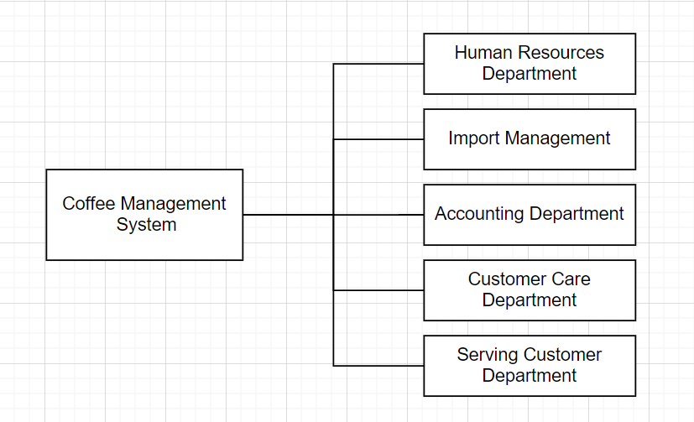

### **2.1.3 Business process**

* + - 1. Human Resources Department

***Picture 2.1.3.1 Human Resources Department***

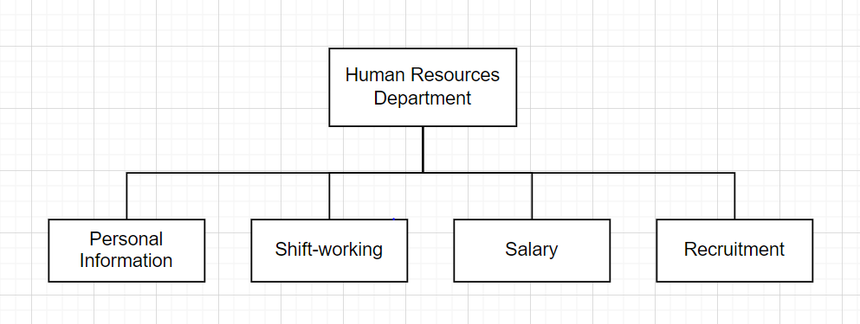

The Human Resources Department is to supervise and evaluate the working process of member staff in the coffee shop. This department includes of:

* Personal information of staff member
  + Import employee’s information into the system database.
  + Update / Delete / Add employee’s regular data, information in the system.
  + Stored hours, day, shift-working, extra-hours to export salary
* Shift-working
  + Arrange individual working schedules of employees.
* Salary
  + Negotiate suitable salary for employee based on the position.
* Recruitment
  + Recruit and select new employees into the coffee shop.
    - 1. Accounting Department

***Picture 2.1.3.2.1 Accounting Department***

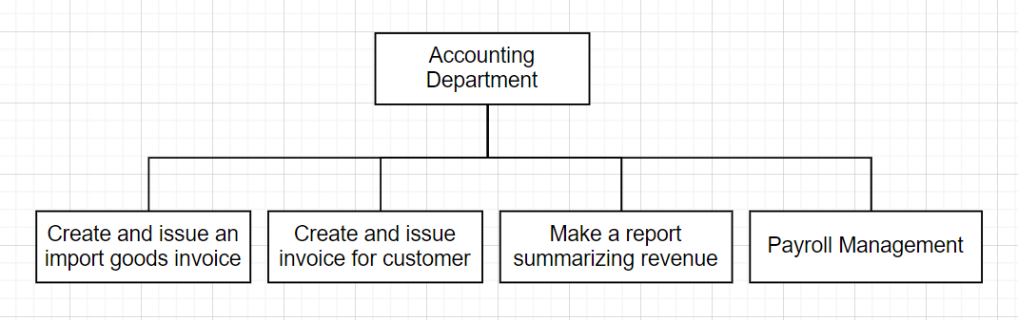

Accounting department refers to the division that receive and handle all things that linked to finance, responsible for managing the overall economic of the business which includes of:

* Create and issue an import goods invoice
  + Create the invoice when goods is imported into the warehouse,

which consists of basic information like price, quantity, name of goods,..

* + Export the invoice of imported goods and store into the system database
* Create and issue invoice for customer
  + Create the invoice when a customer orders drinking, which consists of basic information such as employee’s id, total money, name of drinking,...
  + Export the invoice for customer and store into the system database
* Make the report summarizing revenue
  + Manage and prepare financial statements, payment off bills, customer bills, payroll.
* Payroll management
  + Calculate employee’s salary, bonus, benefit accurately before making the payment to individuals.
    - 1. Customer Care Department

***2.1.3.3.1 Customer Care Department***

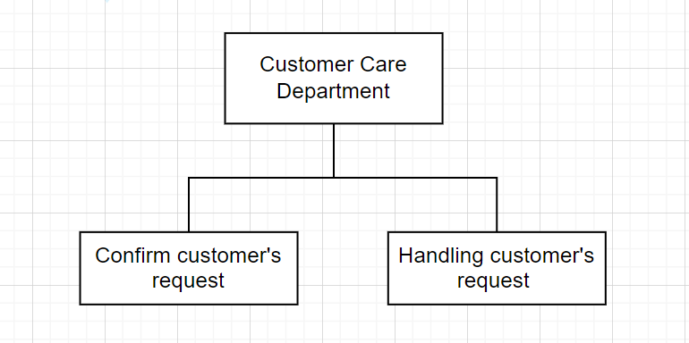

Customer Care Department is a department has a mission to advise, help, answer all the customer’s question in order to satisfy and meet the needs of customer as well as achieve the business's goals, this department consists of:

* Confirm customer’s request
  + Customer care department will receive customer’s request in different ways through social media such as facebook, fanpage,..
* Handling customer’s request
  + After receiving a customer's request, the Customer Care Department will reply and guide the customer to solve the problem.
* Moreover, the Customer Care Department usually asks the customer about the satisfaction as well as experience about the service, space, hygiene, safety and quality of the drinking.
  + - 1. Import Management

***Picture 2.1.3.4.1 Import Management Department***

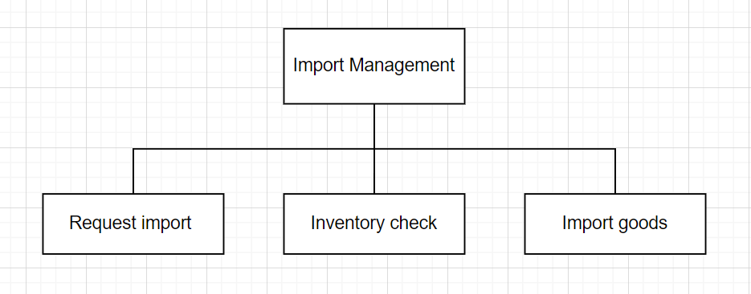

Import Management is a department that is responsible for import goods into the warehouse, which consists of:

* Request import
  + Import management checks goods in the warehouse. This department will send requests to the supplier to import new goods.
* Inventory check
  + Import management checks if goods are filled, still remains or not.
* Import goods
  + Import goods into the warehouse and store the details into the system database.
    - 1. Serving Customer Department

Serving customer department is responsible for serving customers in the coffee shop, which consists of activities such as bringing drinks for customers, cleaning up the table, attracting more customers and introducing promotions to customers.

## **Software requirements**

### 2.2.1 Functional requirements

The system must satisfy:

* Saving requirements:

+ Saving employee’s information: employee’s ID, employee’s name, position, telephone number, sexual, working-starting date, working-finishing date, status of working.

+ Saving customer’s information: customer’s ID, customer’s name, telephone number, accumulated points.

+ Saving goods’ information: goods’ ID, goods’ name, price, quantity.

+ Saving drinking’s information: drinking’s ID, drinking’s name, price.

+ Saving bills/transaction’s information.

* Searching requirements:

+ Searching employee’s information

+ Searching drinking’s information

+ Searching goods’ information

+ Searching customer’s information

+ Searching bills/transaction information

* Calculating requirements:

+ Calculating total of bills.

+ Calculating employee’s salary

+ Calculating accumulated points of customer

* Statistics requirements:

+ Showing the statistics of revenue

+ Showing the statistics of the number of drinks.

+ Showing the statistics of customers.

* Beside those functions, the system must satisfy:

+ Query function: the system must be able to meet questions and answers demanded from users.

+ Synthesizing and reporting functions: allow staff to track and supervise the operation of the coffee shop.

+ Updating function: the system must be able to self update accurate, timely data and minimize human interventions and mistakes.

+ Automatic functions: this maximize the convenience of users with manual activities

### Non-functional requirements

* Interface: multilingual usage, user-friendly interface.
* Quality attributes
  + Evolutionary feature

+ Updating and upgrading versions are simple to conduct.

* + Exploitability:

+ The interface is engaging and user-friendly.

+ The instruction and description are intelligible.

* + Efficiency:

+ The application works well, stable and reliable.

* + Compatibility:

+ The system performs stably on different platforms and devices.

***Table 2.2 Software requirements***

|  |  |  |  |  |  |
| --- | --- | --- | --- | --- | --- |
| **No.** | **Requirements name** | **Computer Skills** | **Time to get used to** | **Time to process** | **Meaning** |
| 1 | Managing drinking in the menu | A | 1 minute | 10s | Add, search, update, delete drinks in the menu |
| 2 | Managing invoice in the system database | A | 1 minute | 10s | Add, search, update, delete invoice in the system database |
| 3 | Managing customer in the system database | A | 1 minute | 10s | Add, search, update customers’ information in the system database |
| 4 | Managing goods in the system database | A | 1 minute | 10s | Add, search, update, delete goods’ information in the system database |
| 5 | Managing shipment and import goods in the system database | A | 1 minute | 10s | Add, search shipment in the system database |
| 6 | Managing employee in the database | A | 1 minute | 10s | Add, search, update, delete customers’ information in the system database |
| 7 | Managing order process | A | 1 minute | 10s | Make payment and process order in the system database |
| 8 | Calculating the total of bill | A | 1 minute | 12s | Calculate the total of bills |
| 9 | Calculating employees’ salary | A | 1 minute | 12s | Calculate employees’ salary |
| 10 | Calculating accumulated points of customer | A | 1 minute | 12s | Calculating accumulated points of customer |
| 11 | Showing the statistics of revenue | A | 1 minute | 14s | Show the statistics of revenue |
| 12 | Showing the statistics of customer | A | 1 minute | 14s | Show the statistics of customer |
| 13 | Showing the statistics of number of drinkings | A | 1 minute | 14s | Show the statistics of number of drinkings |

# **CHAPTER 3: ANALYSIS AND DESIGN**

## **3.1 Use-case Diagram**

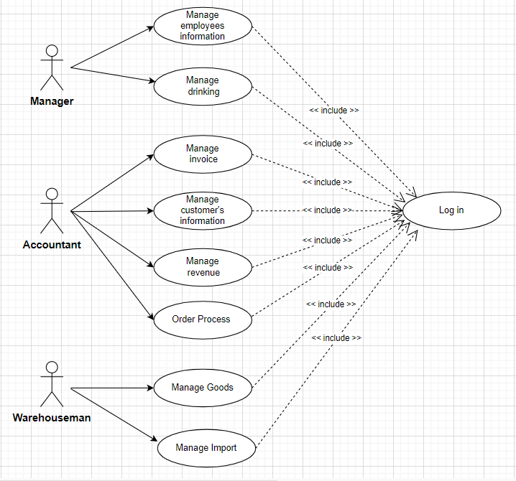

***Picture 3.1.1 Use-case Diagram of the system***

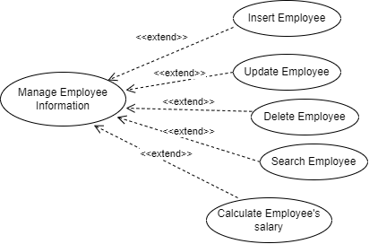

***Picture 3.1.2 Use-case Diagram of Manage Employee Information***

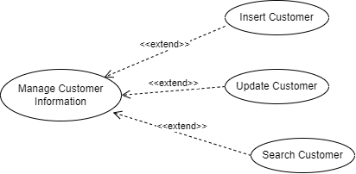

***Picture 3.1.3 Use-case Diagram of Manage Customer Information***

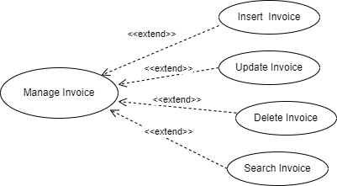

***Picture 3.1.4 Use-case Diagram of Manage Invoice***

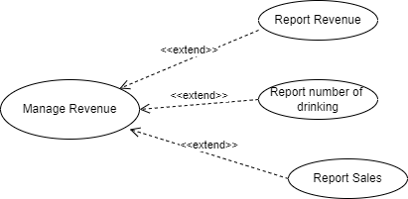

***Picture 3.1.5 Use-case Diagram of Manage Revenue***

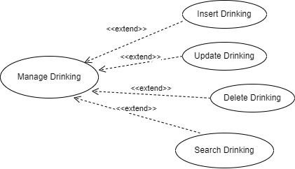

***Picture 3.1.6 Use-case Diagram of Manage Drinking***

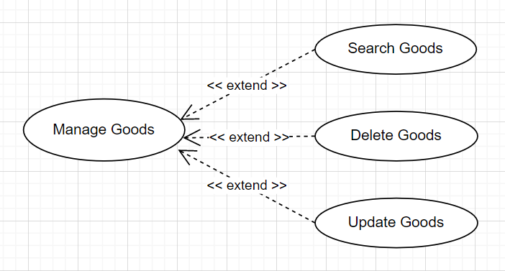

***Picture 3.1.7 Use-case Diagram of Manage Goods***

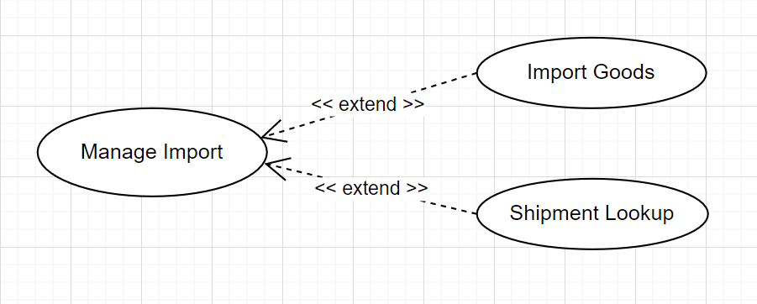

***Picture 3.1.7 Use-case Diagram of Manage Import***

## **3.2 List of actors**

|  |  |  |
| --- | --- | --- |
| **No** | **Actor** | **Meaning** |
| 1 | Manager | People can use all functions in the system. |
| 2 | Accountant | People do activities related to make payment, customers’ information |
| 3 | Warehouseman | People do activities related to managing warehouses. |

***Table 3.2 List of actors of the system***

## **3.3 List of use cases**

|  |  |  |
| --- | --- | --- |
| **No** | **Use Case** | **Meaning** |
| 1 | Login | Allow user to login the system |
| 2 | Managing goods | Warehouseman uses functions to update/delete/search to manage goods |
| 3 | Managing invoices | Accountant uses functions insert/update/delete/search to manage invoices |
| 4 | Managing revenue | Accountant uses functions to manage revenue |
| 5 | Managing employees’ information | Manager uses functions to insert/update/delete/search/show employees’ salary to manage employees |
| 6 | Managing customers’ information | Accountant uses functions to insert/update/delete/search to manage customers |
| 7 | Managing drinks | Manager use functions insert/update/delete/search to manage drinks |
| 8 | Managing import | Warehouseman uses functions to import goods and shipment lookup |
| 9 | Orderinging process | Accountant make order after customer paying |

## **3.4 Describe use cases and activity diagrams**

### **3.4.1 Use Case Login.**

* Use Case name: Login Account
* Describe: the user enters username (Employee ID) and password to access to the application
* Preconditions: the user has existing account (when manager creates an account,password will be created)
* Postconditions: change into the manager's menu frame, accountant's menu frame or warehouseman’s menu frame based on employee position
* Relationship: the user and the employee management system
* Events flow:

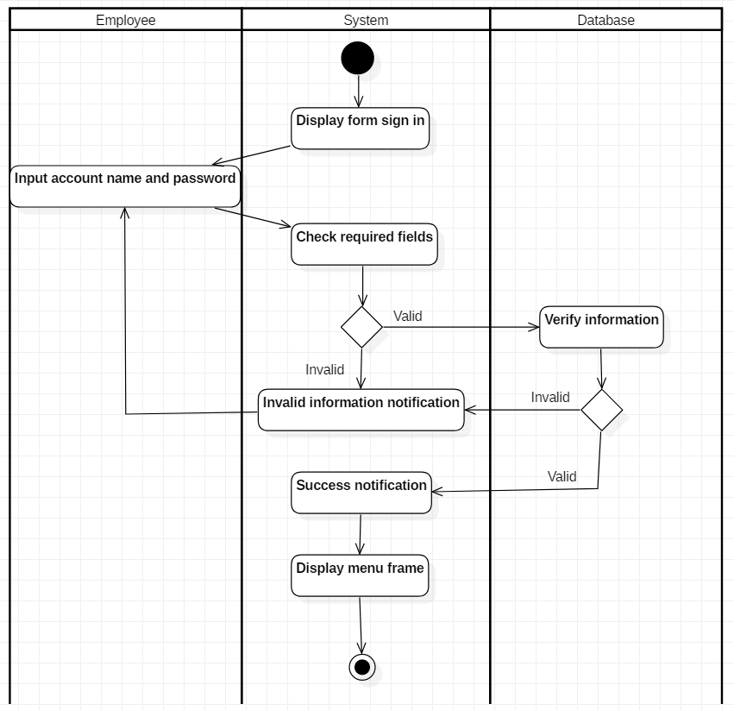

### **3.4.2 Use Case Invoices Management**

* Use Case name: Invoices Management
* Describe: After the customer picks a drink in the menu, the accountant makes a payment and prints out bill for the customer
* Preconditions: The accountant must access to the system successfully
* Postconditions: The bill’s information stored in database, display success notification and close frame
* Relationship: the accountant and orders
* Events flow:

3.4.2.1 Insert Invoice

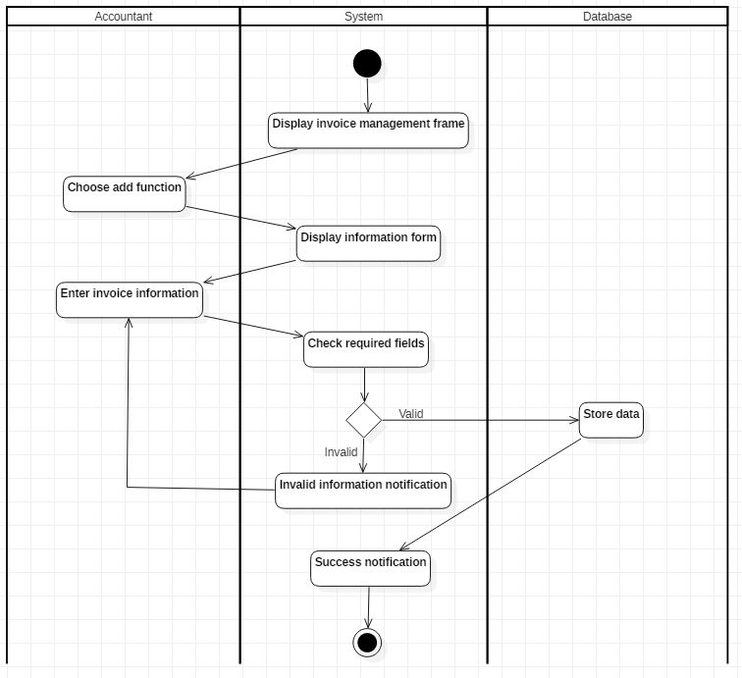

3.4.2.2 Edit Invoice

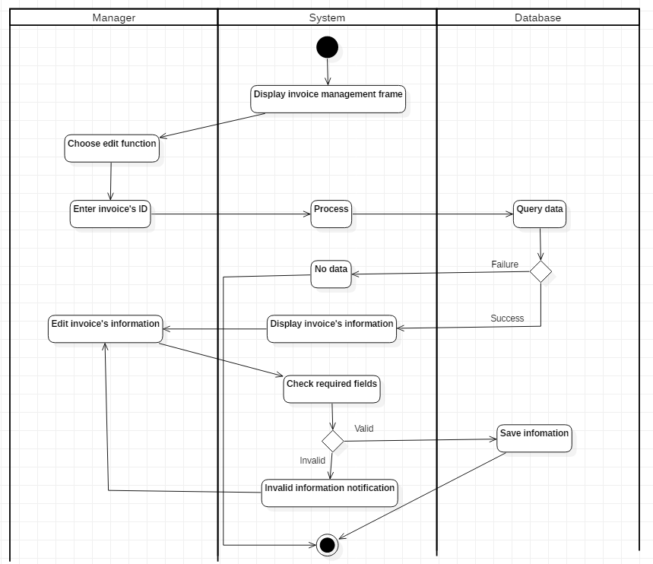

3.4.2.3 Delete Invoice

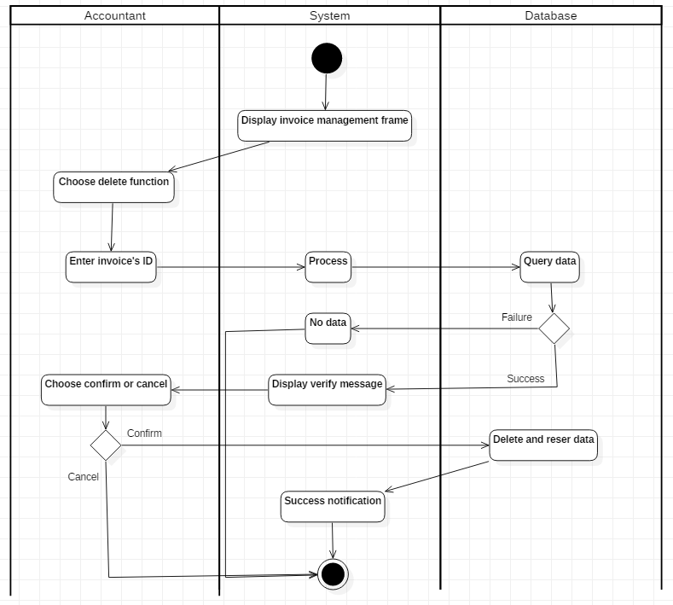

3.4.2.4 Search Invoice

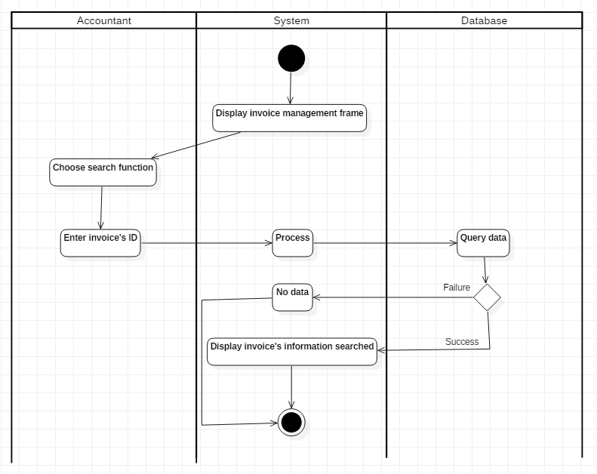

### **3.4.3 Revenues Management**

* Use Case name: Revenues Management
* Describe: The accountant can manage revenues of the coffee shop, show the revenues, sales, the number of drinks that sold in a month or a year
* Preconditions: The accountant must access to the system successfully
* Postconditions: display pdf, excel or chart based on user selection
* Relationship: the accountant and the invoice management system
* Events flow:

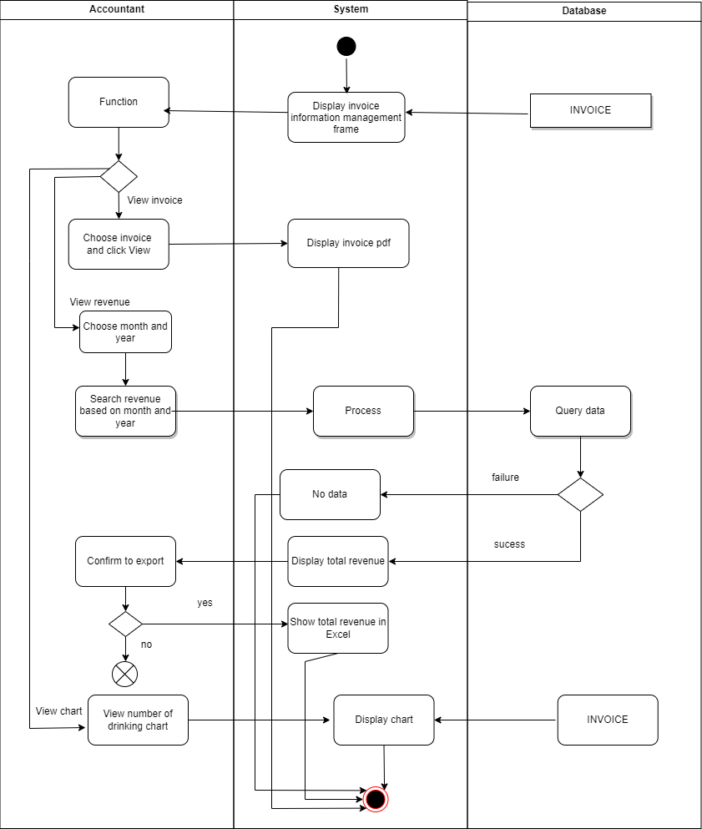

### **3.4.4 Employees Management**

* Use Case name: Employees Management
* Describe: The manager can insert, update, delete, search employees’ information or view employees’ salary by a month or a year.
* Preconditions: the manager must access the system successfully
* Postconditions: the data stored in database, display information searched, display employee’s salary
* Relationship: the manager and the employee management system
* Events flow:
  + - 1. Insert Employee

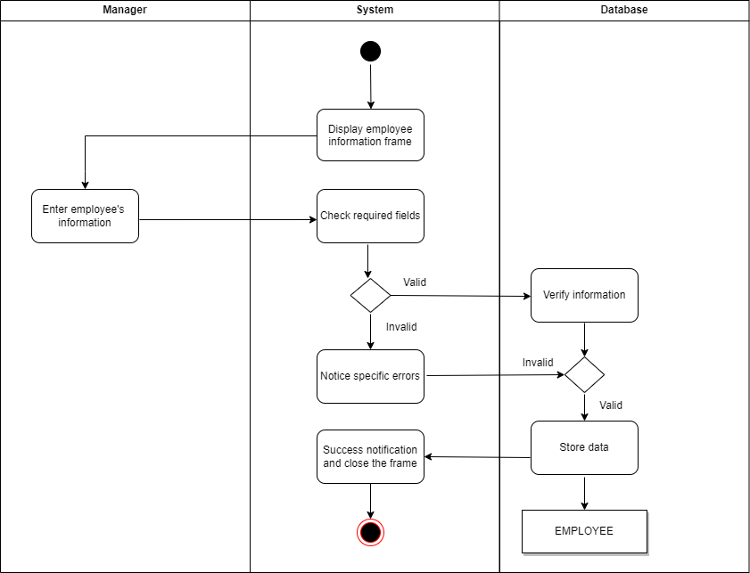

3.4.4.2 Edit Employee

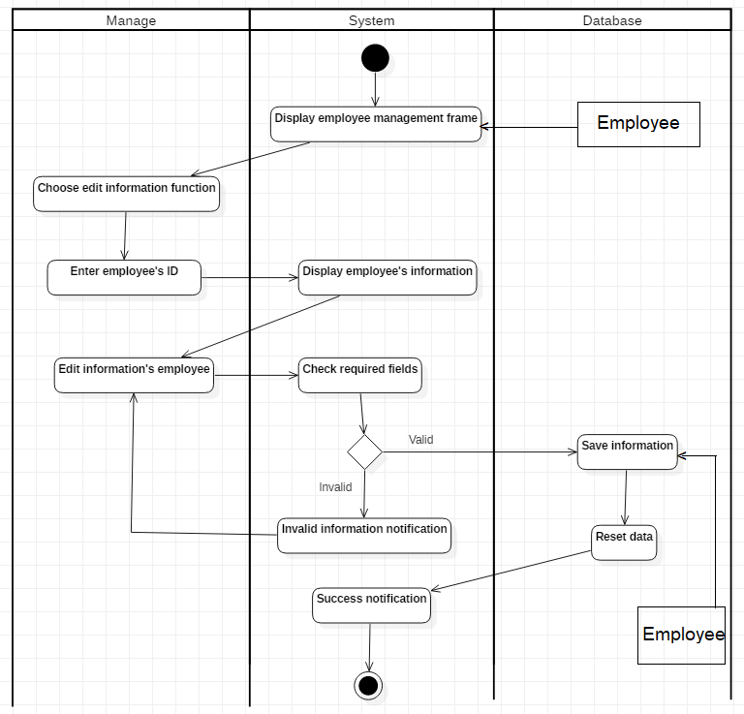

3.4.4.3 Delete Employee

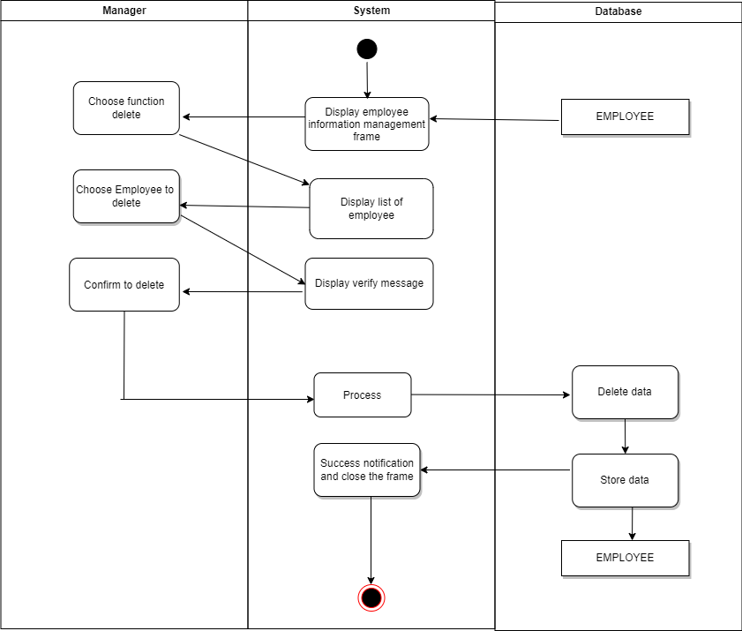

3.4.4.4 Search Employee

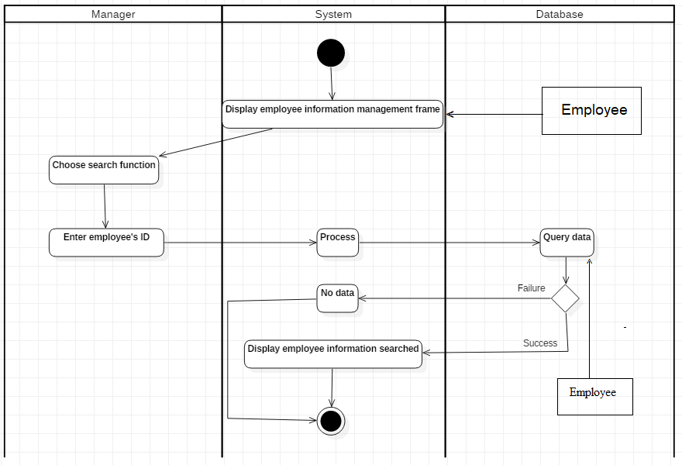

3.4.4.5 Employee’s salary report

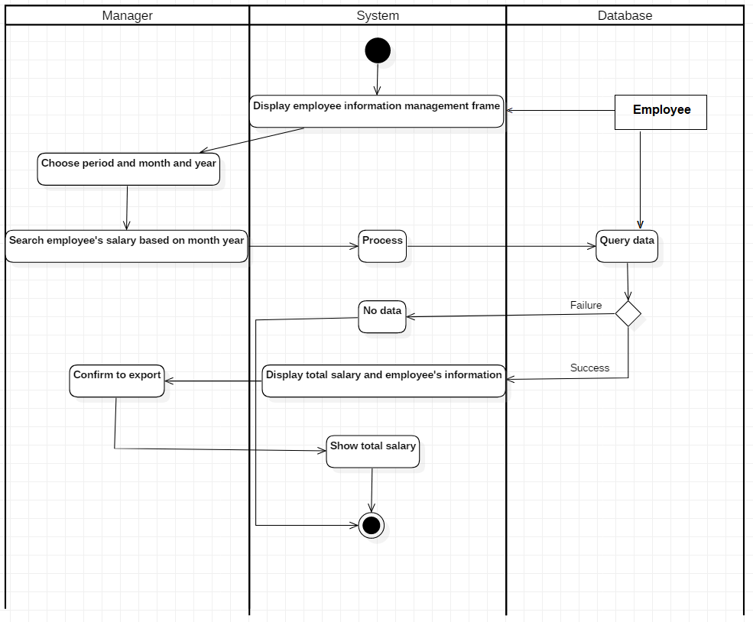

3.4.4.6 Delete Employee



### **3.4.5 Drinks Management**

* Use Case name: Drinks Management
* Describe: the manager can insert, update, delete, search drinks’ information
* Preconditions: the manager must access to the system successfully
* Postconditions: the data stored in the database, display information searched.
* Relationship: the manager and the drinks management system
* Events flow:
  + - 1. Insert Drinks

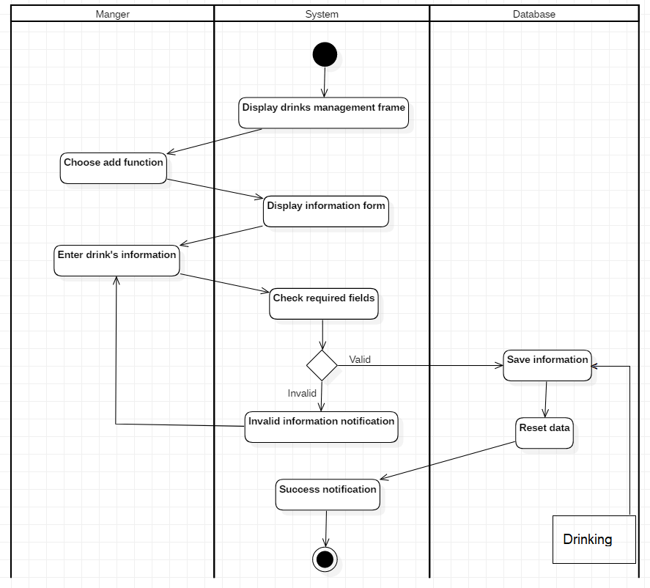

* + - 1. Edit Drinks

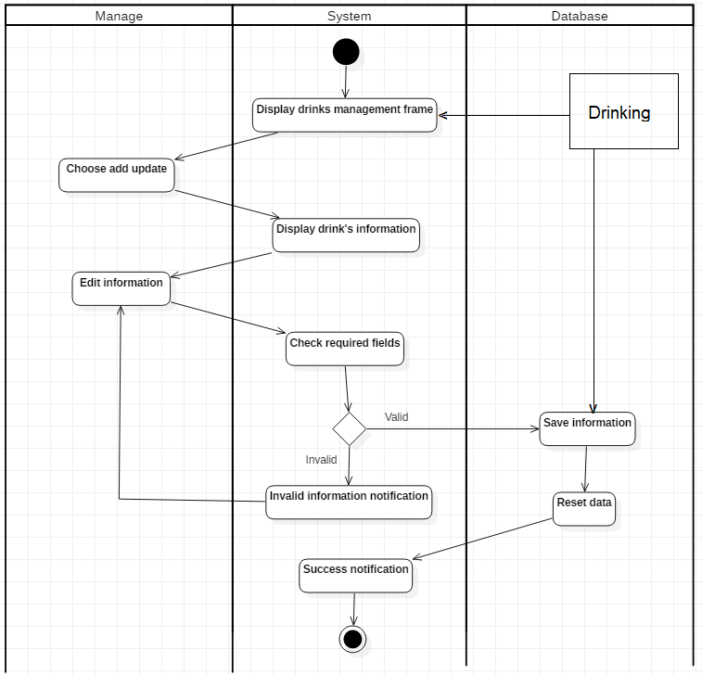

* + - 1. Delete Drinks

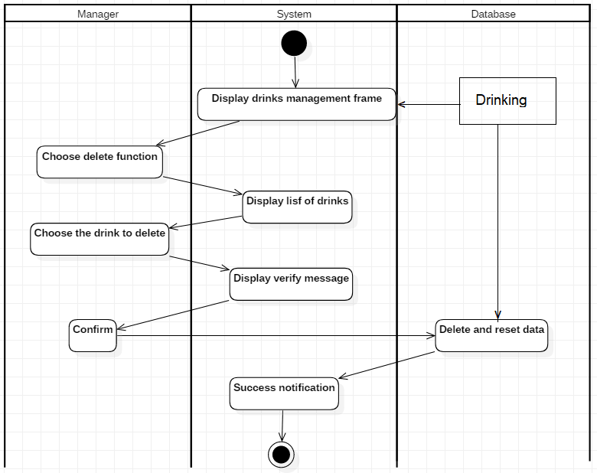

* + - 1. Search Drinks

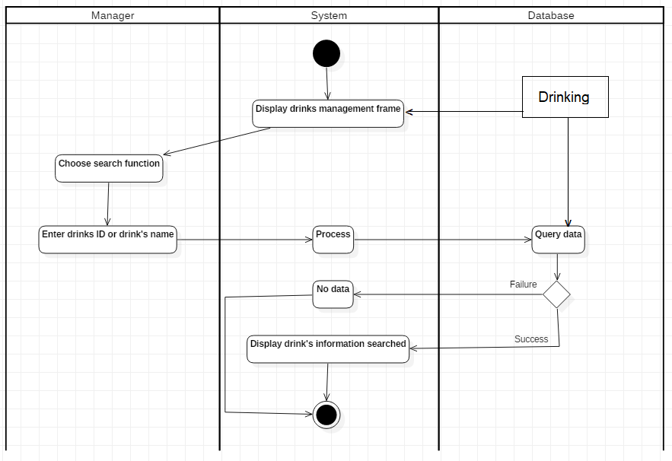

### **3.4.6 Customers Management**

* Use Case name: Customer management
* Describe: The accountant can insert, update and search customers’ information
* Preconditions: The accountant must access the system successfully
* Postconditions: The data stored in database, display information searched
* Relationship: The accountant and the customers’ information management system
* Events flow:

3.4.6.1 Insert Customer

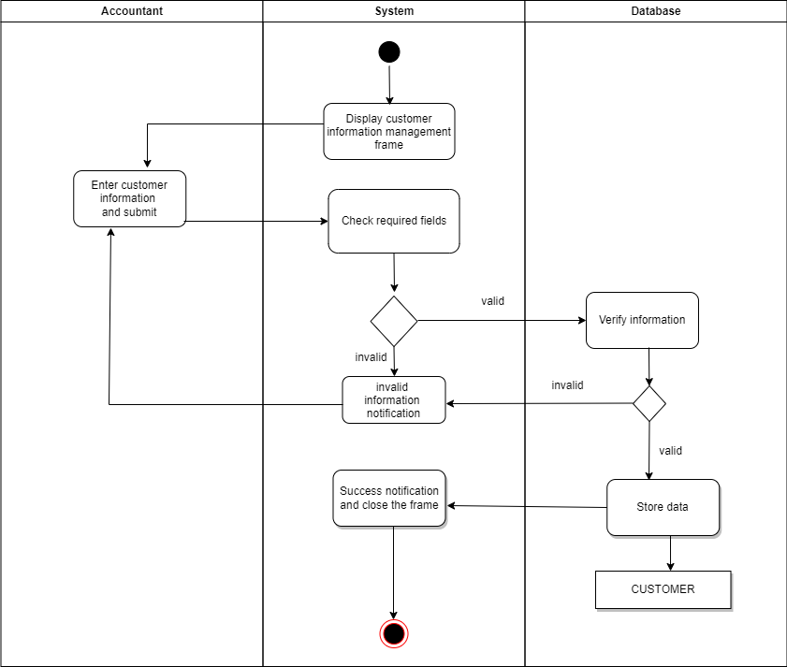

3.4.6.2 Update/Search Customer

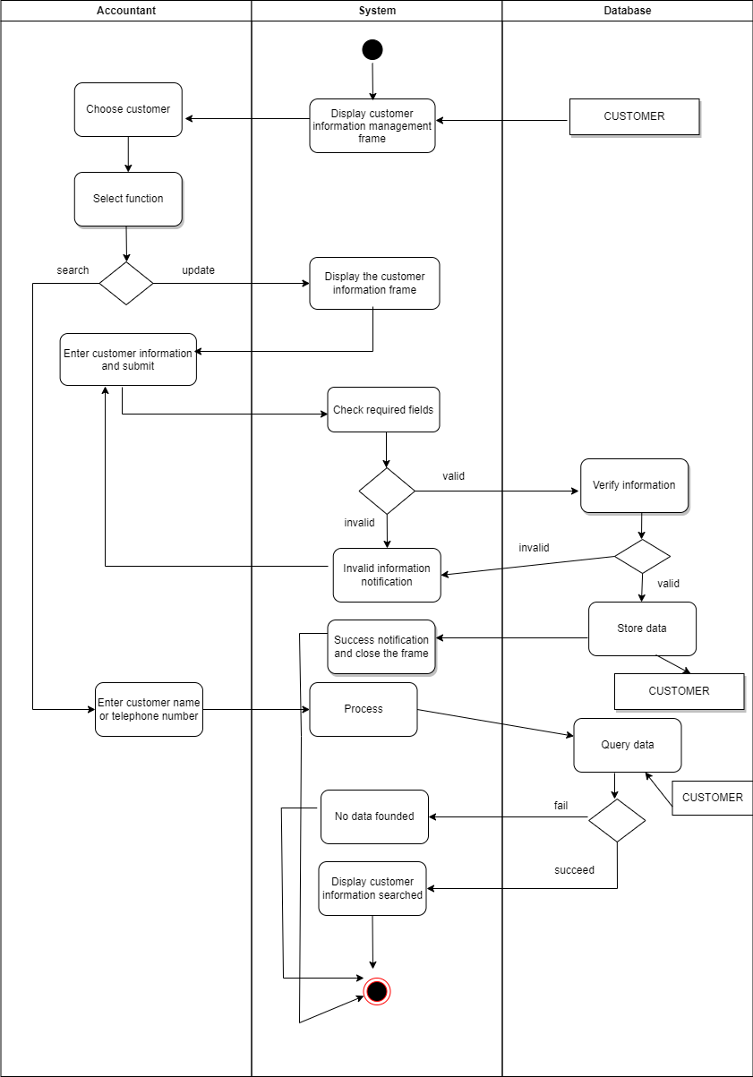

### **3.4.7 Goods Management**

* Use Case name: Goods management
* Describe: The warehouseman can update, delete and search goods’ information
* Preconditions: Th warehouseman must access the system successfully
* Postconditions: The data stored in database, display information searched
* Relationship: Th warehouseman and importing goods management system
* Events flow:

3.4.7.1 Search Goods

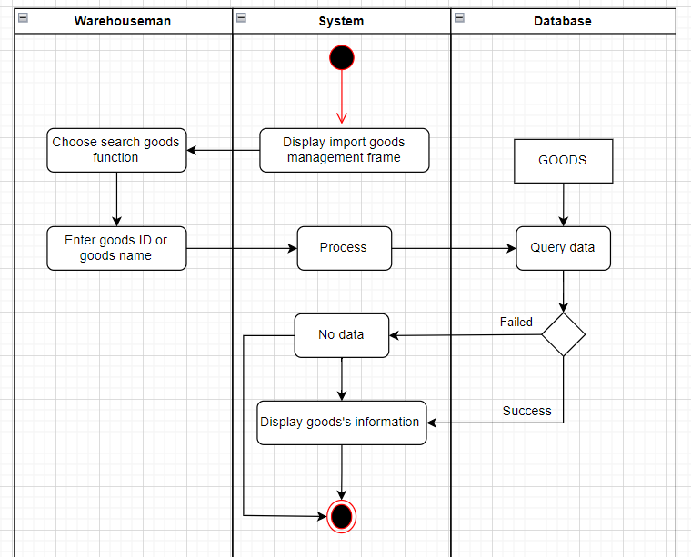

3.4.7.2 Edit Goods

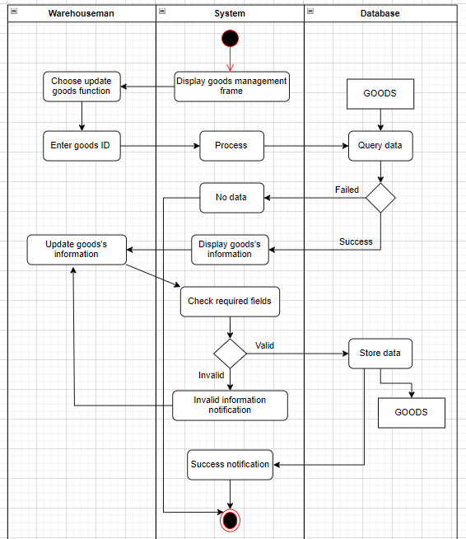

* + - 1. Delete Goods

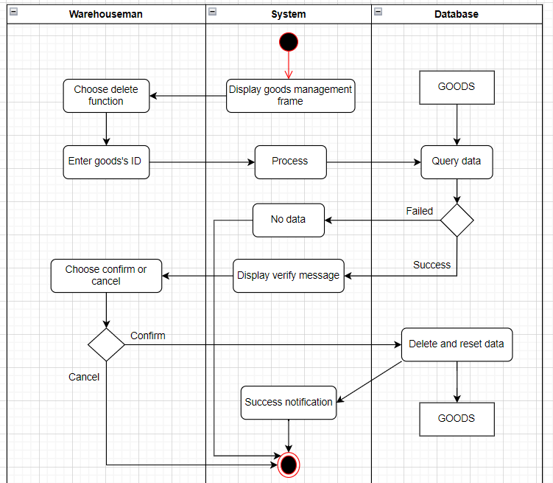

### **3.4.8 Import Management**

Importing Goods and Shipment Lookup

* Use Case name: Import management
* Describe: The warehouseman can import goods and shipment lookup
* Preconditions: Th warehouseman must access the system successfully
* Postconditions: The data stored in database, display information searched
* Relationship: The warehouseman and the import management system
* Events flow:

### 

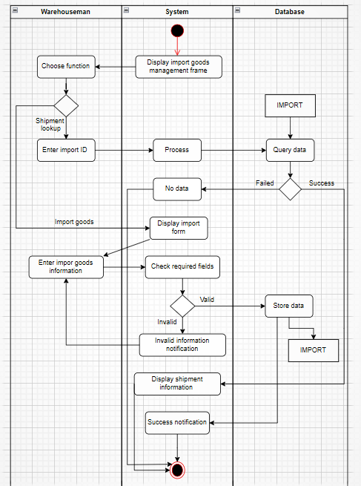

### **3.4.9 Order Process**

* Use Case name: Order process
* Describe: The accountant makes orders for customers after picking drinks, then discounts and calculates total money based on membership.
* Preconditions: The accountant must access the system successfully
* Postconditions: The data stored in database, display information of invoices
* Relationship: The invoice, the drink, the customer and the order management system
* Event flows:

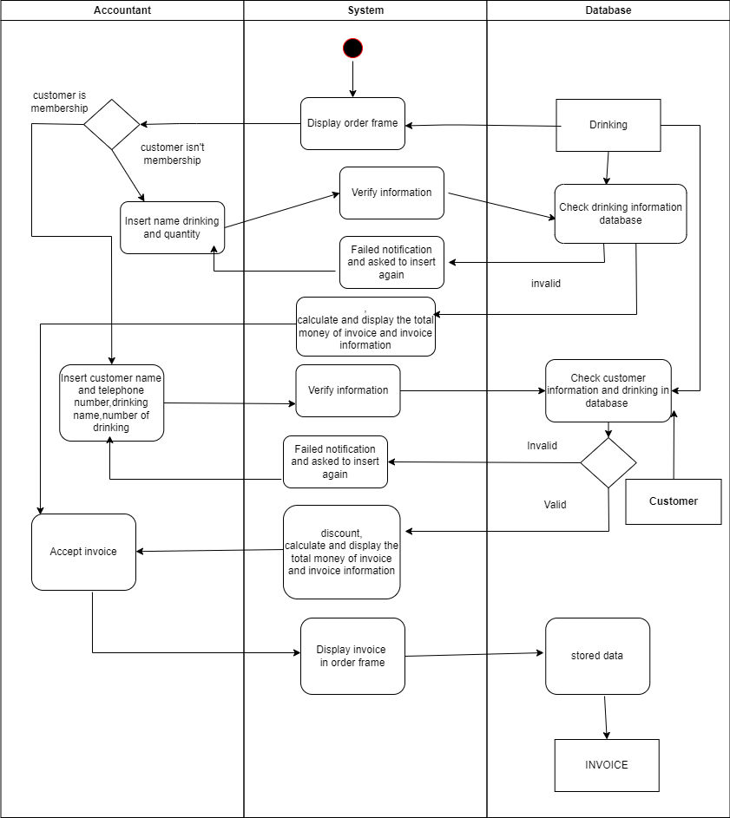

## **3.5. Sequence Diagram and Class Diagram**

### **3.5.1 Login**

* + Sequence Diagram

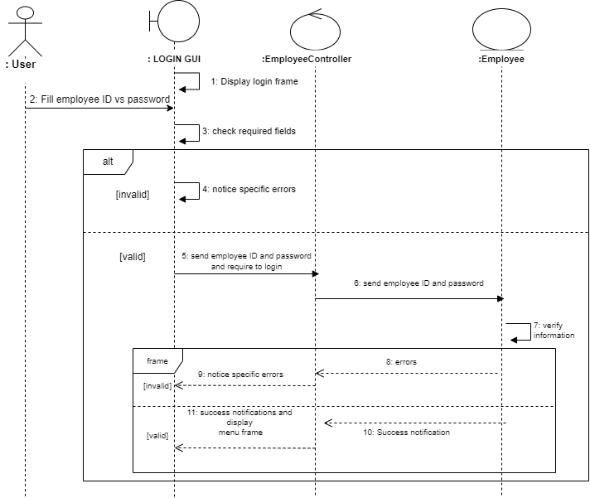

* + Class Diagram

`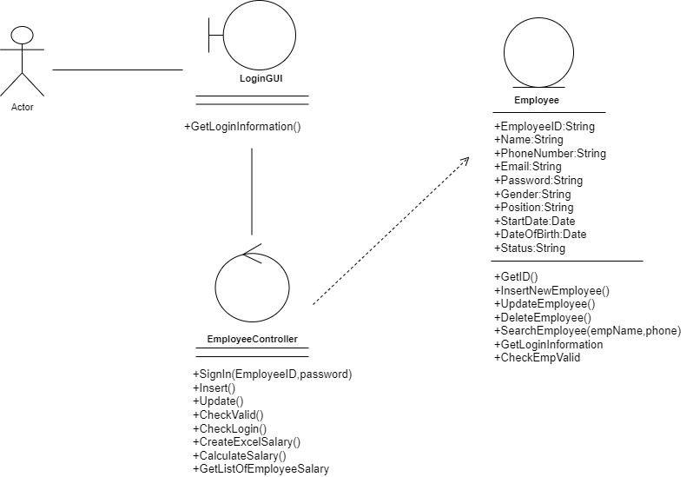

### **3.5.2 Revenues Management**

* + Sequence Diagram

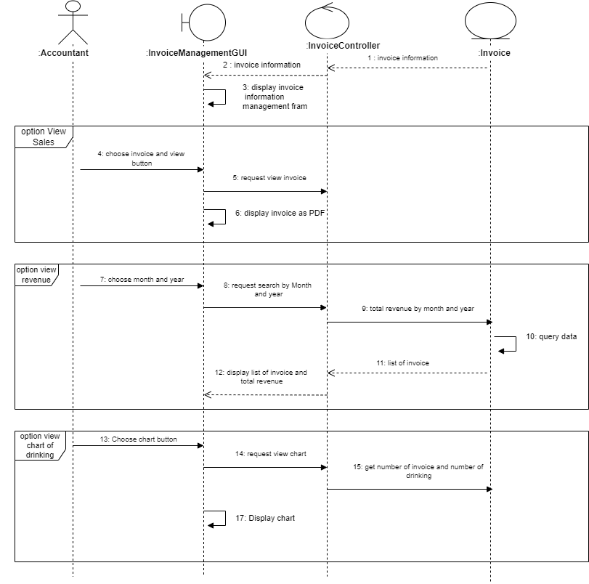

* + Class Diagram

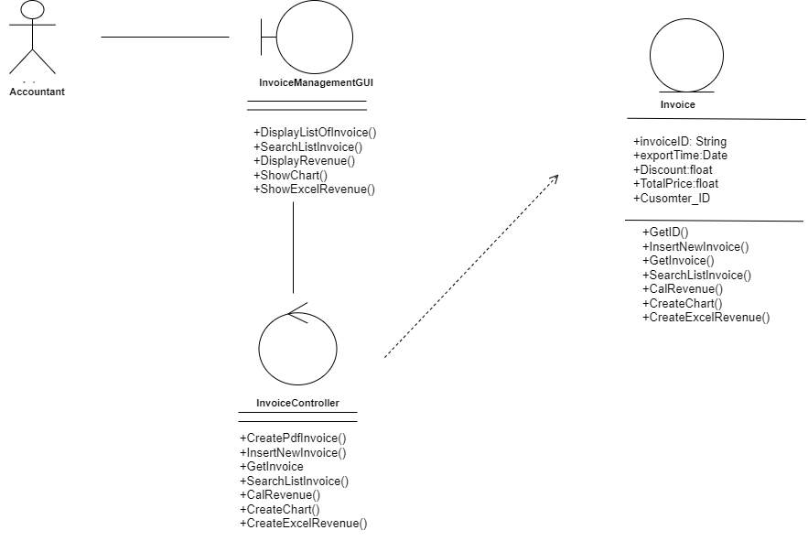

### **3.5.3 Employees Management**

3.5.3.1 Insert employees

* + - Sequence Diagram

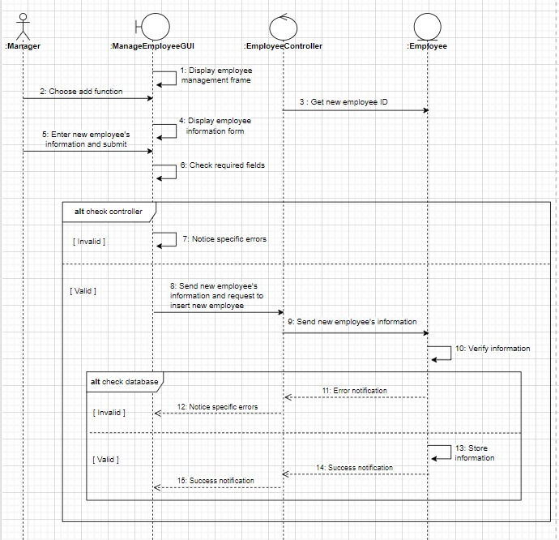

* + - Class Diagram

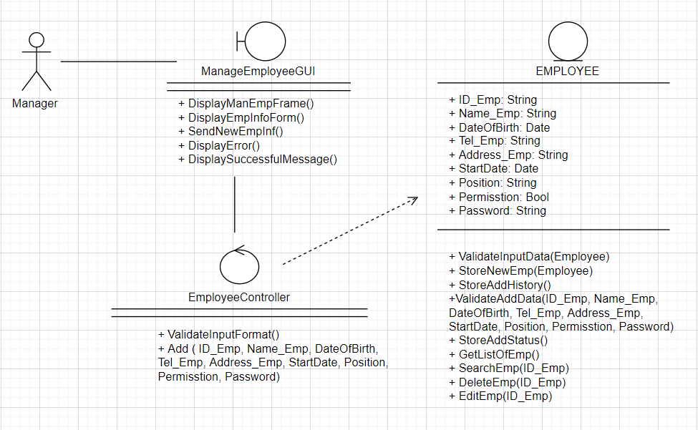

3.5.3.2 Delete Employee

* + Sequence Diagram

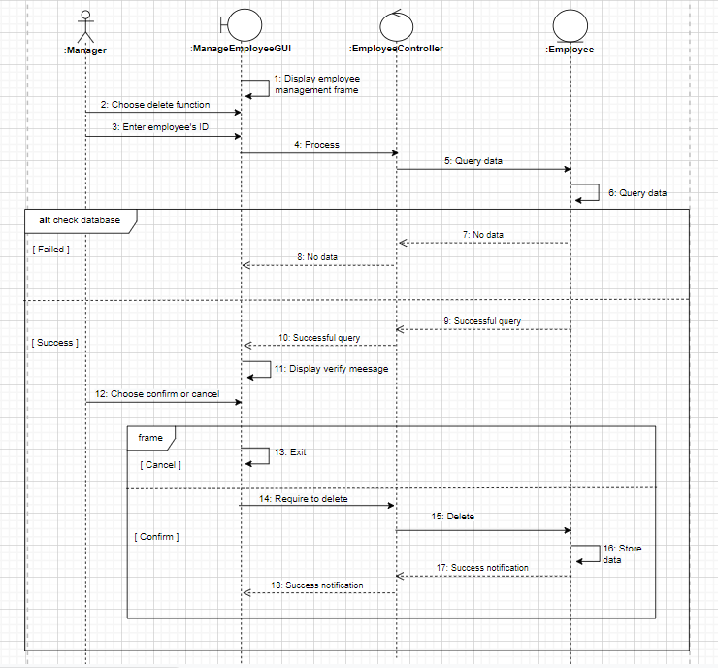

* + Class Diagram

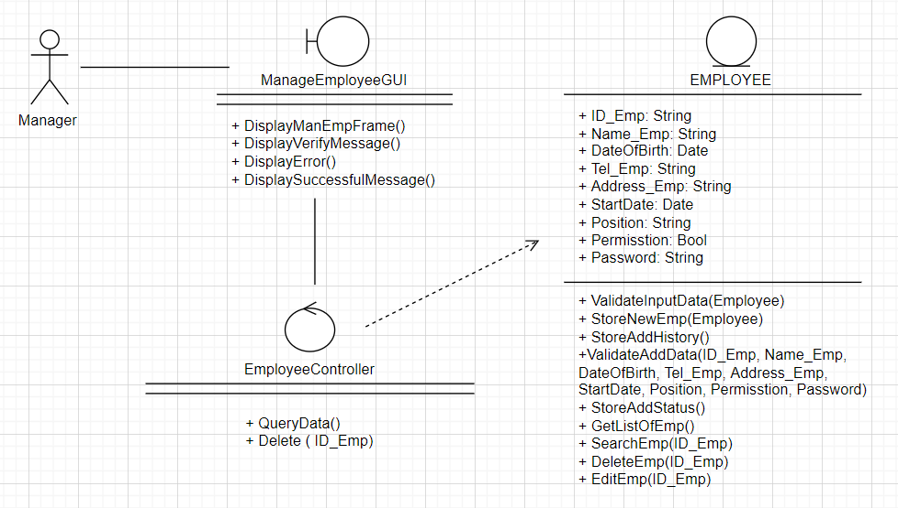

3.5.3.3 Edit Employee Information

* + Sequence Diagram

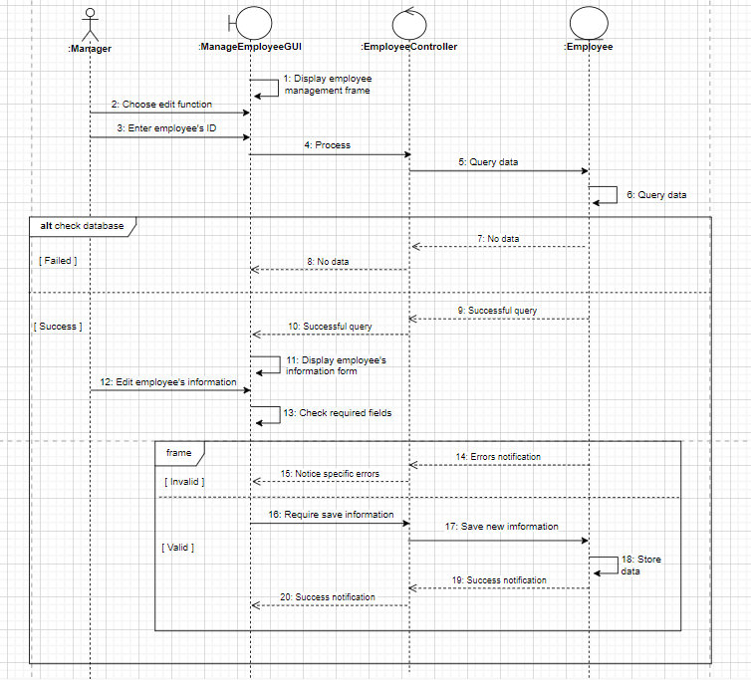

* + Class Diagram

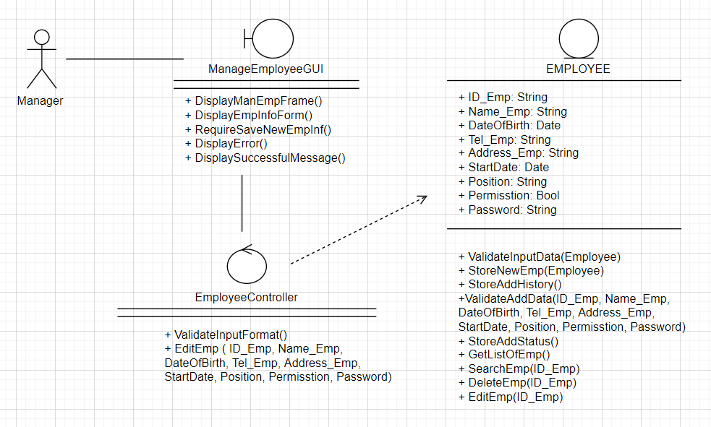

* + - 1. View employee’s salary
  + Sequence Diagram

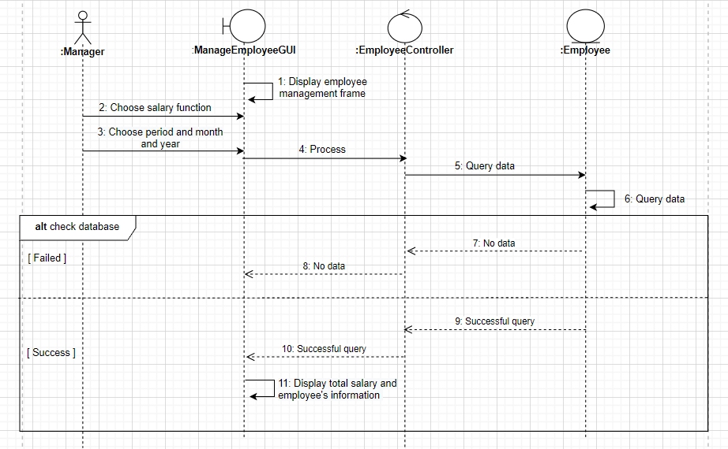

* + Class Diagram

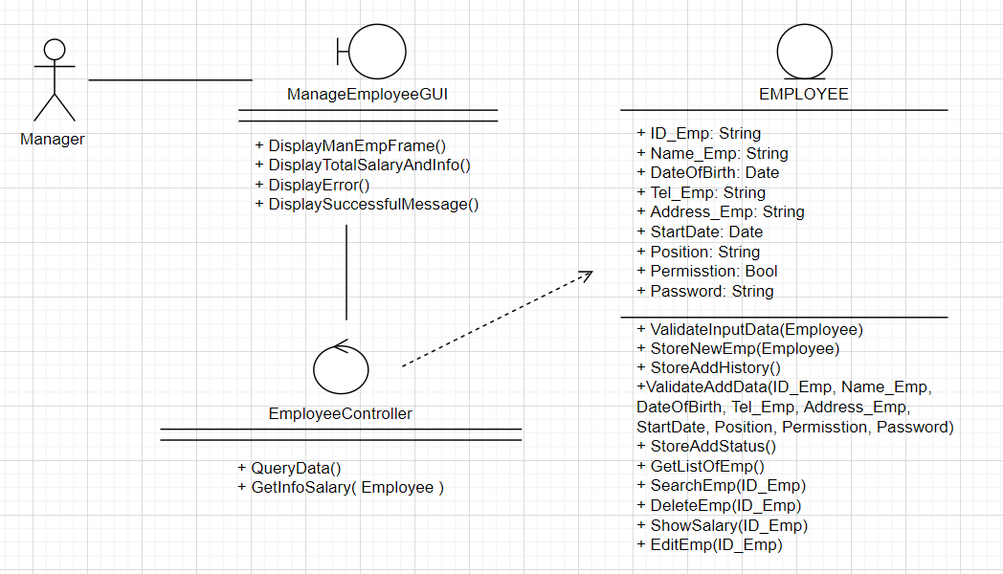

* + - 1. Search Employee
  + Sequence Diagram



* + Class Diagram

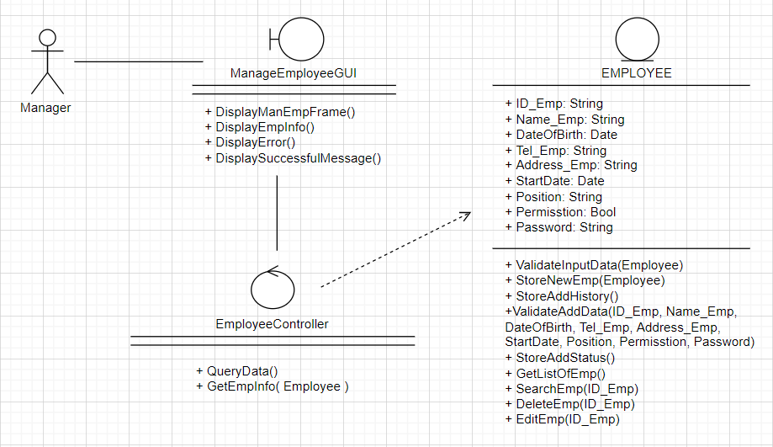

### **3.5.4 Goods Management**

3.5.4.1 Edit goods

* + Sequence Diagram

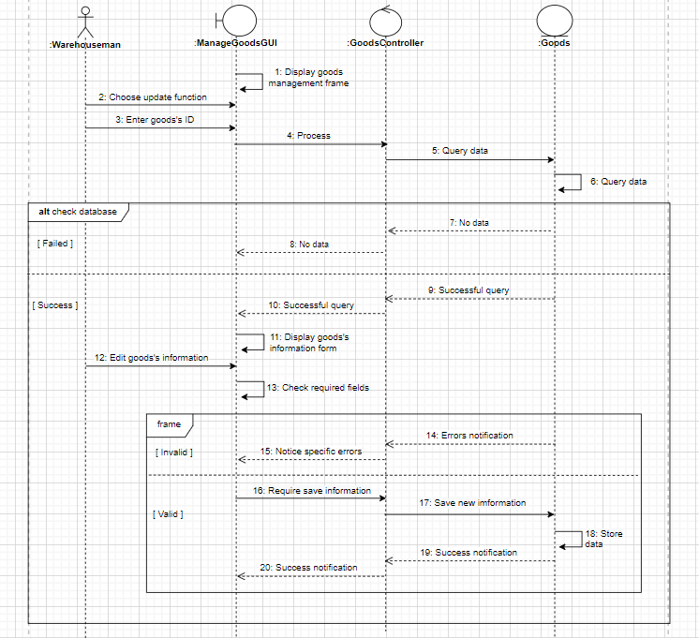

* + Class Diagram

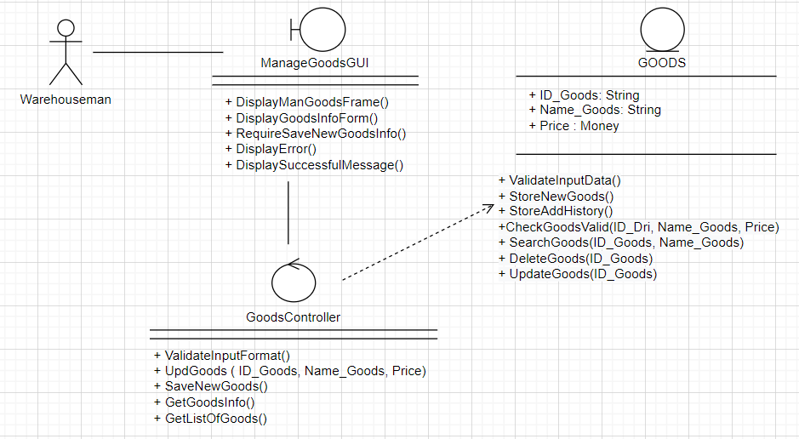

3.5.6.1 Search goods

* + Sequence Diagram

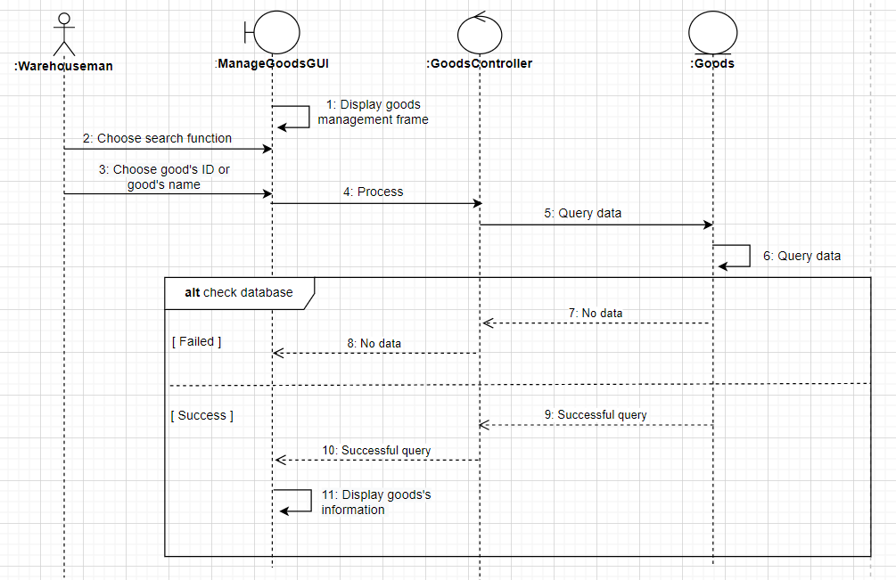

* + Class Diagram

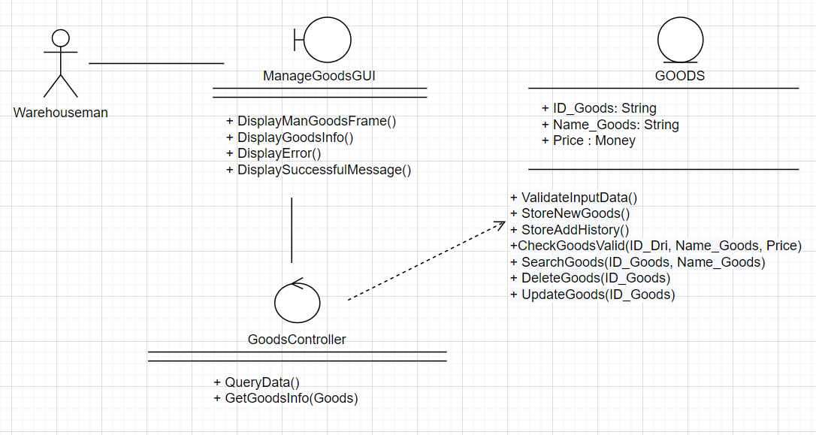

3.5.6.1 Delete goods

* + Sequence Diagram

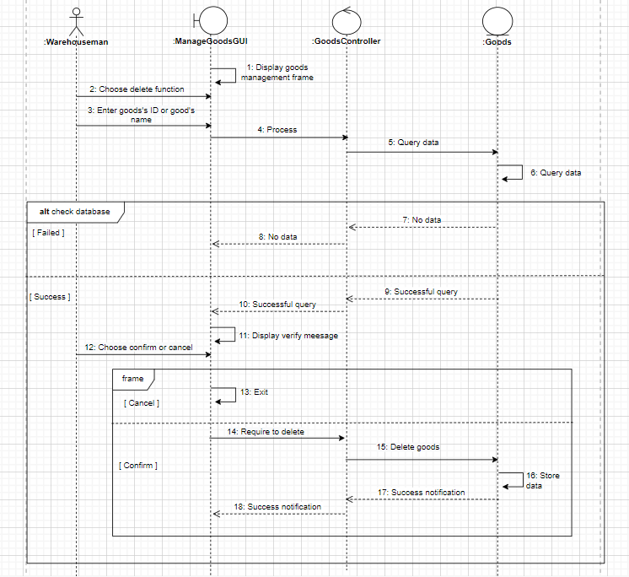

* + Class Diagram

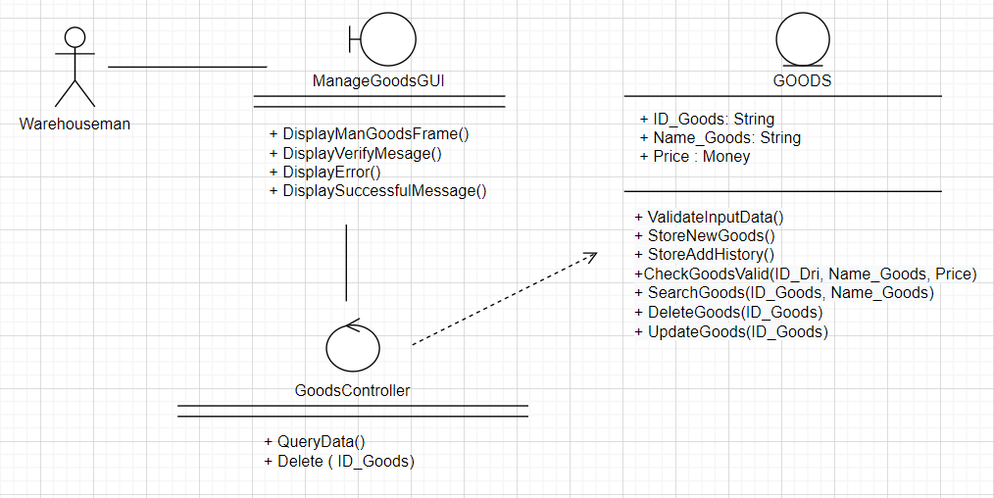

### **3.5.5 Import Management**

3.5.5.1 Import goods

* + Sequence Diagram

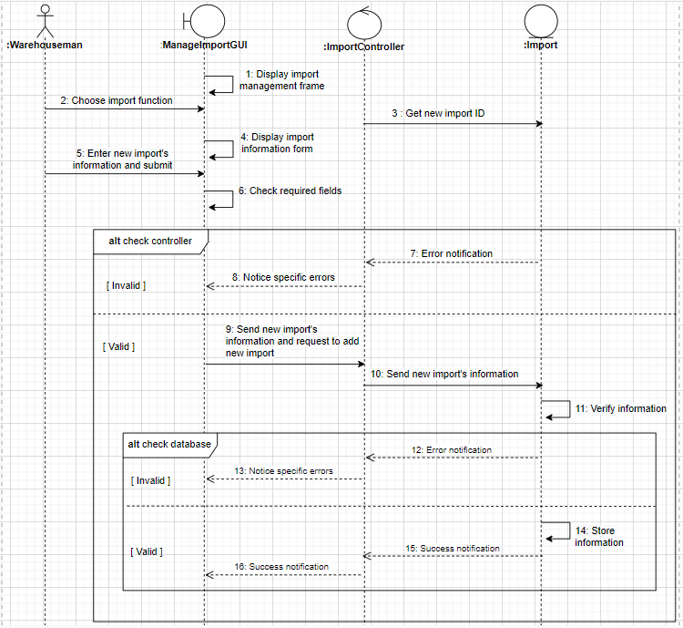

* + Class Diagram

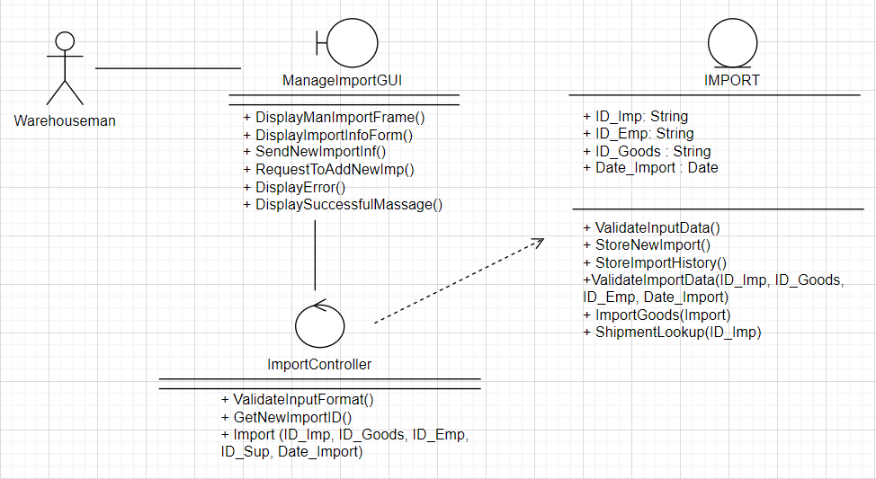

3.5.5.2 Shipment Lookup

* + Sequence Diagram

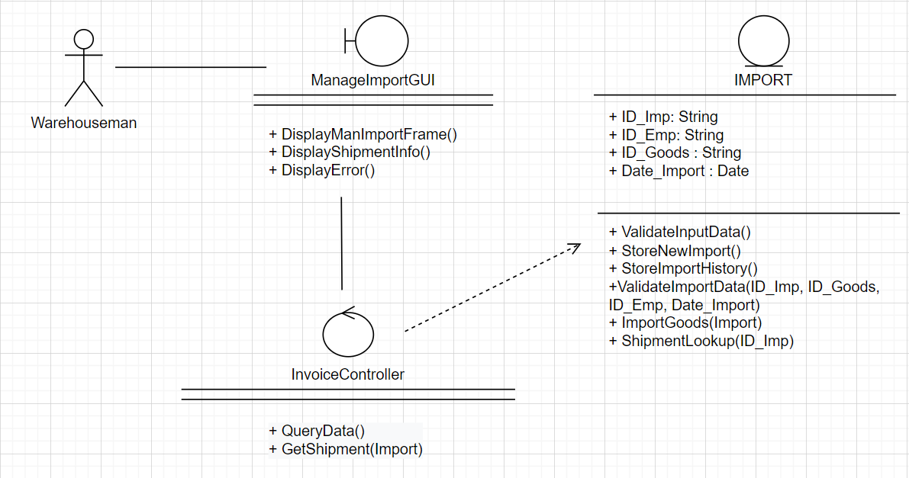

* + Class Diagram

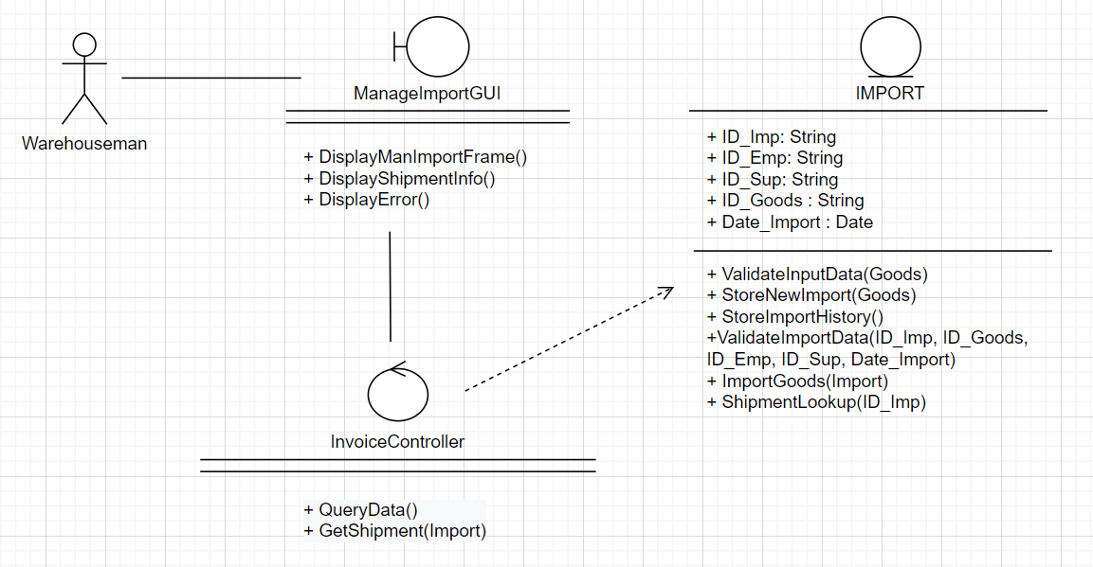

### **3.5.6 Drinks Management**

3.5.6.1 Insert drinks

* + Sequence Diagram

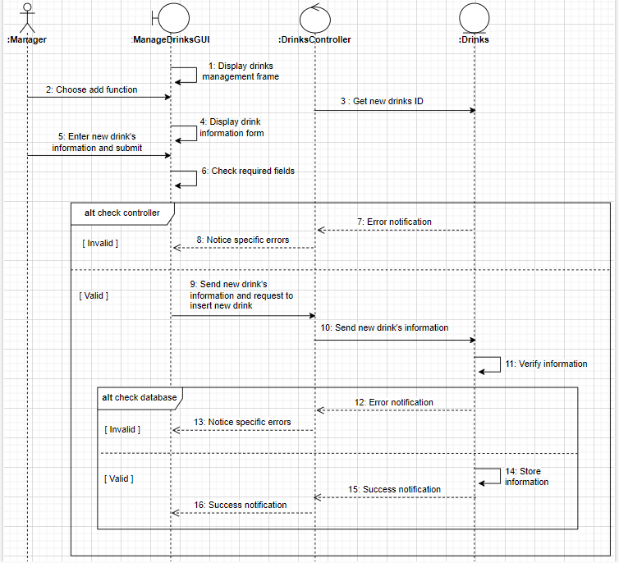

* + Class Diagram

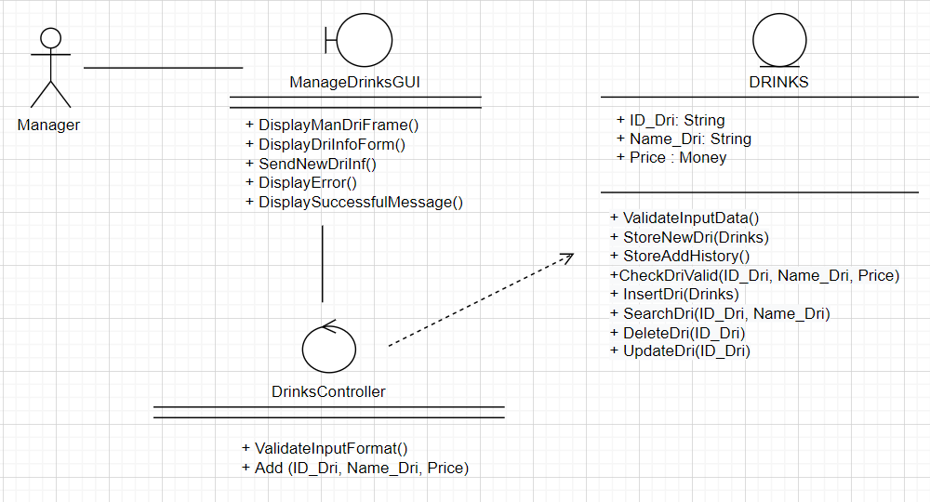

3.5.6.2 Update drinks

* + Sequence Diagram

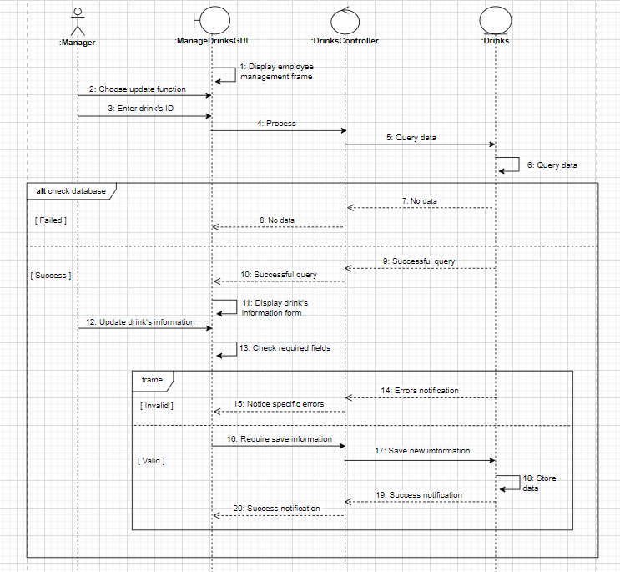

* + Class Diagram

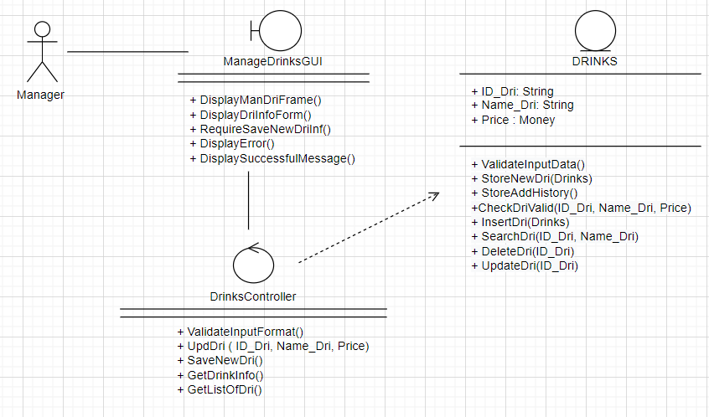

3.5.6.3 Delete drinks

* + Sequence Diagram

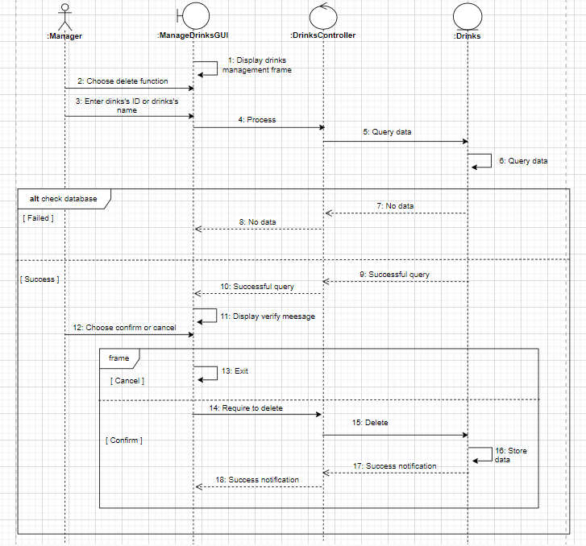

* + Class Diagram

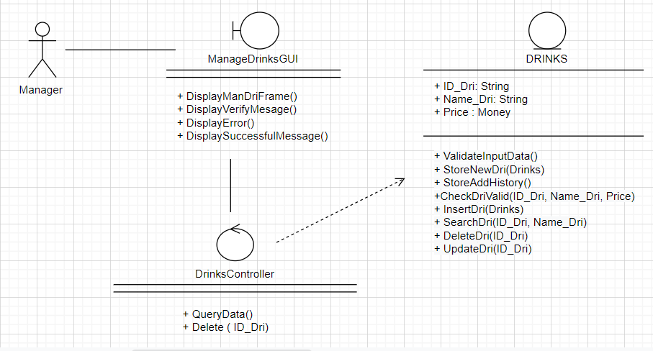

3.5.6.4. Search drinking

* + Sequence Diagram

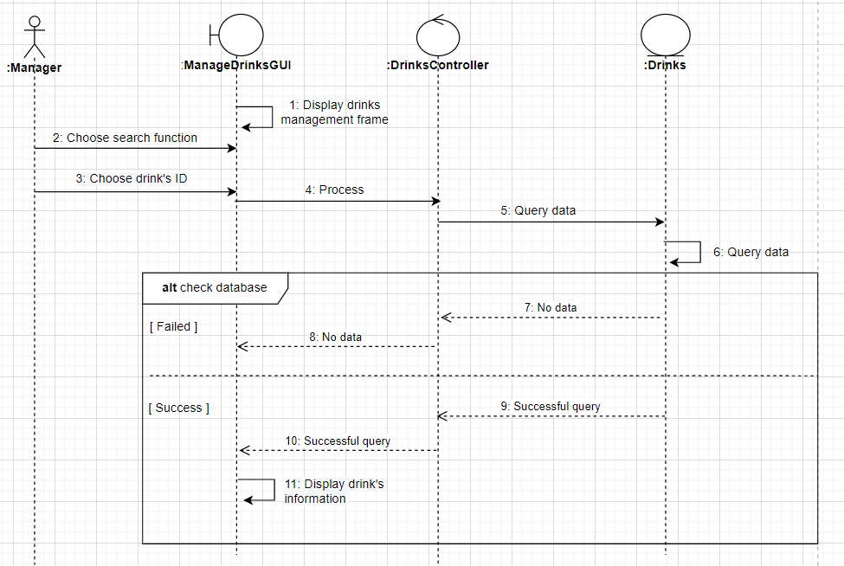

* + Class Diagram

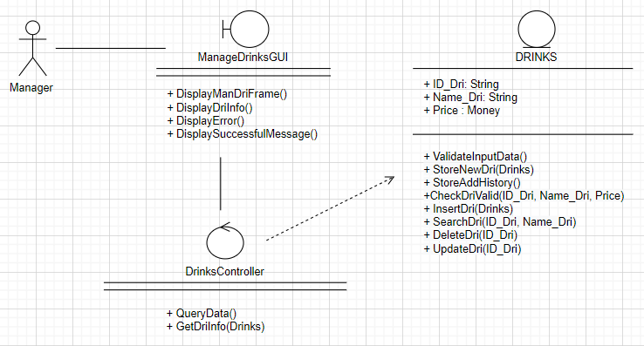

### **3.5.7 Invoices Management**

3.5.7.1 Insert Invoices

* + Sequence Diagram

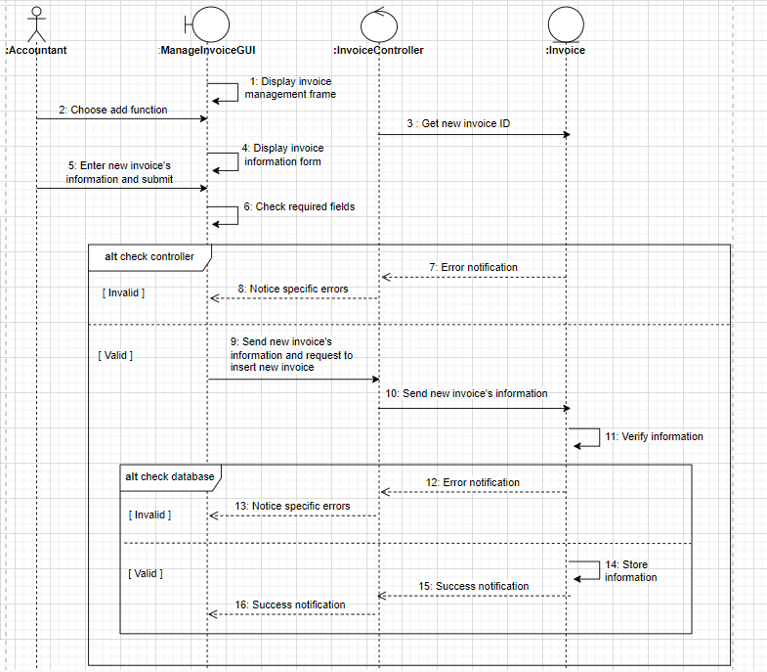

* + Class Diagram

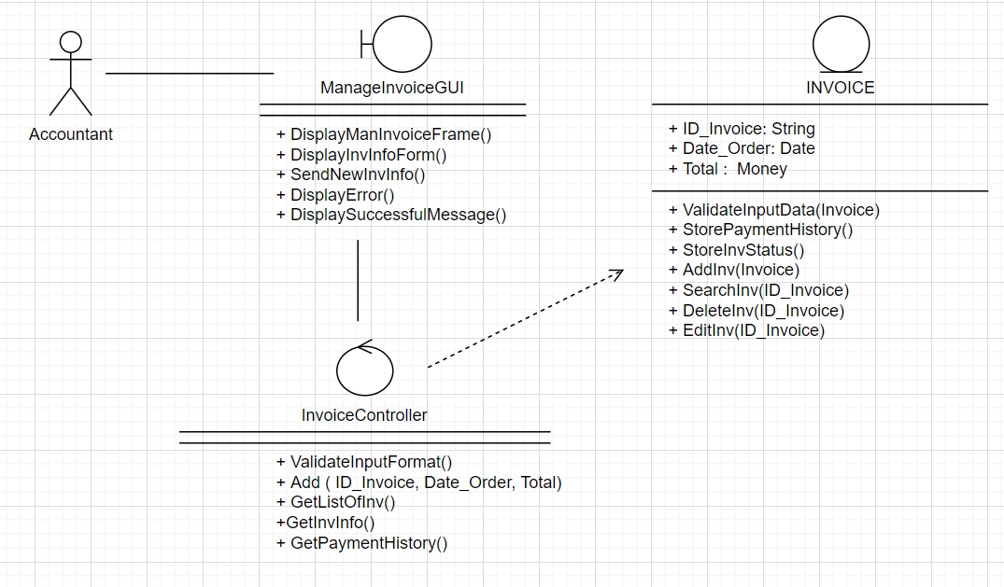

3.5.7.2 Delete Invoices

* + Sequence Diagram

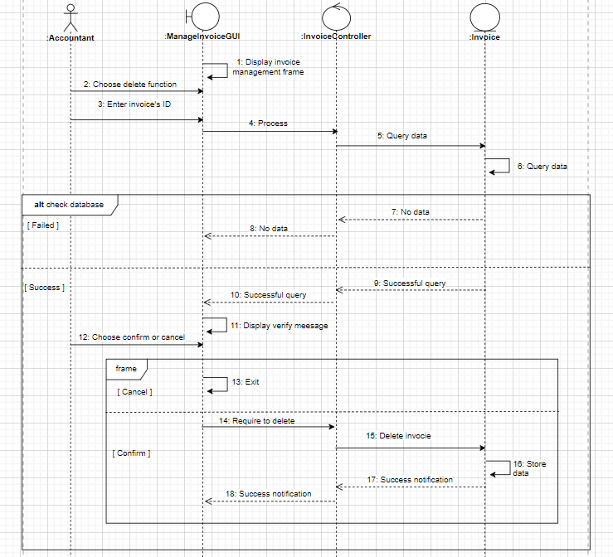

* + Class Diagram

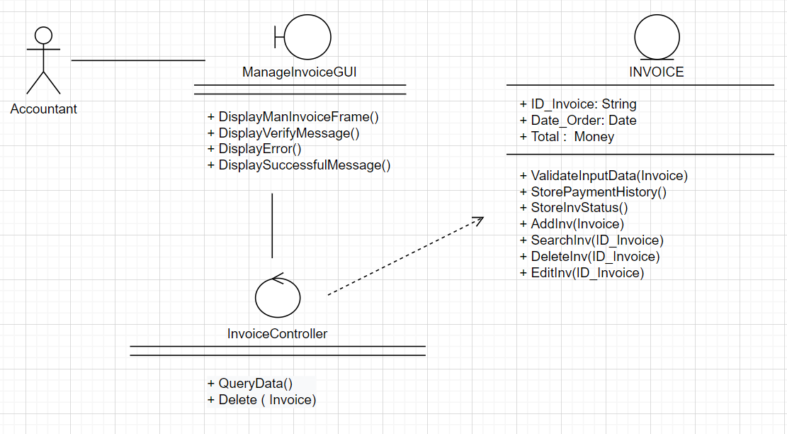

3.5.7.3 Edit Invoices

* + Sequence Diagram

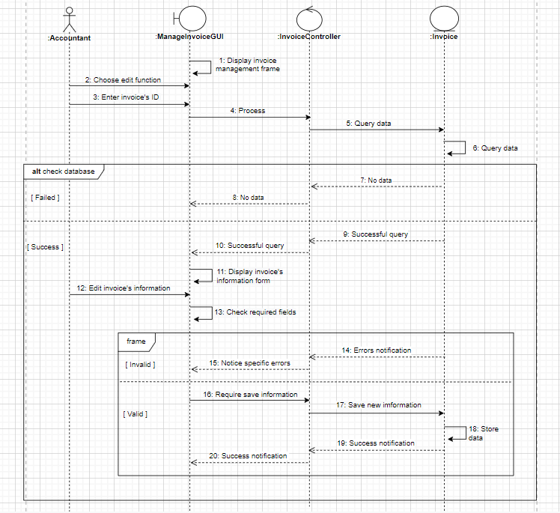

* + Class Diagram

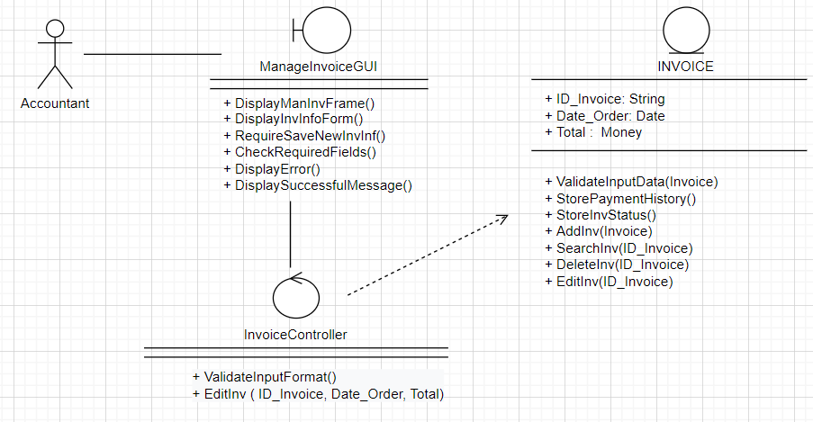

3.5.7.4 Search Invoice

* + Sequence Diagram

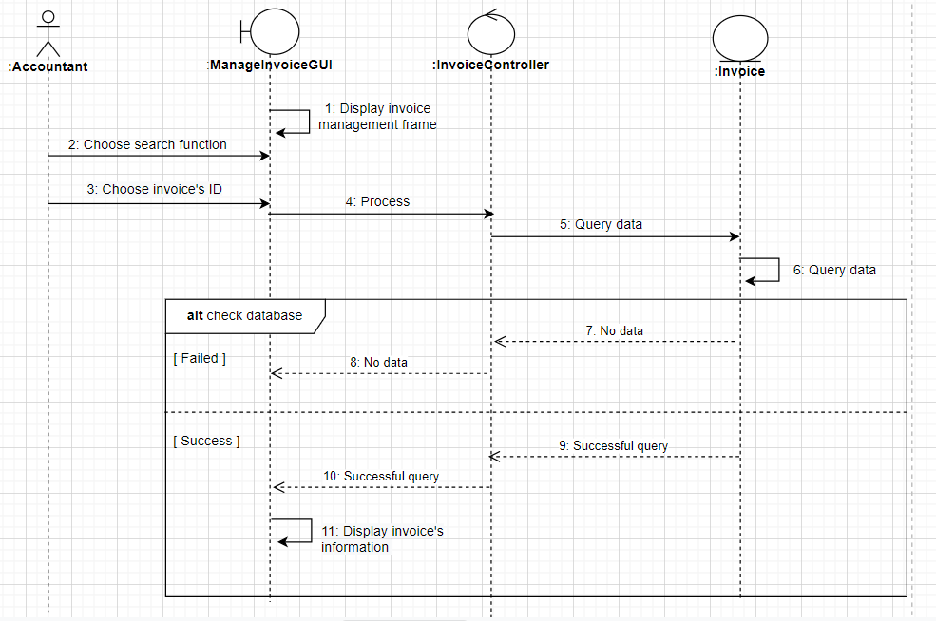

* + Class Diagram

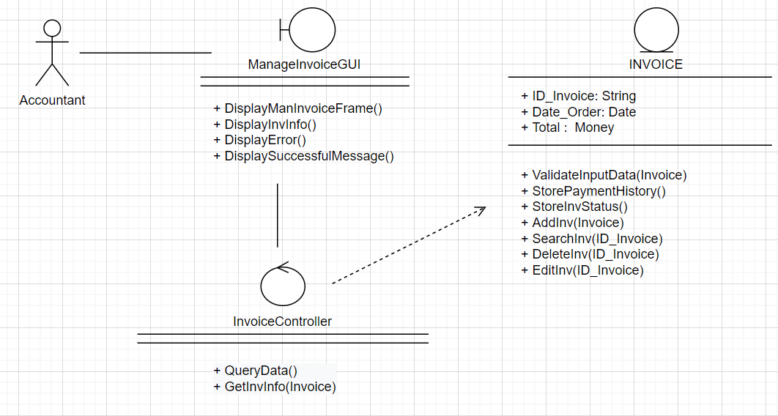

### **3.5.8 Customers Management**

3.5.8.1 Insert customer

* + Sequence Diagram

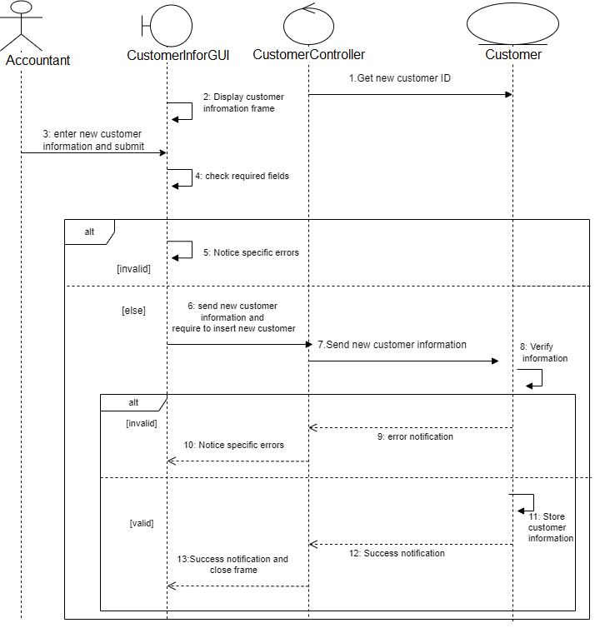

* + - 1. Search and update customer
  + Sequence Diagram

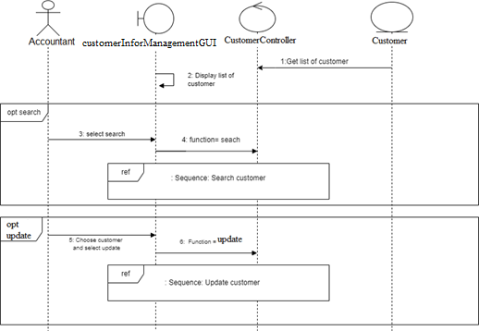

3.5.8.3 Update customer

* + Sequence Diagram

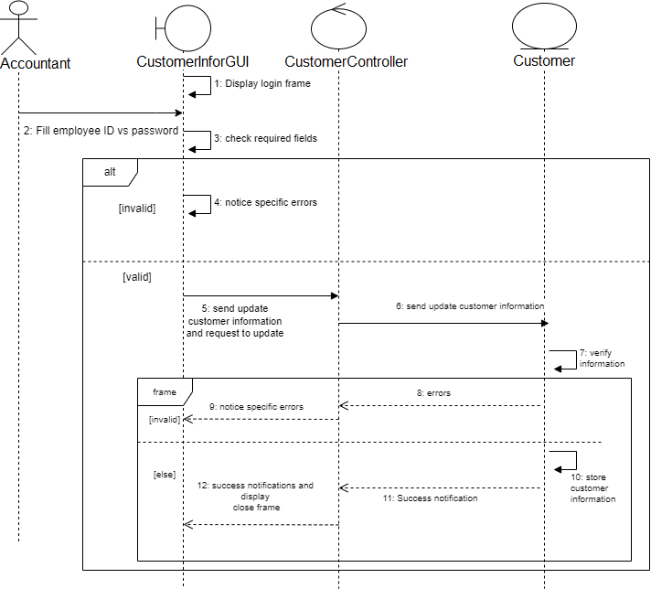

3.5.8.4 Search customer

* + Sequence Diagram

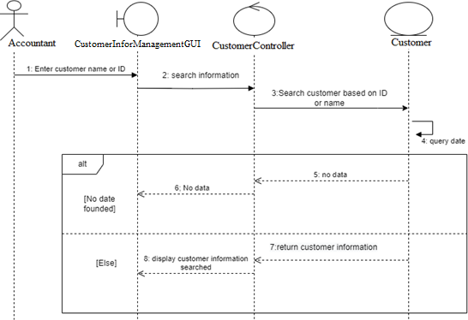

* + Class Diagram

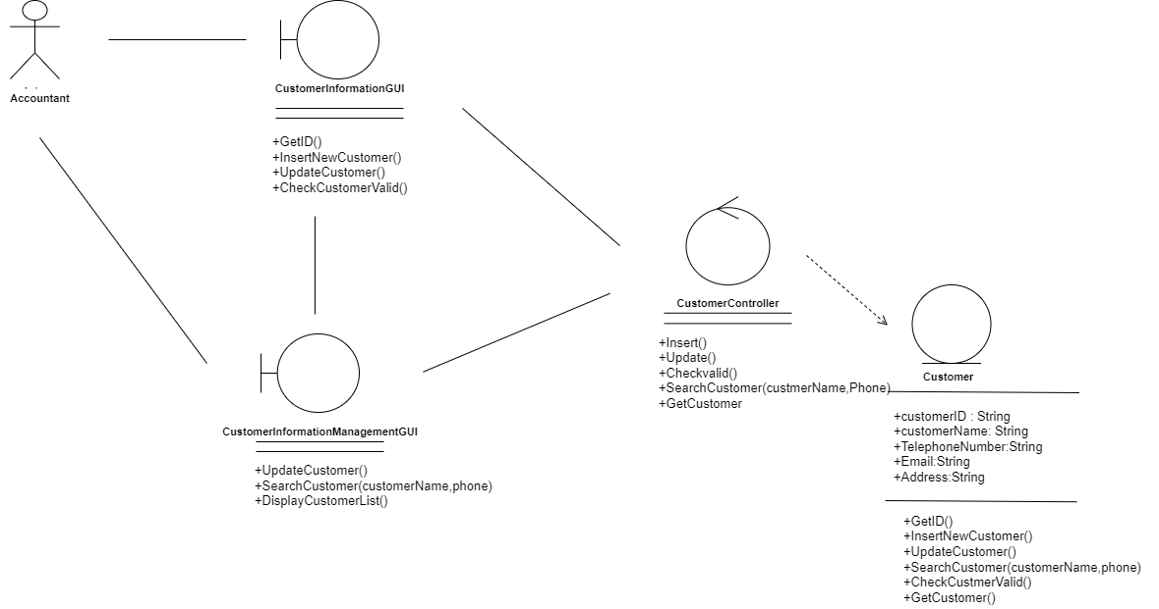

### **3.5.9 Order Process**

3.5.9.1 When customer is a member

* + Sequence Diagram

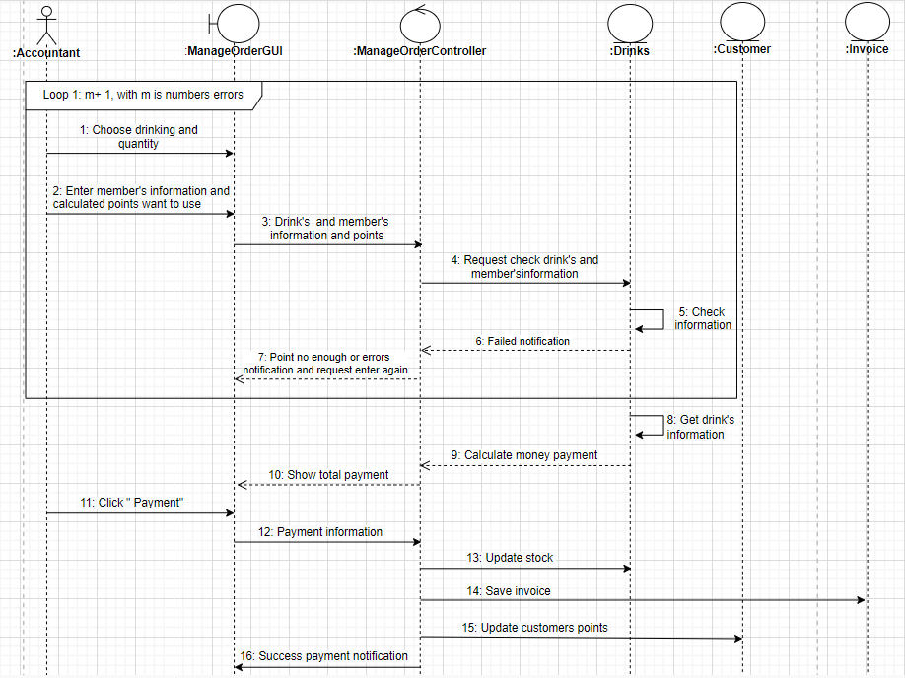

* + Class Diagram

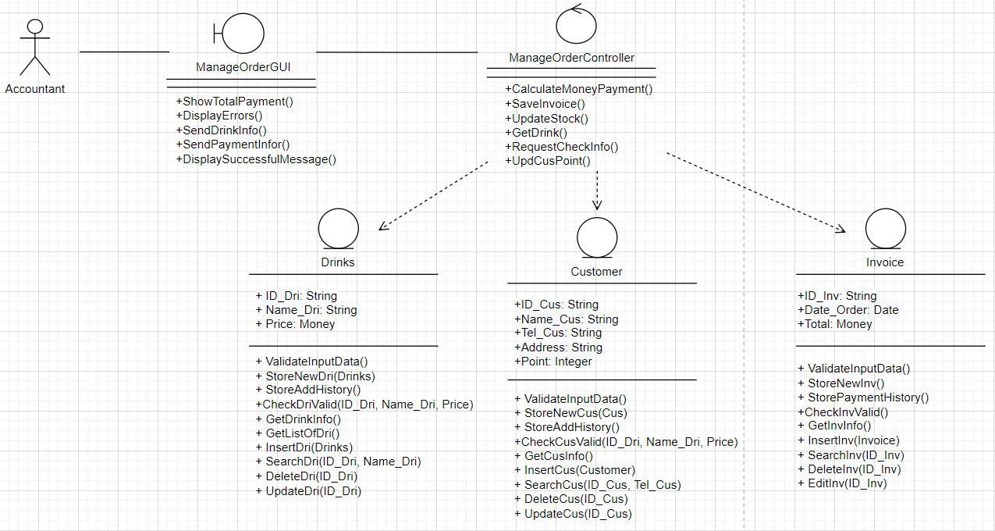

3.5.9.2 When customer isn’t a member

* + Sequence Diagram

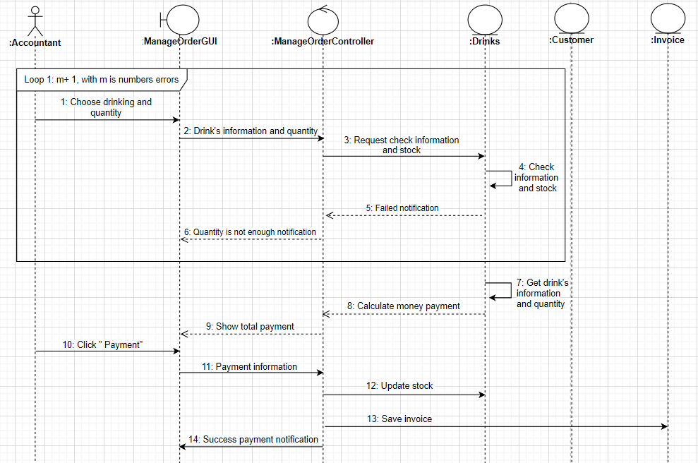

* + Class Diagram

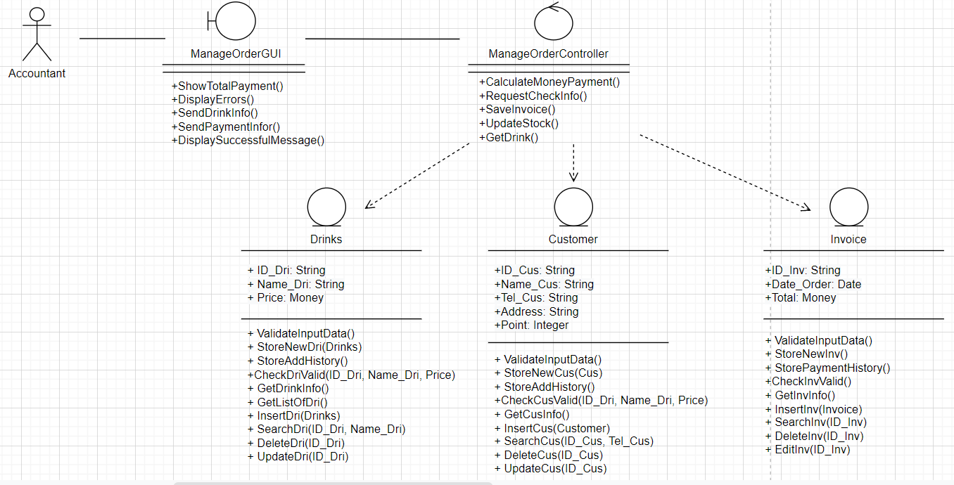

## **3.6 Describe Class Diagram**

* + Employee

|  |  |  |
| --- | --- | --- |
| **Employee** |  | |
| **Attribute** | **Variable** | **Meaning** |
| +Employee’sID | Employee’s ID |
| +Name | Employee’s Name |
| +Phone | Phone number |
| +Email | Email |
| +Password | Password to login to the system |
| +Gender | Gender of employee |
| +Position | Position at work |
| +StartDate | Start Date Of Working |
| +DateOfBirth | Date of birth |
| +Status | Status Of Working |
| **Operation** | **Function** | **Meaning** |
| +GetID() | Get new employees’ ID |
| +InsertEmployee() | Insert new employees |
| +UpdateEmployee() | Update existing employees |
| +DeleteEmployee() | Search employees’ information based on employees’ name or citizenID |
| +GetEmployee() | Get employees’ information |
| +SearchEmployee(name,phone) | Search an employees’ information based on employees’ name or citizenID |
| +CheckEmpValid() | Check validity of an employees’ information |

* + Employee Controller

|  |  |  |
| --- | --- | --- |
| **Employee**  **Controller** |  | |
| **Operation** | **Function** | **Meaning** |
| +SignIn(EmployeeID,password) | Sign in by account |
| +Insert() | Insert new employees |
| +Update() | Update existing employees |
| +CheckValid() | Check validity of employees’ information |
| +CheckLogin() | Check EmpID and password when employees login their accounts |
| +CreateExcelSalary() | Create excel to report employees’ salary |
| +CalculateSalary() | Calculate employees’ salary by a month or a year |
| +GetListOfEmployeeSalary | Get list of employees |
|  | +Delete() | Delete employees in system |
|  | +GetInfoSalary() | Get information salary from database |

* + Employee Manage GUI

|  |  |  |
| --- | --- | --- |
| **Employee**  **Manage GUI** |  | |
| **Operation** | **Function** | **Meaning** |
| + DisplayManEmpFrame() | Display manage employees’ frames to users choose the function they need. |
| + DisplayVerifyMessage() | Display verify message when proceed to delete the employees |
| + DisplayError() | Display notice specific errors |
| + DisplaySuccessfulMessage() | Display successful message when success processing |
| + DisplayEmpInfoForm() | Display employees’ information form to users enter employees’ information |
| + SendNewEmpInf() | Send new employees’ information to employee controller |
| + DisplayEmpInfo() | Display employees’ information |
| + RequireSaveNewEmpInf() | Request employee controller save new employees’ information |
|  | + DisplayTotalSalaryAndInfo() | Display employees’ salary and information |

* + Log in GUI

|  |  |  |
| --- | --- | --- |
| **Login GUI** |  | |
| **Operation** | **Function** | **Meaning** |
|  | +GetLoginInformation() | Get ID_Emp, password and employees’ position |

* + Customer

|  |  |  |
| --- | --- | --- |
| **Customer** |  | |
| **Attribute** | **Variable** | **Meaning** |
| +CustomerID | Customers’ ID |
| +CustomerName | Customers’ name |
| +TelephoneNumber | Customers’ phone number |
| +Email | Customers’ email |
| +Address | Customers’ address |
| +Point | Customers’ accumulated points |
| **Operation** | **Function** | **Meaning** |
|  | +GetID() | Get ID_Emp, password and employees’ position |
|  | +InsertNewCustomer() | Insert new customers |
|  | + UpdateCustomer() | Update existing customers |
|  | +SearchCustomer(  customerName,phone) | Search customers’ information based on their name and their phone number |
|  | + CheckCustomerValid() | Check validity of customers’ information |
|  | + GetCustomer() | Get customers’ information |

* + Customer Information GUI

|  |  |  |
| --- | --- | --- |
| **Customer**  **Information**  **GUI** |  | |
| **Operation** | **Function** | **Meaning** |
|  | +GetID() | Get new customers’ ID |
| +InsertNewCustomer() | Insert new customers into system database |
| +UpdateCustomer() | Update existing customers in system database |
| +CheckCustomerValid() | Check validity of customers’ information |

* + Customer Information Management GUI

|  |  |  |
| --- | --- | --- |
| **Customer**  **Information**  **Management**  **GUI** |  | |
| **Operation** | **Function** | **Meaning** |
|  | +UpdateCustomer() | Update customers |
| +SearchCustomer  (Name_Cus,phone) | Search customers’ information based on Name_Customer and their phone number |

* + Customer Controller

|  |  |  |
| --- | --- | --- |
| **Customer**  **Controller** |  | |
| **Operation** | **Function** | **Meaning** |
|  | +Insert() | Insert new customers into database |
| +Update() | Update existing customers |
| +CheckValid() | Check validity of customers’ information |
| +SearchCustomer(customer  Name,phone) | Search customers’ information based on Name_Cus and their phone number |
| +GetCustomer | Get customer information |

* + Invoice

|  |  |  |
| --- | --- | --- |
| **Invoice** |  | |
| **Attribute** | **Variable** | **Meaning** |
| +ID_Invoice:String | Invoices’ ID |
| +exportTime:Date | Time export invoices |
| +Discount:float | Discount for invoices |
| +TotalPrice:float | Total price of invoices |
| +ID_Cus: String | CustomerID of the invoice |
| +ID_Emp: String | EmployeeID of the invoice |
| **Operation** | **Function** | **Meaning** |
|  | +ValidateInputData() | Validate input data from fields |
|  | +AddInv() | Insert new invoices |
|  | + EditInv() | Edit existing information invoices |
|  | +DeleteInv() | Delete invoices based on ID_Inv |
|  | +SearchInv() | Search invoices by ID_Inv |
|  | + CheckInvoiceValid() | Check validity of invoices’ information |
|  | + StorePaymentHistory | Create a new invoice for customers after making a purchase and store it into database |
|  | +StoreInvStatus() | Store invoices’ status paid or not |

* + Invoice Management GUI

|  |  |  |
| --- | --- | --- |
| **Invoice**  **Management**  **GUI** |  | |
| **Operation** | **Function** | **Meaning** |
|  | + DisplayManInvoiceFrame() | Display invoice management frame for users choose the functions they need |
| + DisplayVerifyMessage() | Display verify message when proceed to delete the invoices |
|  | + DisplayError() | Display notice specific errors |
|  | +DisplaySuccessfulMessage() | Display successful message when success processing |
|  | + DisplayInvInfoForm() | Display invoices’ information form for user to enter invoices’ information |
|  | + SendNewInvInf() | Sens new invoices’ information to invoices’ controller |
|  | + DisplayInvInfo() | Display invoices’ information |
|  | + RequireSaveNewInvInf() | Request invoices’ controller save new invoices’ information |
|  | + CheckRequiredFields() | Check the input fields are in the correct format |

* + Invoice controller

|  |  |  |
| --- | --- | --- |
| **Invoice**  **Controller** |  | |
| **Operation** | **Function** | **Meaning** |
|  | +ValidateInputFormat() | Validate input format |
| +Add() | Add drinks to the database |
|  | +Edit() | Edit invoices |
|  | +GetListOfInv() | Get list of invoices form database |
|  | +GetInvInfo() | Get invoices’ information from database |
|  | +GetPaymentHistory() | Get the payment history related to a customers |
|  | +Search() | Search invoices’ information based on ID_Invoice |
|  | +Delete() | Delete invoices |

* + Drinks

|  |  |  |
| --- | --- | --- |
| **Drinks** |  | |
| **Attribute** | **Variable** | **Meaning** |
| +ID_Dri: String | Drinks’ ID |
| +Name_Dri: String | Drinks’ name |
| +Price: Money | Drinks’ price |
| **Operation** | **Function** | **Meaning** |
|  | +ValidateInputData() | Validate input data from fields |
|  | +StoreNewDri(Drinks) | Store drinks’ information into the database |
|  | +StoreAddHistory() | Store add history |
|  | +DeleteDri(ID_Dri) | Delete drinks based on ID_Dri |
|  | +SearchDri(ID_Dri) | Search drinks based on ID_Dri |
|  | + UpdateDri(ID_Dri) | Update drinks’ information by ID_Dri |
|  | +CheckDriValid() | Check validity of drinks’ information are valid or not |
|  | +Add(Drinks) | Insert new drinks into database |

* + DrinksController

|  |  |  |
| --- | --- | --- |
| **Drinks**  **Controller** |  | |
| **Operation** | **Function** | **Meaning** |
|  | +ValidateInputFormat() | Validate input format |
| +Add(ID_Dri, Name_Dri, Price) | Add drinks to the database |
|  | + GetListOfDri() | Get list of drinks into database |
|  | +GetDrinkInfo() | Get drinks’ information from database |
|  | +UpdDri() | Update drinks’ information |
|  | +Delete() | Delete drinks base on ID_Dri |
|  | QueryData() | Query data into database |

* + ManageDrinksGUI

|  |  |  |
| --- | --- | --- |
| **Manage**  **Drinks**  **GUI** |  | |
| **Operation** | **Function** | **Meaning** |
|  | + DisplayManDriFrame() | Display drinks management frame for user choose the functions they need |
| + DisplayVerifyMessage() | Display verify message when proceed to delete the drink |
|  | + DisplayError() | Display notice specific errors |
|  | +DisplaySuccessfulMessage() | Display successful message when success processing |
|  | + DisplayDriInfoForm() | Display drinks’ information form for users enter their drinks’ information |
|  | + SendNewDriInf() | Send new drinks’ information to drinks controller |
|  | + DisplayDriInfo() | Display drinks’ information |
|  | + RequireSaveNewDriInf() | Request drinks controller save new drinks’ information |
|  | + CheckRequiredFields() | Check the input fields are in the correct format |

* + Goods

|  |  |  |
| --- | --- | --- |
| **Goods** |  | |
| **Attribute** | **Variable** | **Meaning** |
| +ID_Goods: String | Goods’ ID |
| +Name_Goods: String | Goods’ Name |
| +Price: Money | Goods’ price |
| **Operation** | **Function** | **Meaning** |
|  | +ValidateInputData() | Validate input data from fields |
|  | +StoreNewGoods() | Store goods’ information into the database |
|  | +StoreAddHistory() | Store add history |
|  | +DeleteGoods(ID_Goods) | Delete goods based on ID_Goods |
|  | +SearchGoods(ID_Goods) | Search goods based on ID_Goods |
|  | + UpdateGoods(ID_Goods) | Update goods’ information by ID_Goods |
|  | +CheckGoodsValid() | Check validity of goods’ information are valid or not |

* + GoodsController

|  |  |  |
| --- | --- | --- |
| **Goods**  **Controller** |  | |
| **Operation** | **Function** | **Meaning** |
|  | +ValidateInputFormat() | Validate input format |
|  | + GetListOfGoods() | Get list of goods into database |
|  | +GetGoodsInfo() | Get goods’ information from database |
|  | +UpdateGoods() | Update goods’ information |
|  | +DeleteGoods() | Delete goods based on ID_Dri |
|  | QueryData() | Query data into database |
|  | +SearchGoods() | Search goods’ information |

* + ManageGoodsGUI

|  |  |  |
| --- | --- | --- |
| **Manage**  **Goods**  **GUI** |  | |
| **Operation** | **Function** | **Meaning** |
|  | + DisplayManGoodsFrame() | Display goods management frame for users choose the function they need |
| + DisplayVerifyMessage() | Display verify message when proceed to delete the goods |
|  | + DisplayError() | Display notice specific errors |
|  | +DisplaySuccessfulMessage() | Display successful message when success processing |
|  | + DisplayGoodsInfoForm() | Display goods’ information form for users enter goods’ information |
|  | + SendNewGoodsInf() | Send new goods’ information to goods controller |
|  | + DisplayGoodsInfo() | Display goods’ information |
|  | + RequireSaveNewGoodsInf() | Request goods controller save new goods’ information |
|  | + CheckRequiredFields() | Check the input fields are in the correct format |

* + Import

|  |  |  |
| --- | --- | --- |
| **Import** |  | |
| **Attribute** | **Variable** | **Meaning** |
| +ID_Imp: String | Import’s ID |
| +ID_Emp: String | Employee’s ID |
| +Date_Import: Date | Date import |
| +ID_Goods | Good’s ID |
| **Operation** | **Function** | **Meaning** |
|  | + ValidateInputData() | Validate input data from fields |
|  | + StoreNewImport() | Store new import information into the database |
|  | + StoreImportHistory() | Store import goods history |
|  | +ValidateImportData(ID_Imp, ID_Goods, ID_Emp, Date_Import) | Check validity of imports’ information are valid or not |
|  | + ImportGoods(Import) | Import goods |
|  | + ShipmentLookup(ID_Imp) | Shipment lookup imported |

* + GoodsController

|  |  |  |
| --- | --- | --- |
| **Import Controller** |  | |
| **Operation** | **Function** | **Meaning** |
|  | + ValidateInputFormat() | Validate input format |
|  | + GetNewImportID() | Get new imports’ ID |
|  | + Import () | Add imports’ information into database |
|  | + QueryData() | Query data into database |
|  | + GetShipment(Import) | Get shipment from database |

* + ManageImportGUI

|  |  |  |
| --- | --- | --- |
| **Manage**  **Import**  **GUI** |  | |
| **Operation** | **Function** | **Meaning** |
|  | + DisplayManImportFrame() | Display import management frame for user choose the function they need |
|  | + DisplayError() | Display notice specific errors |
|  | +DisplaySuccessfulMessage() | Display successful message when success processing |
|  | + DisplayImportInfoForm() | Display imports’ information form for user enter imports’ information |
|  | + SendNewGoodsInf() | Send new imports’ information to imports controller |
|  | + DisplayShipmentInfo() | Display shipment information |
|  | + RequireToAddNewImp() | Request imports controller add new imports’ information |
|  | + CheckRequiredFields() | Check the input fields are in the correct format |

## **3.7. State Diagram**

### **3.7.1 Order and serving**

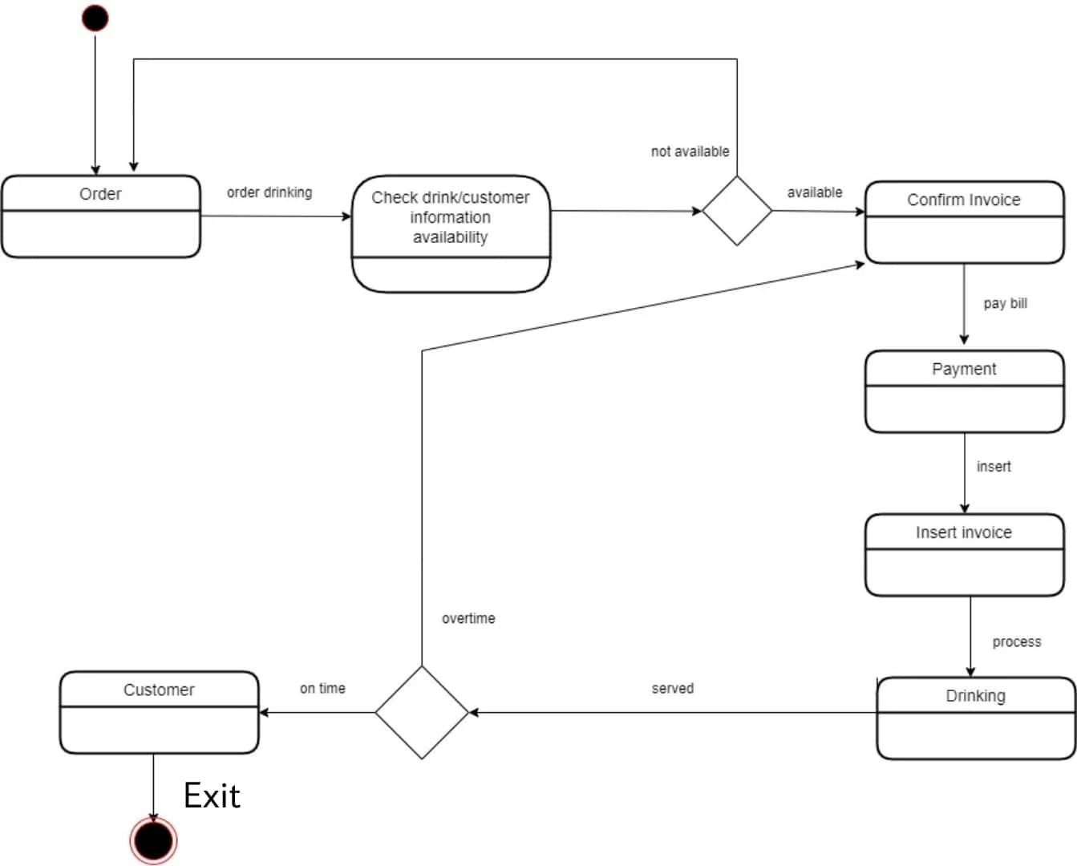

### **3.7.2 Import Goods**

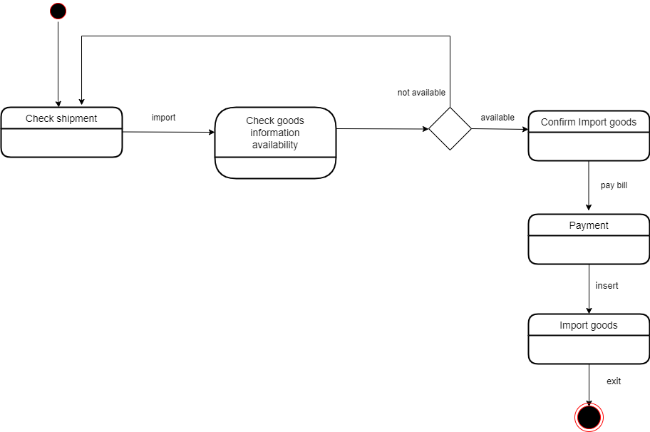

## **3.8** **ERDs model**

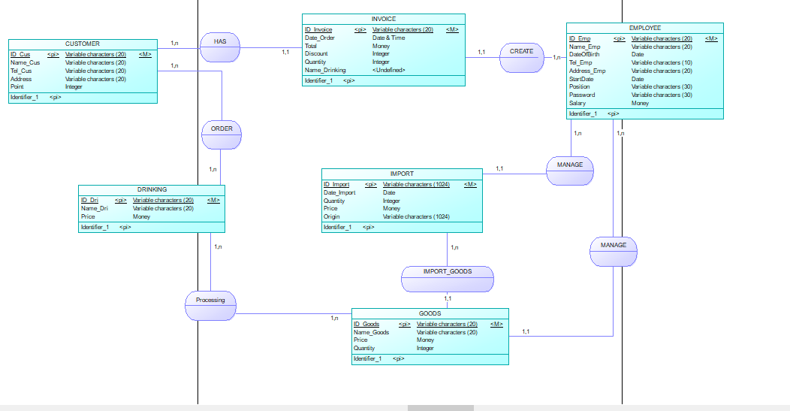

## **3.9 Mapping to Relational Model from ERDs**

### **3.9.1 Relational Model**

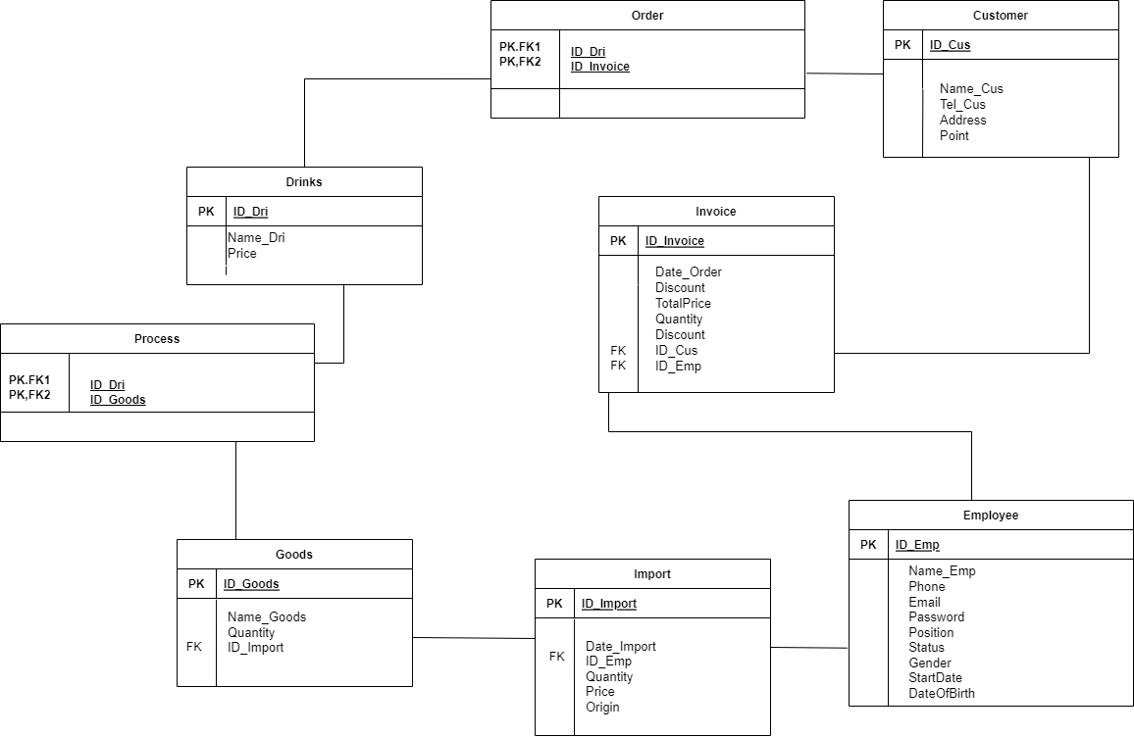

### **3.9.2 Data organization**

EMPLOYEE(**ID_Emp**,Name_Emp,DateOfBirth,Tel_Emp,StartDate.Position,Password,Status)

INVOICE(**ID_Invoice**,Date_Order,exportTime,TotalPrice,Quantity,Discount,ID_Cus,ID_Emp)

ORDER(**ID_Dri**,**ID_Invoice**)

DRINKING**(ID_Dri**,Name_Dri,Price)

CUSTOMER(**ID_Cus**,Name_Cus,Tel_Cus,Address,Point)

GOODS**(ID_Goods**,Name_Goods,Price)

IMPORT(**ID_Import**,Date_Import,ID_Emp,ID_Goods)

PROCESS**(ID_Dri**,**ID_Goods**)

### **3.9.3 Describe table**

***3.9.3.1 Table EMPLOYEE***

|  |  |  |  |
| --- | --- | --- | --- |
| **Column Name** | **Datatype** | **Description** | **Constraint** |
| ID_Emp | Varchar(20) | Employee ID | Not null |
| Name_Emp | Varchar(20) | Employee name |  |
| Email | Varchar(20) | Employee email |  |
| Password | Varchar(20) | Employee password |  |
| Position | Varchar(20) | Employee position |  |
| Status | Varchar(20) | Employee status of working |  |
| Gender | Varchar(20) | Employee gender |  |
| Start_Date | Date | Employee start-working date |  |
| DateOfBirth | Date | Employee Date of birth |  |
| Phone | Varchar(20) | Employee telephone number |  |

***3.9.3.2 Table INVOICE***

|  |  |  |  |
| --- | --- | --- | --- |
| **Column Name** | **Datatype** | **Description** | **Constraint** |
| ID_Invoice | Varchar(20) | Invoice ID | Not null |
| Date_Order | Date | Date invoice ordered |  |
| TotalPrice | Int(11) | Invoice total price |  |
| Quantity | Int(11) | Quantity of drinking |  |
| Discount | Int(4) | Discount of invoice |  |
| ID_Cus | Varchar(20) | Customer ID |  |
| ID_Emp | Varchar(20) | Employee ID |  |

***3.9.3.3 Table CUSTOMER***

|  |  |  |  |
| --- | --- | --- | --- |
| **Column Name** | **Datatype** | **Description** | **Constraint** |
| ID_Cus | Varchar(20) | Customer ID | Not null |
| Name_Cus | Varchar(20) | Customer name |  |
| Address | Varchar(20) | Customer address |  |
| Point | Int(11) | Customer point |  |

***3.9.3.4 Table IMPORT***

|  |  |  |  |
| --- | --- | --- | --- |
| **Column Name** | **Datatype** | **Description** | **Constraint** |
| ID_Import | Varchar(20) | Import ID | Not null |
| ID_Emp | Varchar(20) | Employee ID |  |
| ID_Goods | Varchar(20) | Goods ID |  |
| Price | Int(11) | Goods price |  |
| Origin | Varchar(20) | Goods Origin |  |

***3.9.3.5 Table DRINKS***

|  |  |  |  |
| --- | --- | --- | --- |
| **Column Name** | **Datatype** | **Description** | **Constraint** |
| ID_Dri | Varchar(20) | Drinking ID | Not null |
| Name_Dri | Varchar(20) | Drinking name |  |
| Price | Int(11) | Drinking price |  |

***3.9.3.6 Table ORDER***

|  |  |  |  |
| --- | --- | --- | --- |
| **Column Name** | **Datatype** | **Description** | **Constraint** |
| ID_Dri | Varchar(20) | Drinking ID | Not null |
| ID_Invoice | Varchar(20) | Invoice ID | Not null |

***3.9.3.7 Table GOODS***

|  |  |  |  |
| --- | --- | --- | --- |
| **Column Name** | **Datatype** | **Description** | **Constraint** |
| ID_Goods | Varchar(20) | Drinking ID | Not null |
| Name_Goods | Varchar(20) | Invoice ID |  |
| Quantity | Int(11) | Quantity of goods |  |

***3.9.3.8 Table PROCESS***

|  |  |  |  |
| --- | --- | --- | --- |
| **Column Name** | **Datatype** | **Description** | **Constraint** |
| ID_Goods | Varchar(20) | Goods ID | Not null |
| ID_Dri | Varchar(20) | Drinking ID | Not null |

## **3.10 DFDs Model**

### **3.10.1 Level 0**

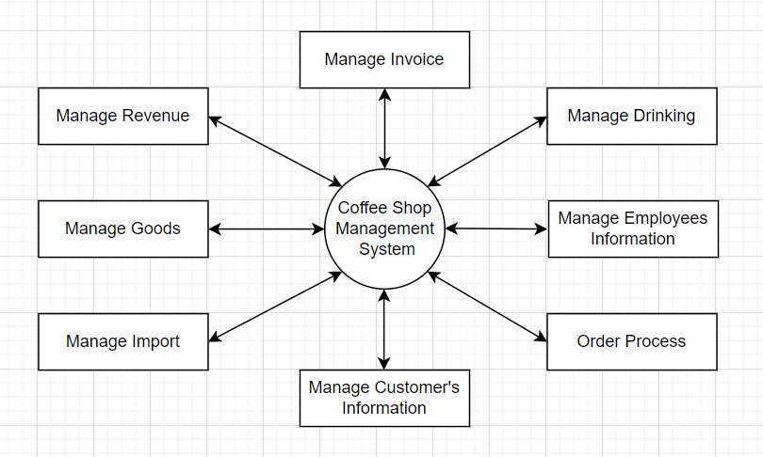

### **3.10.2 Level 1**

Order Process

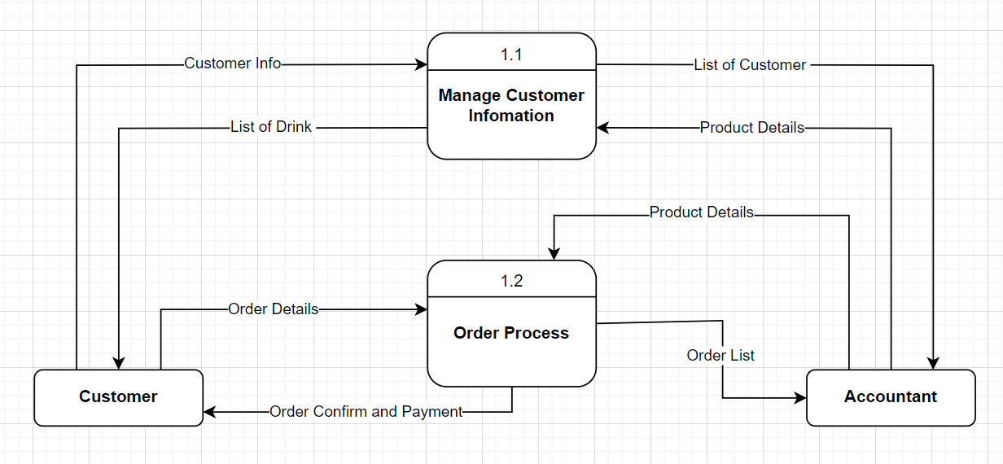

# **CHAPTER 4:  IMPLEMENTATION AND TESTING**

## **4.1 List of main pages of the program**

|  |  |
| --- | --- |
| No | Frame Name |
| 1 | Login frame |
| Manager’s frame | |
| 2 | Revenues statistic frame |
| 3 | Products management frame |
| 4 | Insert frame in Products management |
| 5 | Update frame in Products management |
| 6 | Invoices management frame |
| 7 | Users management |
| 8 | Insert employees frame in Users management |
| 9 | Update employees frame in Users management |
| 10 | Warehouse management frame |
| 11 | Import goods frame in Warehouse management |
| 12 | Delete goods frame in Warehouse management |
| Accountant’s frame | |
| 13 | Sales management frame |
| 14 | Invoices management frame |
| 15 | Customers management frame |
| 16 | Insert customers’ information frame in Customer management |
| 17 | Update customers’ information frame in Customer management |
| 18 | Revenue statistic frame |
| Warehouseman’s frame | |
| 19 | Inventory management frame |
| 20 | Import goods |
| 21 | Delete goods |

## **4.2 User Interface**

1. Login frame

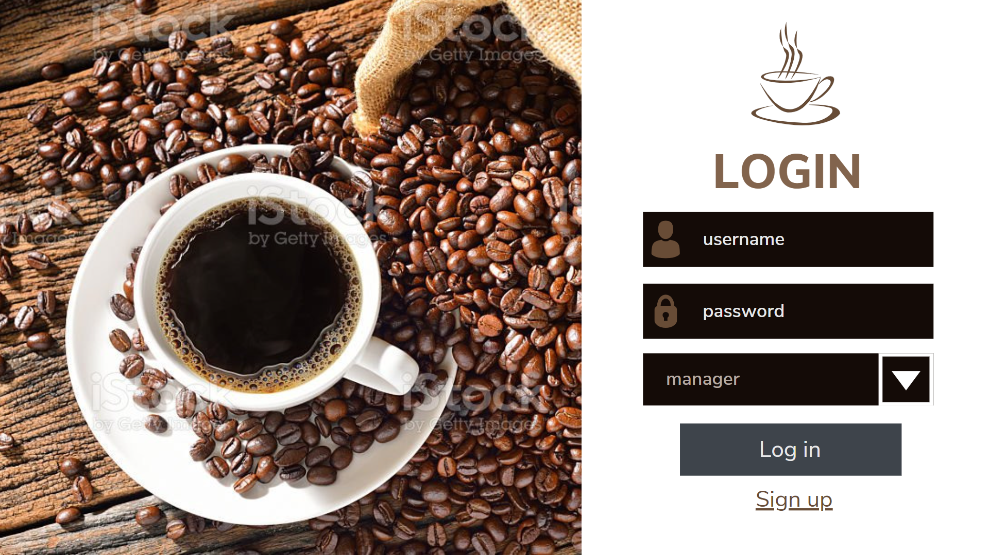

1. Revenue statistic frame

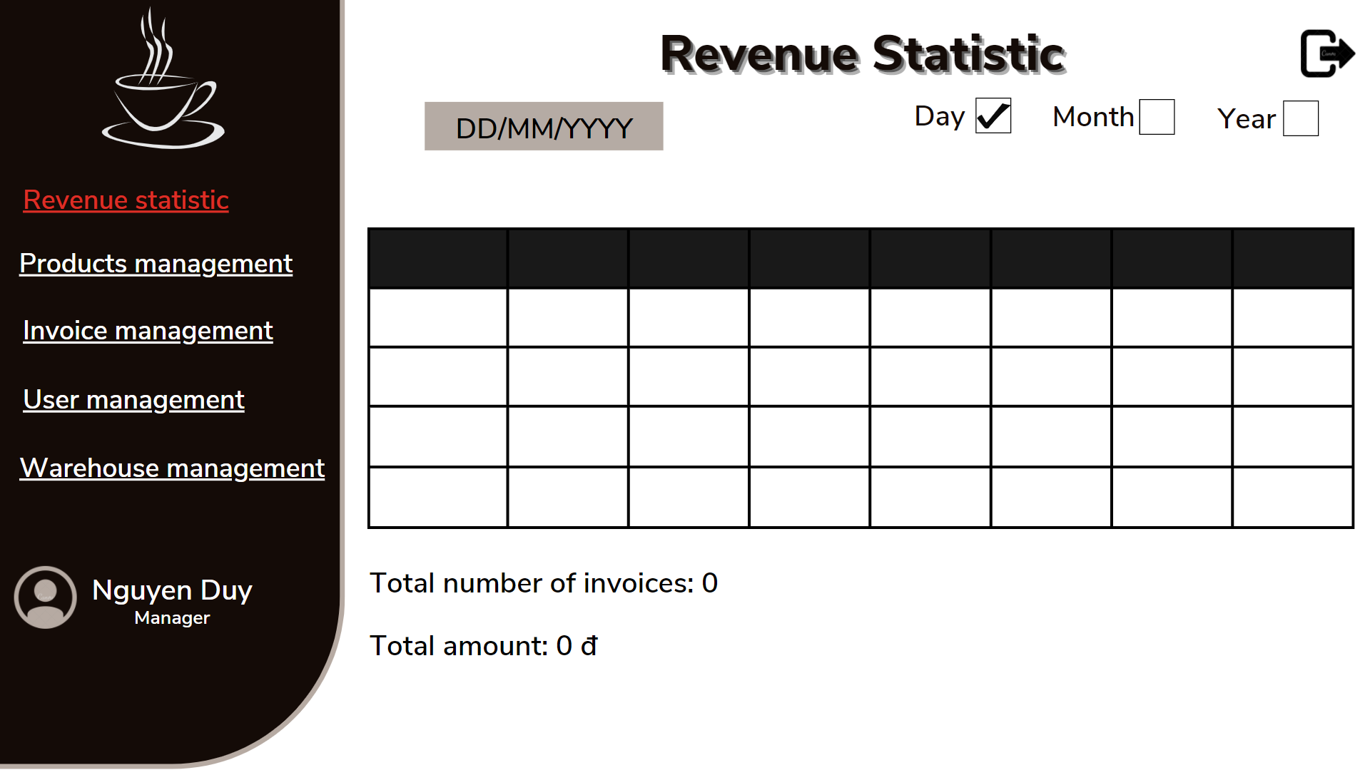

1. Product management frame

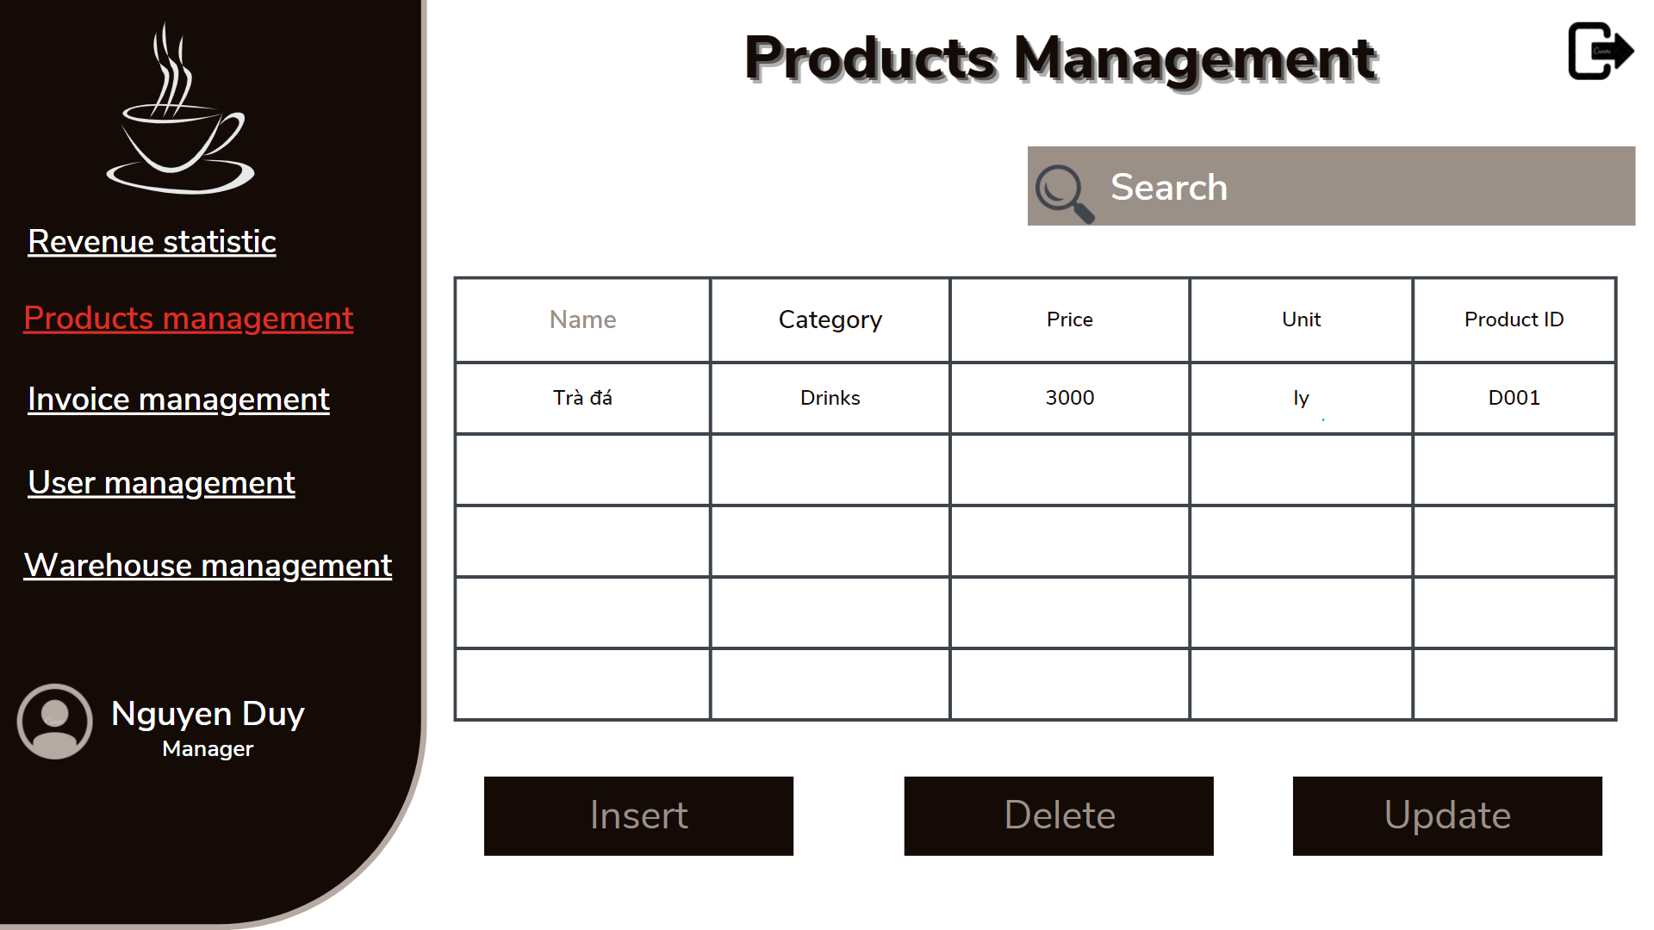

1. Insert frame in Product management

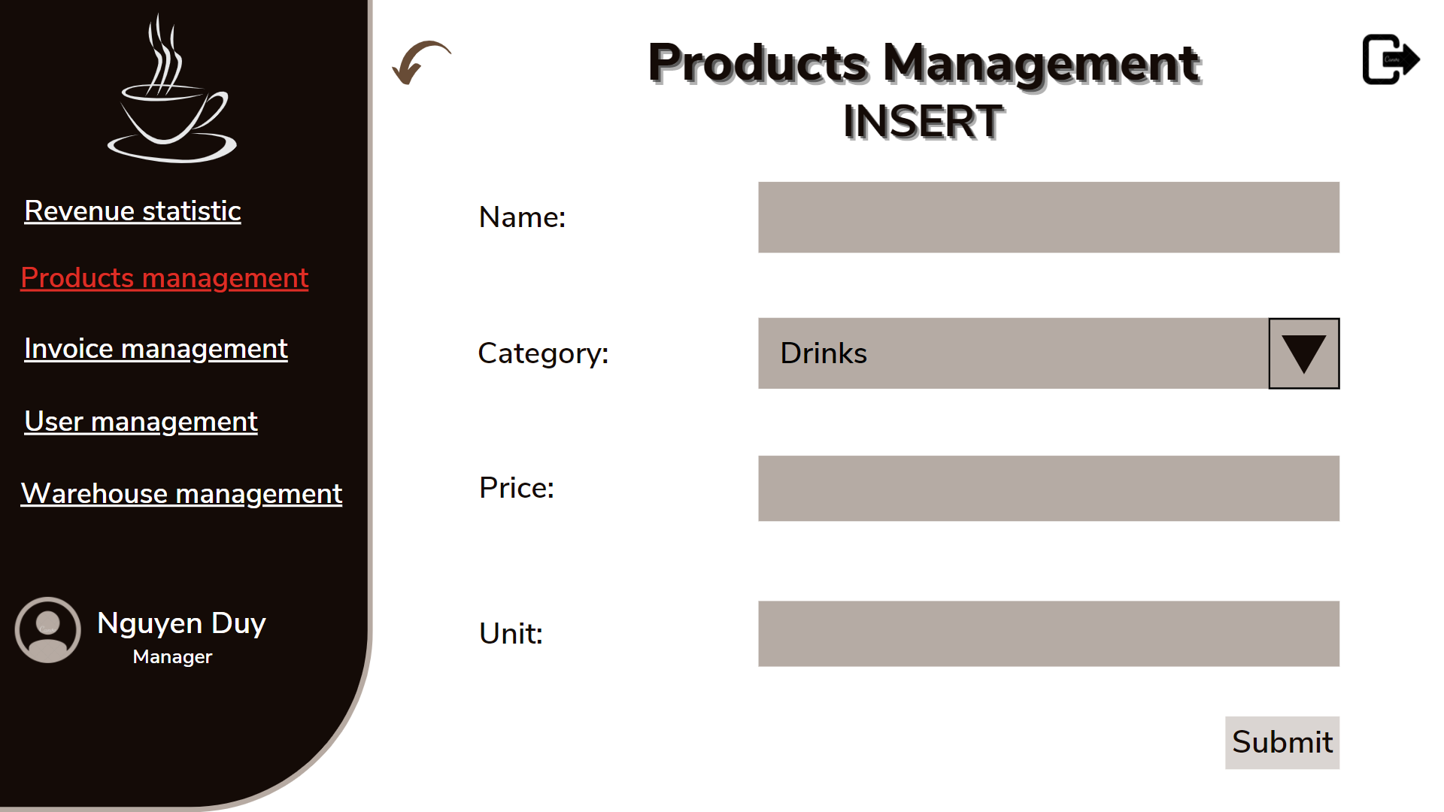

1. Update frame in Product management

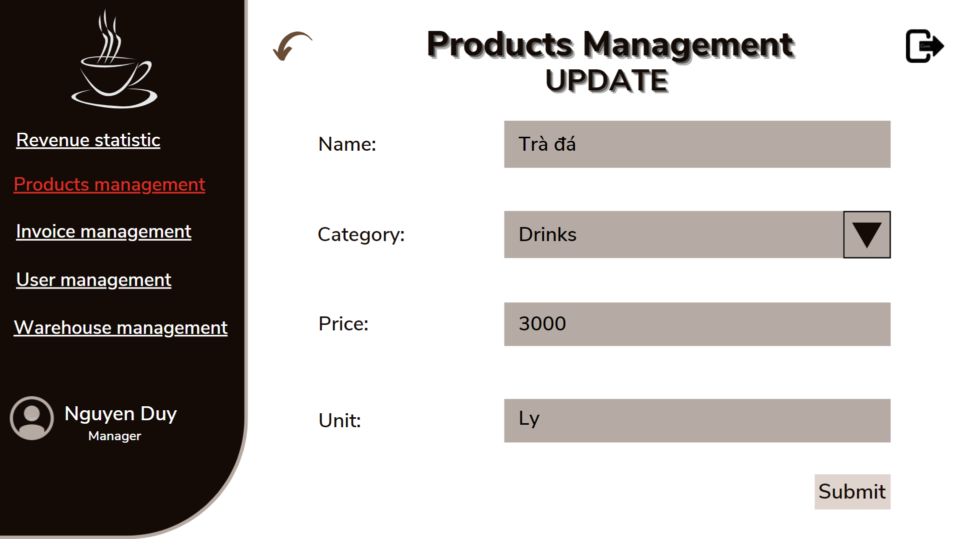

1. Invoice management frame

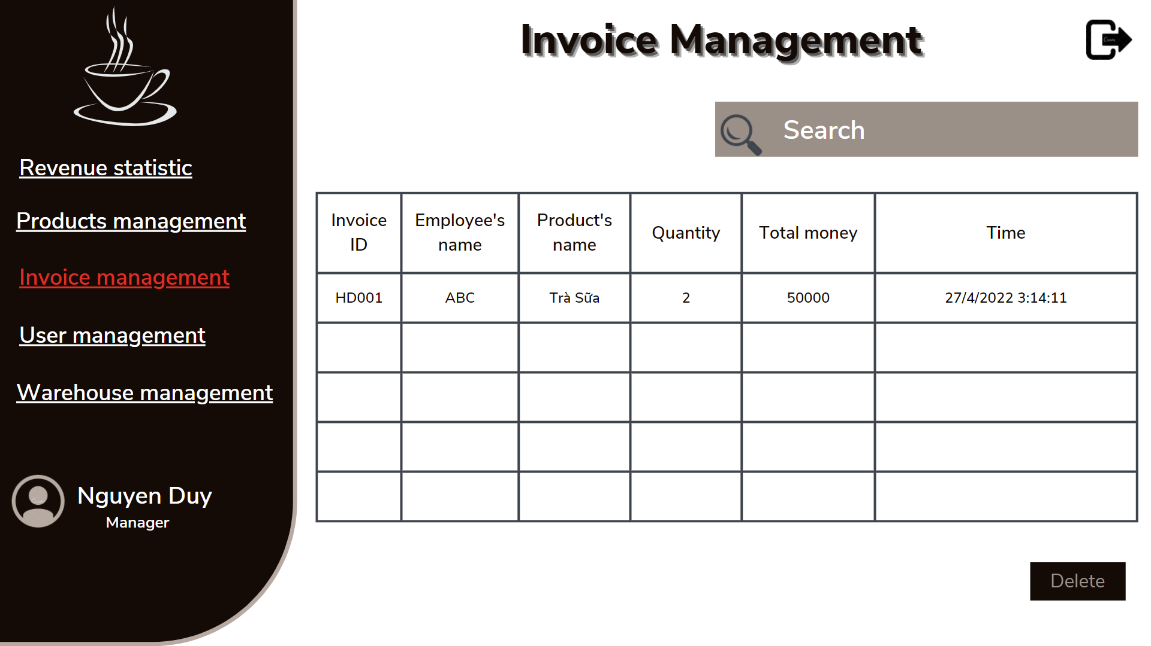

1. User management

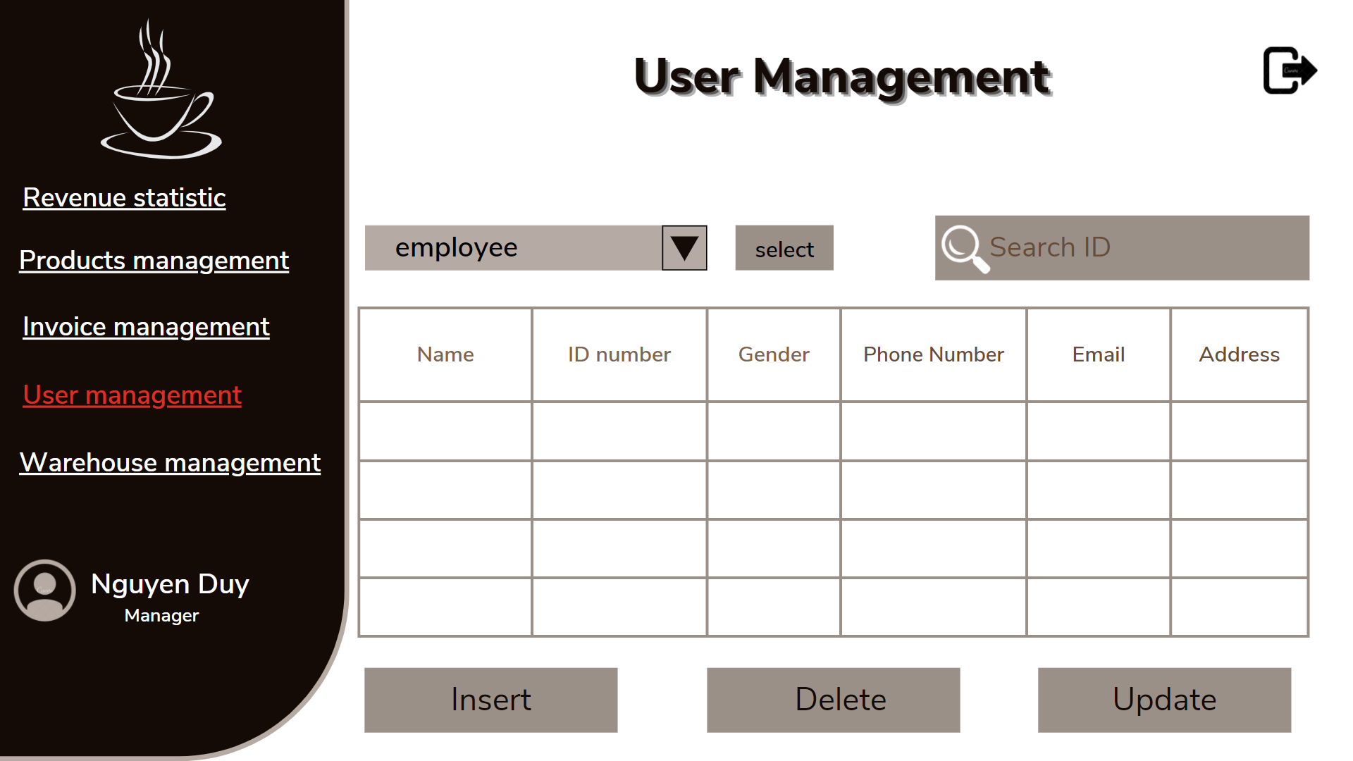

1. Insert employee frame in User management

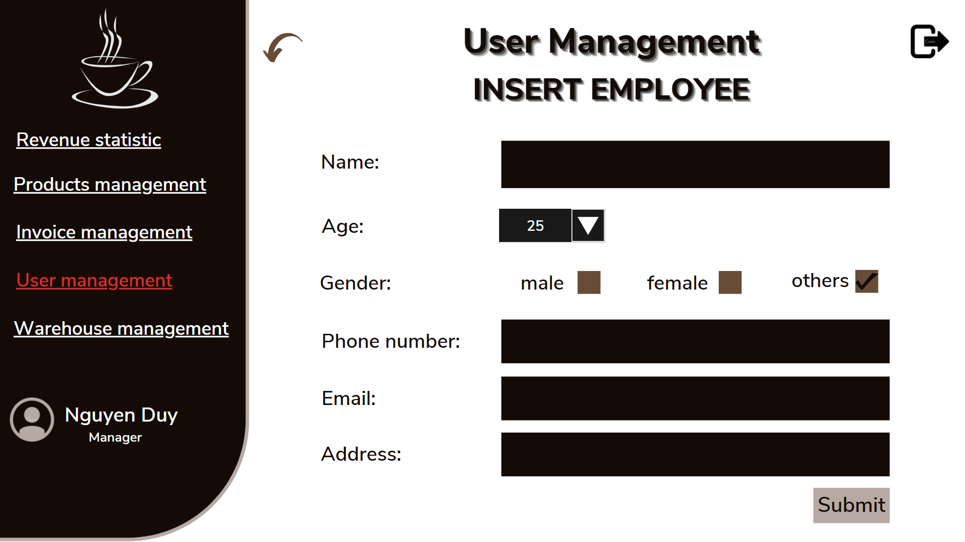

1. Update employee frame in User management

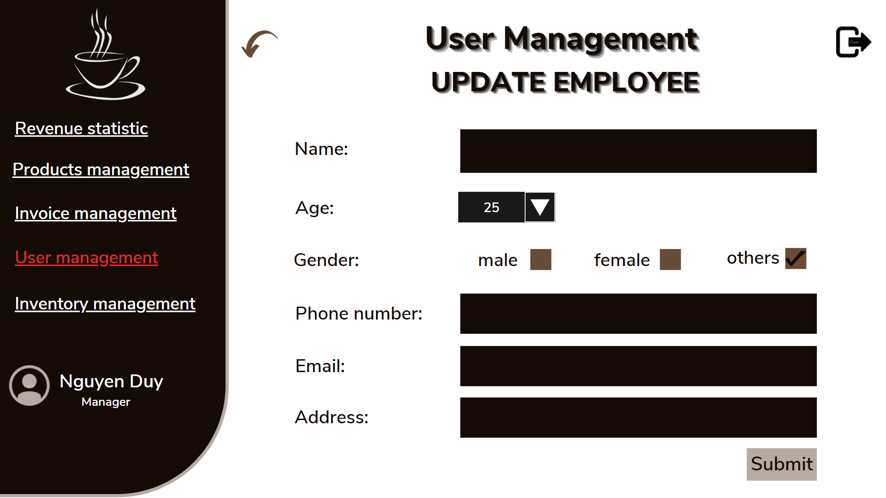

1. Warehouse management frame

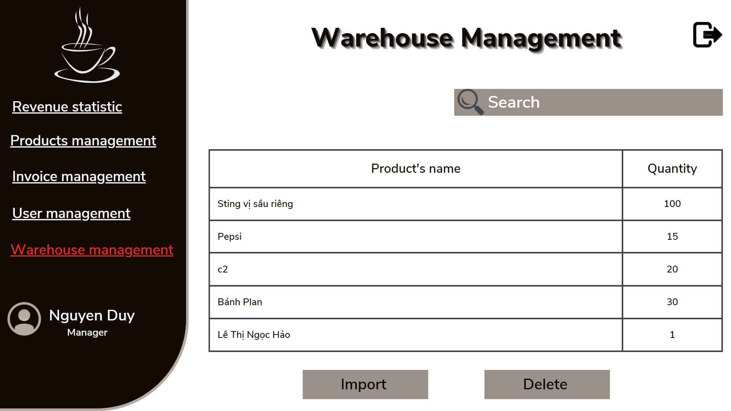

1. Import goods frame in Warehouse management

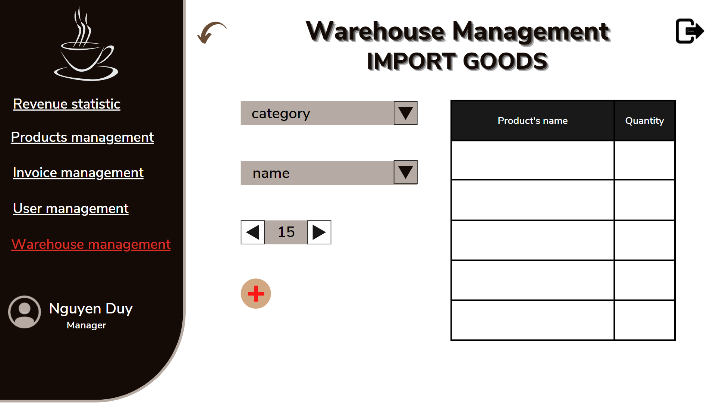

1. Delete goods frame in Warehouse management

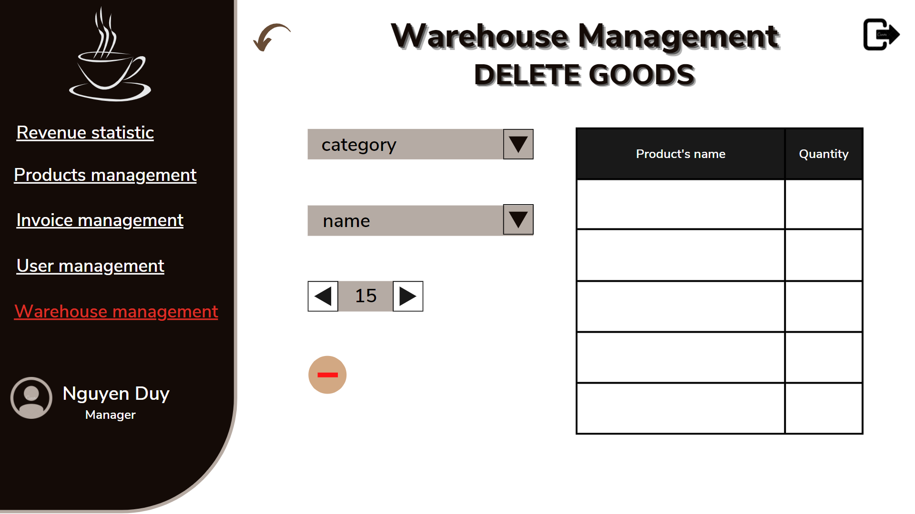

1. Sales management frame

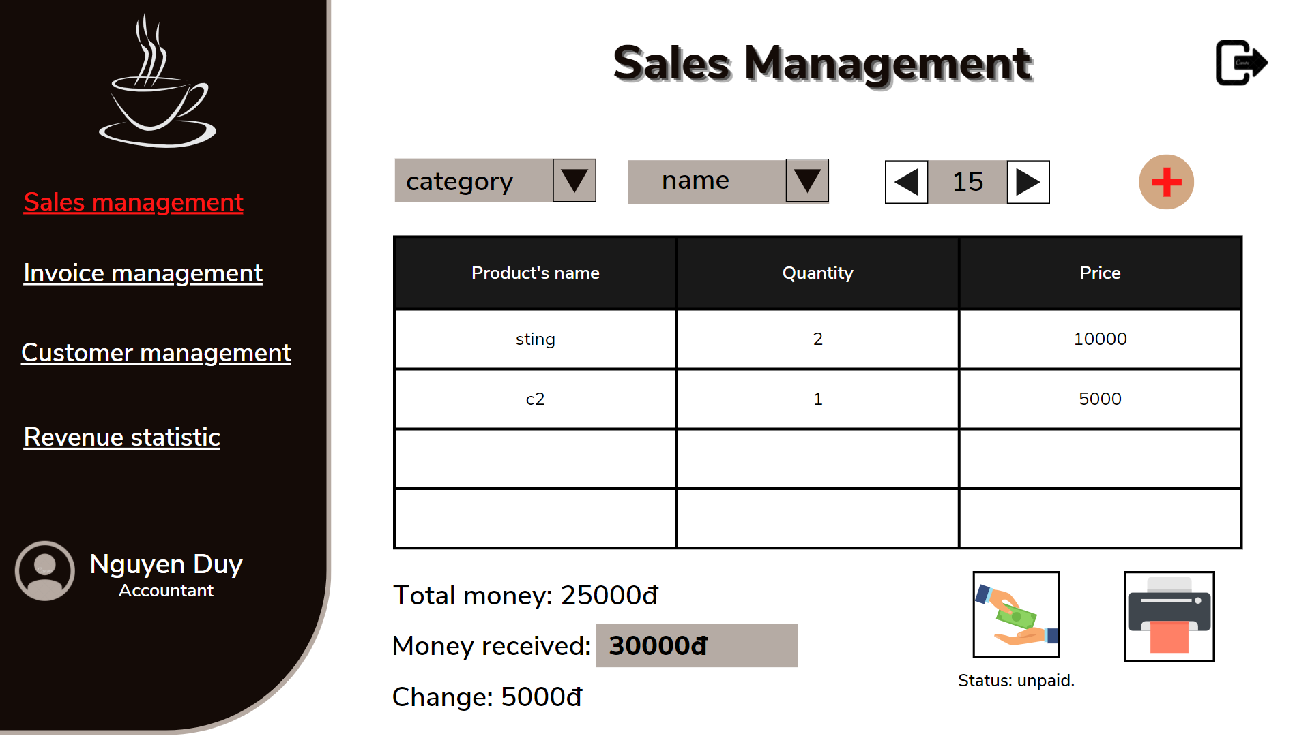

1. Invoice management frame

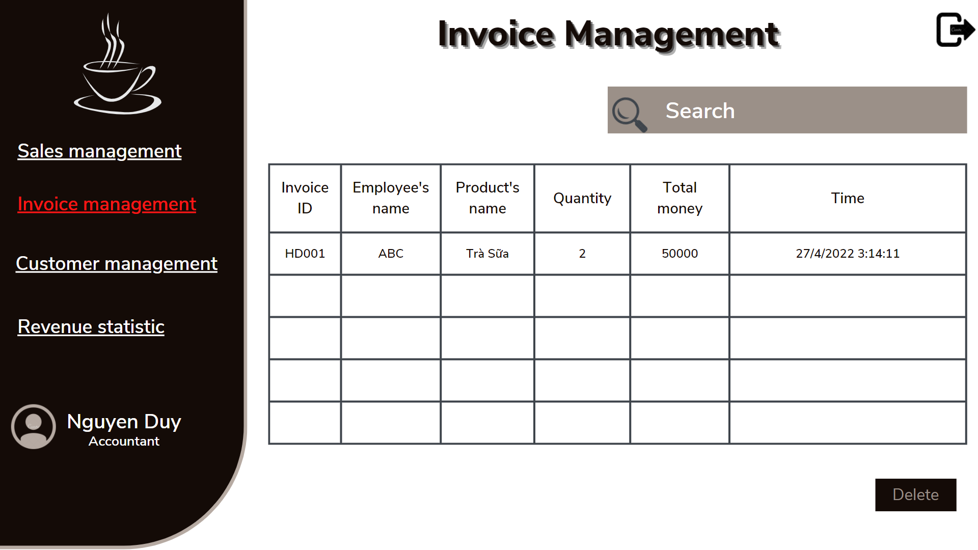

1. Customer management frame

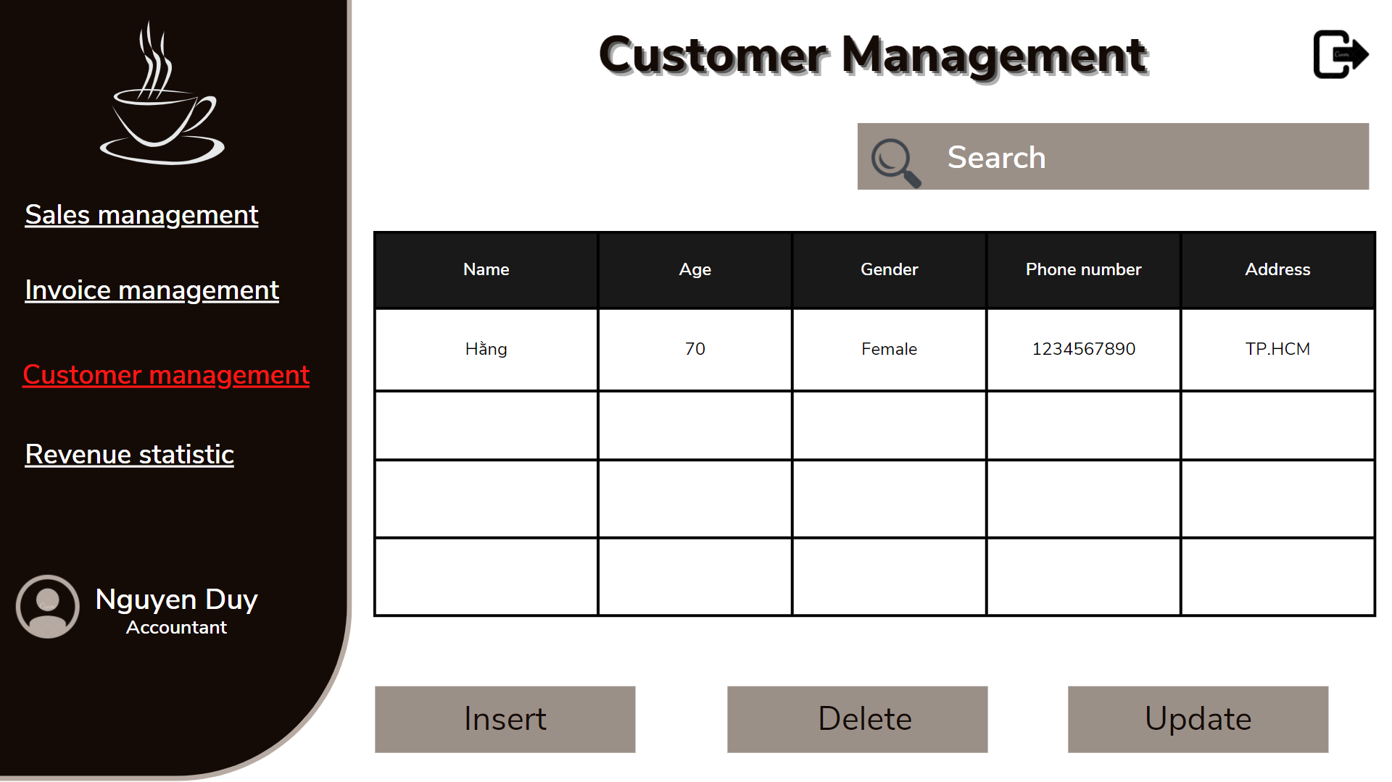

1. Insert customer information frame in Customer management

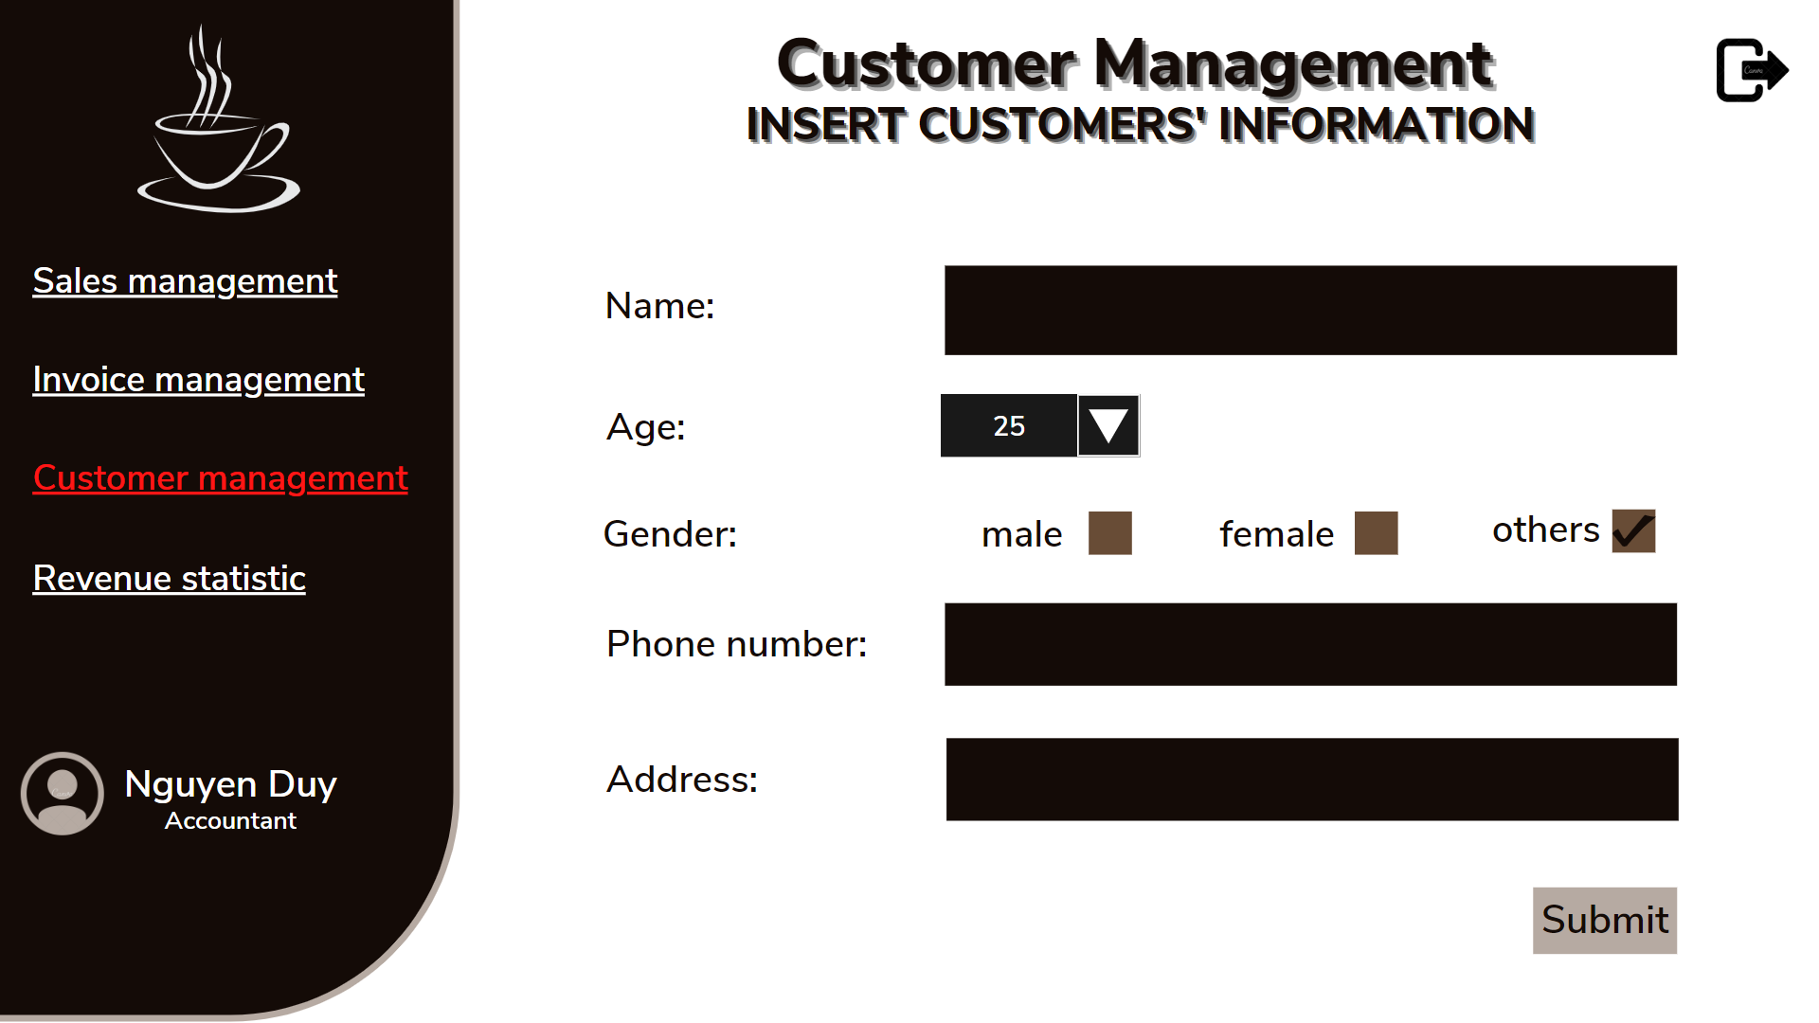

1. Update customer information frame in Customer management

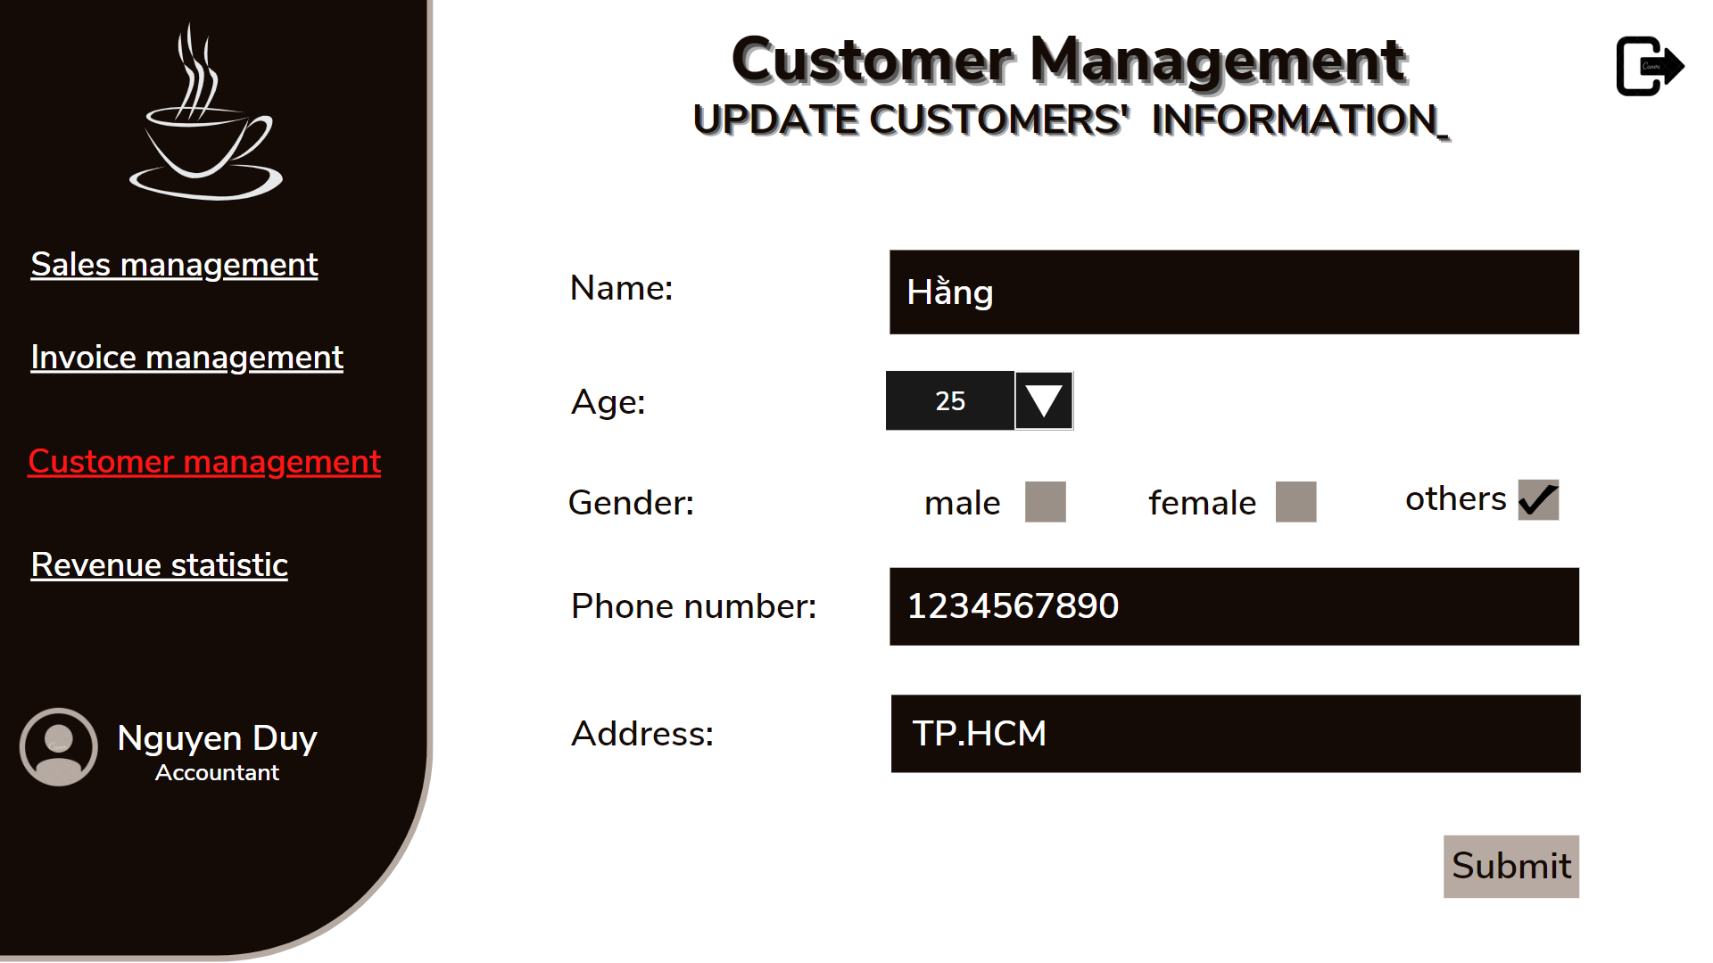

1. Revenue statistic frame

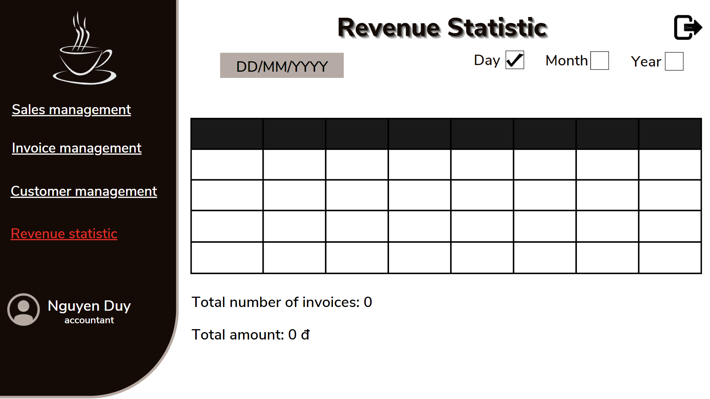

1. Inventory management frame

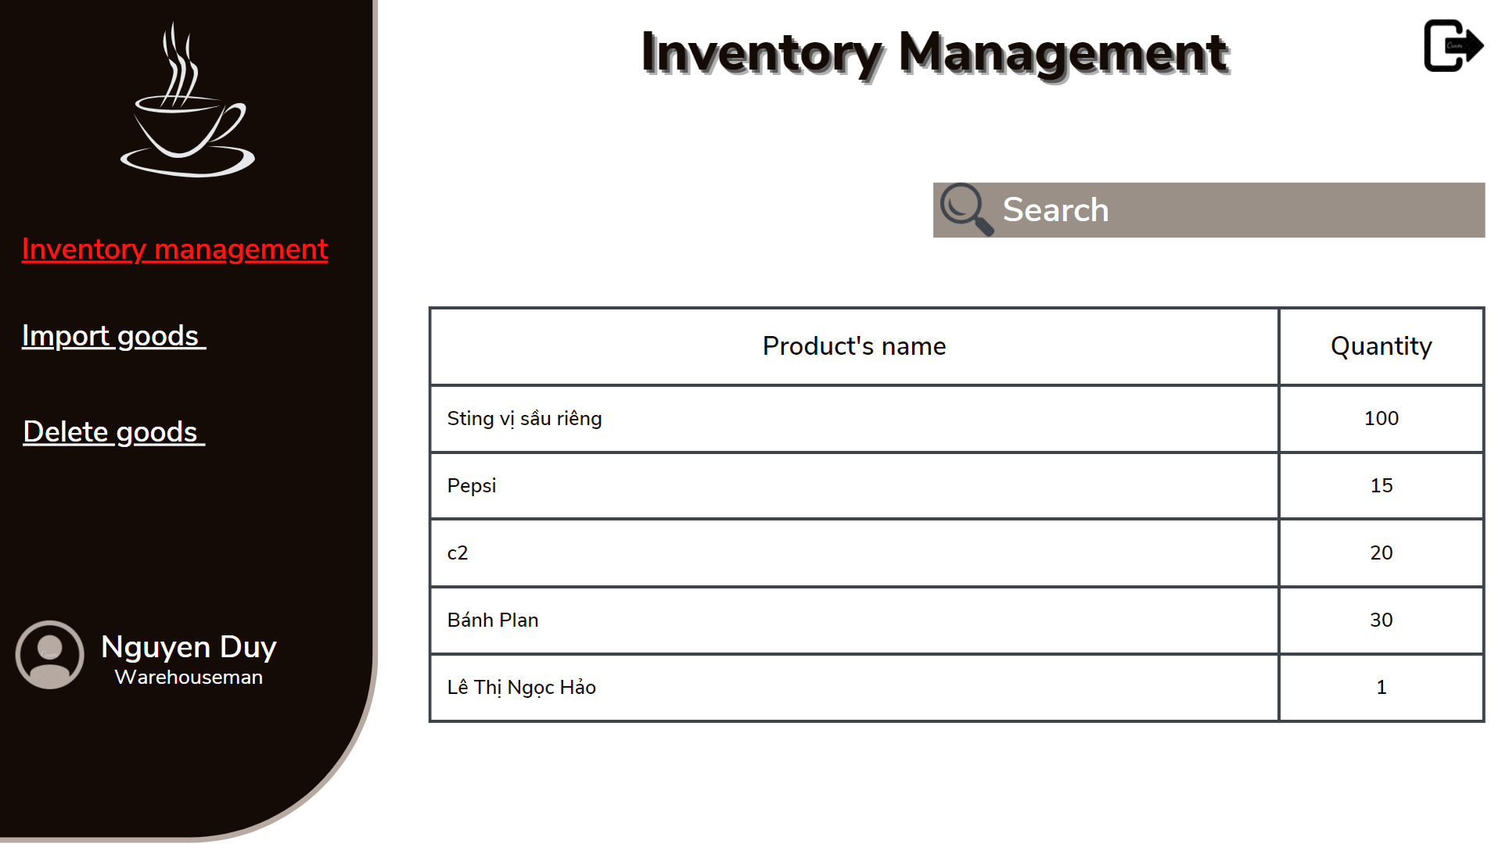

1. Import goods

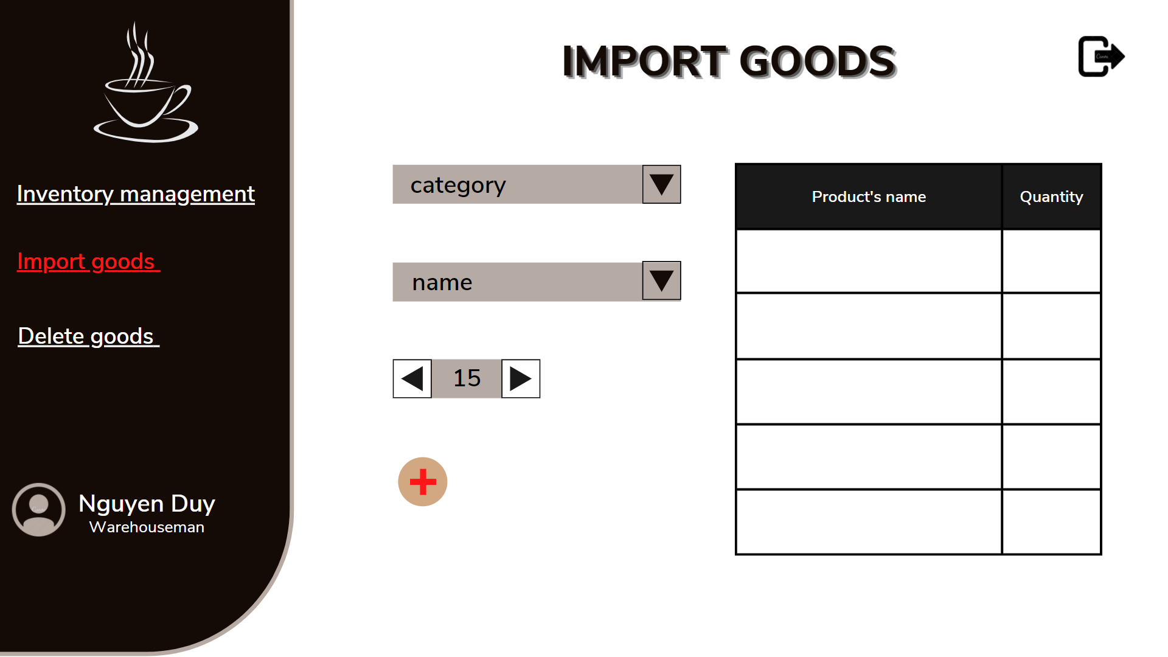

1. Delete goods

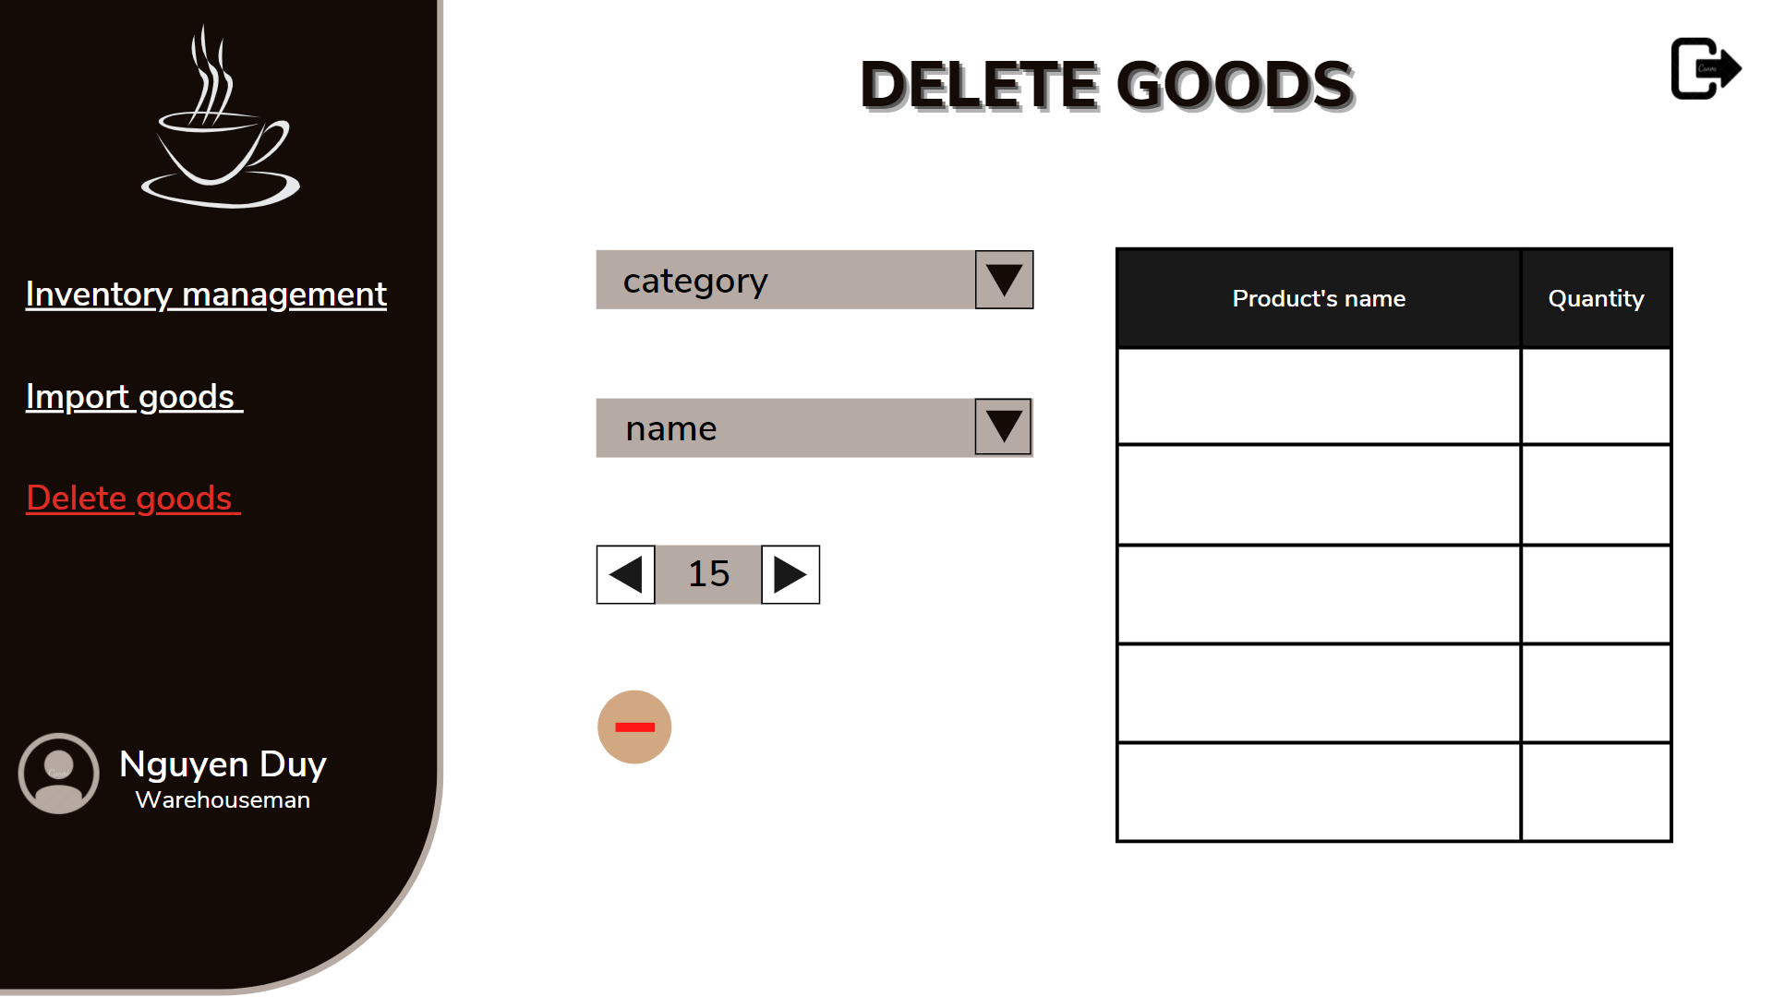

# **CHAPTER 5: CONCLUSION**

## **5.1 Achievement**

Conclusions:

* The application was made for the small business models.
* The application had achieved:
* Fully manage personal information of staff members
* Fully manage information of customers
* Fully manage importing goods
* Fully manage the revenue of the coffee shop
* Fully manage the number of drinks that customers order.

Limitations:

* Because of the limit of time and member, the application still have some restrict:
* Can not manage store by cloud management
* Do not have extra promotion
* All functions is still manual
* Limitation in security

Development:

* Complete all functions by automatic
* Create a function to manage promotions and additional services
* Manage coffee shop with cloud management
* Extend the application to manage a large number of customers, employees and goods.
* Update security system for customers and employees.

## **5.2 Self-assessment**

|  |  |  |  |
| --- | --- | --- | --- |
| Name | ID Student | Contribution | Process |
| Lê Thị Ngọc Hảo | 20521292 | Write report chapter 1, 2, 3  Interview Phuc Long’s manager  Draw use-case diagram of:   * Revenue management * Invoice management * Draw/describe relational model * Draw ERDs model * Draw state diagram: order and serving * List of use-case   Presentation | 100% |
| Nguyễn Duy | 20521234 | Create demo use-case diagram  Create UI Design of:   * Revenue statistic * Invoice management * User management * Customer management * Login   Code: Sales manager   * Describe relational model * Draw state diagram: import goods * List of actors * Draw use-case: Overall,order process   Presentation | 100% |
| Trương Mỹ Song Dân | 20520424 | Write report chapter 4, 5  Create UI Design of:   * Warehouse management * Product management * Import and Delete goods * Customer management * Inventory management   Draw DFDs model: level 0  Draw use-case:Import management  Presentation | 100% |
| Hồ Thị Hằng | 20521285 | Write report chapter 1, 2, 3  Draw all use-case diagram.  Draw activity diagram of:   * Login * Register * Employees management * Dinks management * Customer management * Goods management * Import management * Order process   Draw all sequence diagram  Draw DFDs model: level 1 | 100% |